**Financial Analysis and Risk Management**

***A Study of VIP Industries, Visaka Industries, and Vishnu Chemicals in Market Dynamics***

***Group Number: 4***

Under the supervision of

## Prof. Nagaraju Thota



**Birla Institute of Technology and Science, Pilani, Hyderabad Campus**

# 

# 

# 

# 

# GROUP MEMBERS

| **S.No** | **Name** | **ID** | **Contributed:**  **Yes/ No** |
| --- | --- | --- | --- |
| **1** | Shubham Birla | 2021B3A72965H | YES |
| **2** | Shashank Kumar | 2021B3AA0776H | YES |
| **3** | Sarvesh Goyal | 2021A4PS3093H | YES |
| **4** | Bhargav Nutalapati | 2021B3AA0815H | YES |
| **5** | T Lakshmi S Priya | 2020B3A70834H | YES |

# 

# Acknowledgment and Abstract

We would like to express our deep gratitude to Prof. Nagaraju Thota for giving us this valuable opportunity to work under him for the project and also for taking out valuable time to provide us the required guidance wherever necessary. His inputs proved to be very instrumental for the project. We would like to thank him for giving us such a wonderful opportunity to apply our course knowledge on real life data and get a hand on experience. We are greatly indebted for all his help throughout the course assignment.

The main goal of this project is to evaluate the financial performance of Vishnu Chemicals (VISHNU), Visaka Industries (VISAKAIND), and VIP Industries (VIPIND) by thoroughly analyzing their current and projected pricing over four years, starting on April 1, 2020, and ending on March 31, 2024. Using the CAPM, ARIMA, GARCH, and EGARCH models, the study assesses the returns and risk-adjusted returns of these companies on a daily, weekly, and monthly basis to identify the most successful trading frequencies.

Along with the stated assignment we tried to implement some extra thing like comparison of the company with their respective sector along we that we also tried to implement a optimal portfolio concept which we learned during our SAPM course so we could derive trading strategy from given 3 stocks.

# TABLE OF CONTENTS

Acknowledgment 3

Table of contents 4

***1 VIP Industries***7

1.1 About the company 7

* 1. Nature of the business 7
  2. Ownership category 7
  3. When it started? 6
  4. Significance in the industry 6
  5. Overall greatness of the company 6

1.2 Daily Returns Analysis 8

* 1. Estimating Beta using CAPM 8
  2. Estimating AR and MA coefficient using ARIMA model 10
  3. Forecasting Volatility using GARCH and RGARCH models: 15

1.3 Weekly Returns Analysis 19

* 1. Estimating Beta using CAPM 19
  2. Estimating AR and MA coefficient using ARIMA model 20
  3. Forecasting Volatility using GARCH and RGARCH models: 24

1.4 Monthly Returns Analysis 29

* 1. Estimating Beta using CAPM 29
  2. Estimating AR and MA coefficient using ARIMA model 30
  3. Forecasting Volatility using GARCH and RGARCH models: 35

1.5 Calculating the Value at Risk for VIPIND 38

1.6 VIPIND performance compared to other companies in the sector 39

***2. Visaka Industries*** 41

2.1 About the company 41

* 1. Nature of the business 41
  2. Ownership category 41
  3. When it started? 41
  4. Significance in the industry 41
  5. Overall greatness of the company 42

2.2 Daily Returns Analysis 42

* 1. Estimating Beta using CAPM 42
  2. Estimating AR and MA coefficient using ARIMA model 43
  3. Forecasting Volatility using GARCH and e-GARCH models: 48

2.3 Weekly Return Analysis 55

* 1. Estimating Beta using CAPM 55
  2. Estimating AR and MA coefficient using ARIMA model 56
  3. Forecasting Volatility using GARCH and e-GARCH models: 61

2.4 Monthly Return Analysis 70

* 1. Estimating Beta using CAPM 70
  2. Estimating AR and MA coefficient using ARIMA model 71
  3. Forecasting Volatility using GARCH and e-GARCH models: 76

2.5 Calculating the Value at Risk for VISAKAIND 80

2.6 VISAKA performance compared to other companies in the cement sector 80

***3. Vishnu Chemicals***82

3.1 About the company 82

1. Nature of the business 82
2. Ownership category 82
3. When did it start? 82
4. Significance in the industry 82
5. Overall greatness of the company 83

3.2 Daily Returns Analysis 83

1. Estimating Beta using CAPM 83
2. Estimating AR and MA coefficient using ARIMA model 84
3. Forecasting Volatility using GARCH and e-GARCH models: 88

3.3 Weekly Return Analysis 95

1. Estimating Beta using CAPM 95
2. Estimating AR and MA coefficient using ARIMA model 95
3. Forecasting Volatility using GARCH and e-GARCH models: 100

3.4 Monthly Return Analysis 102

1. Estimating Beta using CAPM 102
2. Estimating AR and MA coefficient using ARIMA model 102
3. Forecasting Volatility using GARCH and e-GARCH models: 107

3.5 Calculating the Value at Risk for VISHNU 112

3.6 VISHNU performance compared to other companies in the chemical sector. 113

***4. Optimum Portfolio******114***

***5.*** ***Conclusion*** ***115***

References 117

**VIP INDUSTRIES (VIPIND)**



Figure 1: VIP Industries logo

# 1.1 ABOUT THE COMPANY

**1.1.1 Nature of Business**

VIP Industries Limited is an Indian company that specializes in creating luggage and travel accessories. Since its inception in 1971, it has grown into a significant presence in Asia. Known for its diverse brand portfolio including VIP, Carlton, Caprese, Skybags, Aristocrat, and Alfa, VIP Industries offers a wide range of products catering to various needs of travelers. From sturdy suitcases to trendy backpacks, they have it all. Their products are not only popular in India but also in other countries. VIP Industries has earned a reputation for quality and innovation in the travel gear industry, making it a trusted choice for travelers worldwide.

**1.1.2 Ownership**



Figure 2: VIP shareholding pattern

The ownership structure of VIP Industries as of March 10, 2024, indicates that the Public (represented in yellow) owns 27.49% of the company's shares, while the Promoter group (represented in green) retains 51.76%. This percentage demonstrates a consistent holding by the Promoters since 2022, which is a positive indicator of stability for the company over the past two years.On the other hand, Mutual Fund holdings (represented in blue) encompass 9.29% of the company's shares. Although this percentage increased in 2023, it has now reached an all-time low of 9.29%. The board of directors for the firm comprises 10 individuals, with Mr. Dilip G. Piramal serving as Chairman.

**1.1.3 History**

VIP Industries Limited, also known as VIP, has been around since 1971. It was founded by Dilip Piramal in Mumbai, India. It started by making molded luggage and quickly became popular. In the following years, from the 1990s to the 2000s, VIP Industries grew and started making different types of luggage and travel stuff. In the 2010s, VIP Industries kept growing by buying other brands like Carlton, Skybags, and Aristocrat. They're known for being good at coming up with new ideas and listening to what customers want. They're one of the top companies in Asia. Now, VIP Industries is a big name not just in India but also in other countries. They're also working on being more eco-friendly. So, overall, VIP Industries is well-known for making good luggage and travel gear, and they've been growing steadily over the years.

**1.1.4 Overall Greatness of The Company**

In the Travel accessory-producing market, VIP is a notable and trustworthy participants. VIP prioritizes customer satisfaction by offering a diverse range of products to meet various needs and preferences. They also stand out as the market leader in the luggage and travel accessories industry with a strong presence in India.VIP's stable ownership structure with constant promoter holding over the years reflects confidence in the company’s long-term prospects as well.

# 1.2 Daily returns Analysis

**1.2.1 Estimate Beta using CAPM**

The CAPM Model says:

E(Rf) =Rf + 𝝱*(Rm-Rf)

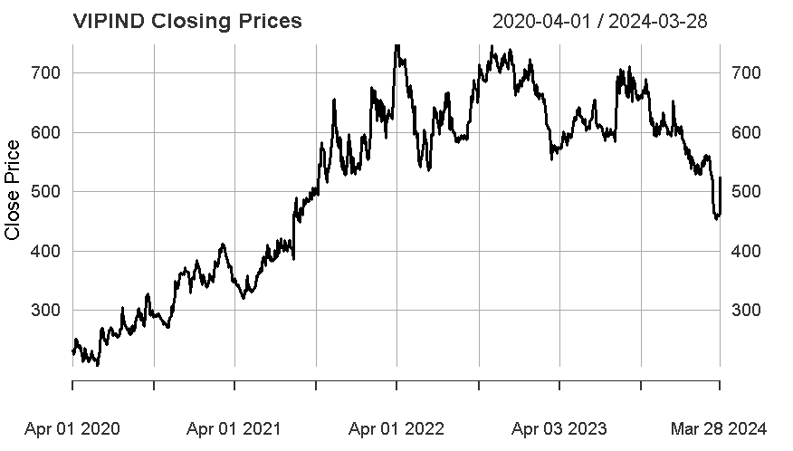

Where:

E(R): Expected return of the firm, Rf: risk-free rate,& Rm: returns of the market

Beta is obtained by performing a linear regression using market returns as the independent variable and securities returns as the dependent variable. The regression’s slope is used to characterize the security’s beta. It shows the degree to which changes in the company returns can affect the protection returns.

Daily calculations were made for the return between 1st April 2020 to 28th March 2024. Plotting the closing price across the specified period allows us the compute excess returns for both the index and the same security.

When the returns of the security were plotted across the research period, no pattern could be found. For most of the study, the returns ranged from -5% to 10%, with a few outliers where the return approached 20% in August 2021 and -7% a few times during the period. The returns were either a random walk or a white noise phase return.

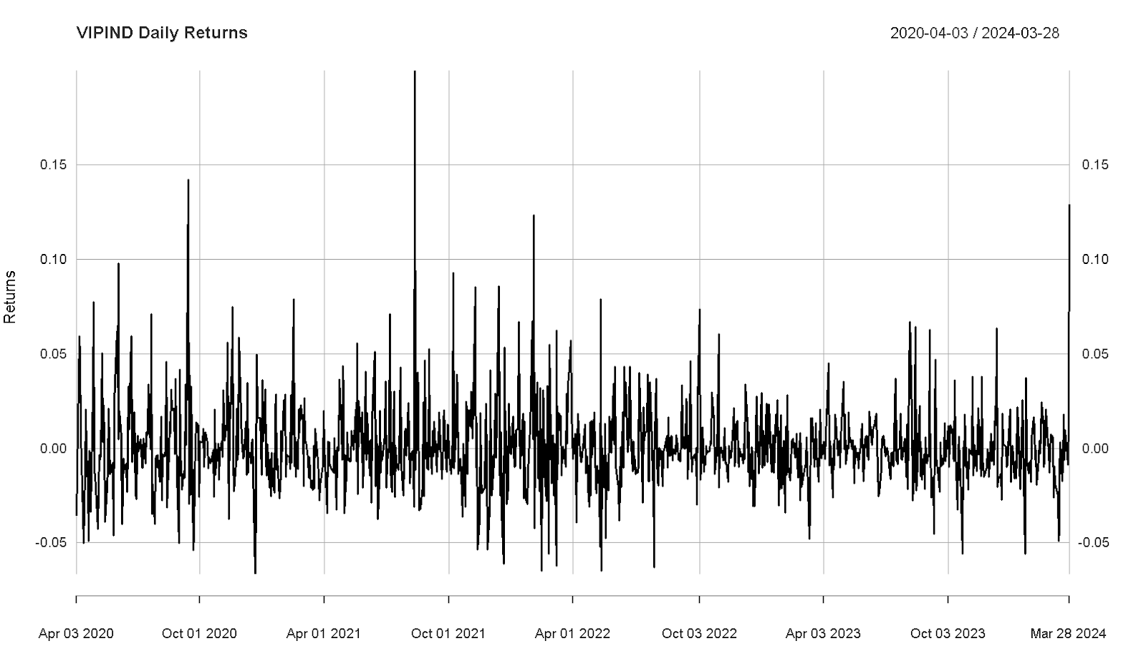

*Fig 2.1.1: Daily closing Prices*

Linear regression performed on security returns and market returns led to give us the following result given below:-

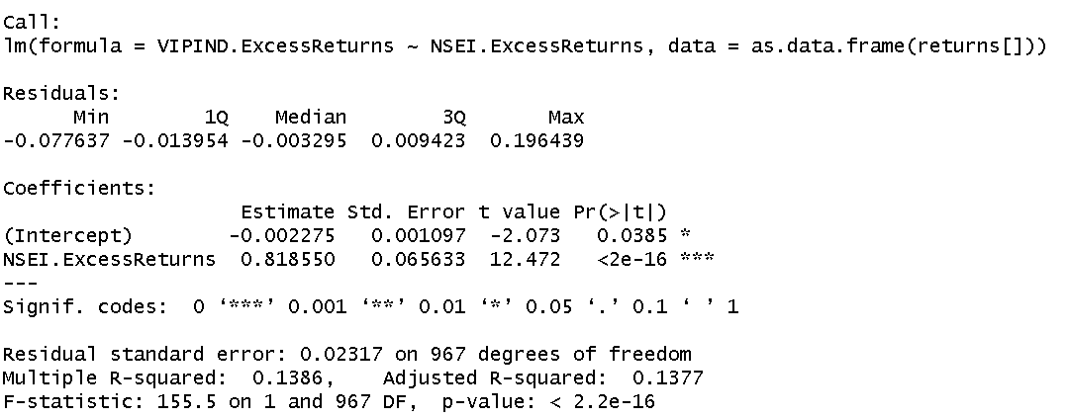

*Fig 2.1.3: Linear Regression for Daily Returns*

The regression above helps us to calculate the value of beta by taking into consideration the daily returns of the firm VIPIND. The slope of the linear model is around .8185 and the regression intercept is -0.002275. The p-value is significantly less than 0.05, meaning that, at a 95% confidence interval the slope is significant

.

**Beta Estimation:** From the above model we can see that our beta for the company VIPIND is 0.8185 when daily returns for the company are taken into consideration. This means that our company is less sensitive to the changes happening in the macroeconomic factors/variables than the market. When the market returns change by 1% our company returns when only change by 0.8185%.

**1.2.2. Estimating AR and MA coefficient using the ARIMA model**

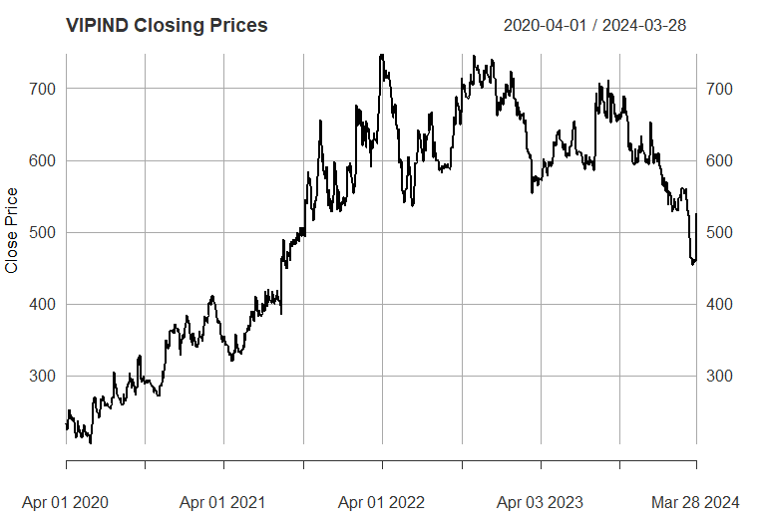

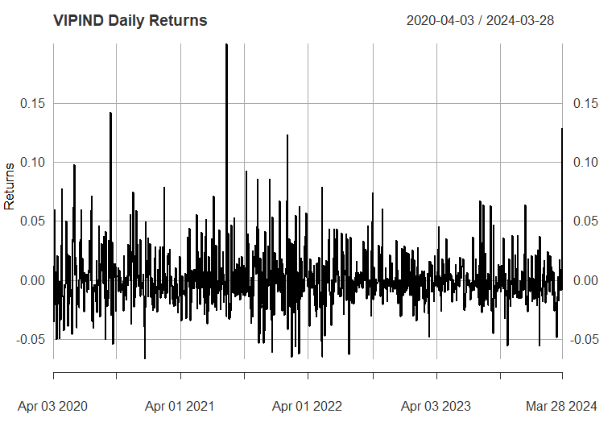

We now test for stationarity using the Augmented Dickey-Fuller test. The p-value resulting from the ADF test is 0.01, which is less than 0.05 or 5%. Hence, the series is stationary and rejects the null hypothesis.

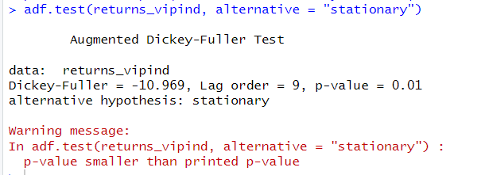

*Fig 2.1.4:Augmented Dickey-Fuller Test for Daily Returns*

**THE ACF PLOT**

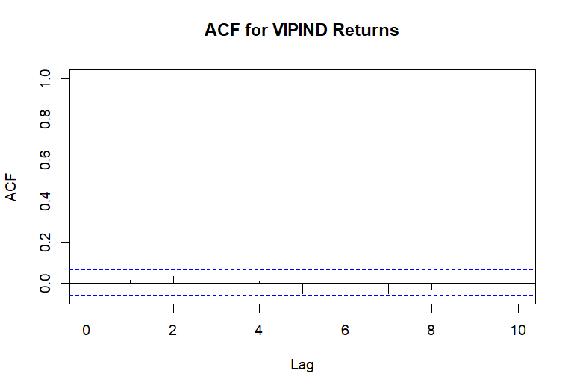

*Fig 2..5: ACF Plot for Daily Returns*

* The ACF value at lag 0 is always 1 because a series is perfectly correlated with itself.
* All subsequent lags show ACF values that are within the confidence bounds, hovering around zero without any significant peaks. This indicates that there is little to no autocorrelation at any lag, suggesting the returns are random (as is often expected with financial returns) and do not exhibit time-based patterns.
* The absence of significant peaks also suggests that an AR model may not be appropriate for this time series because there doesn't seem to be any autoregressive behavior. If you were to fit an ARIMA model, you might not need an AR component based on this plot.

Considering the results of the ADF test you provided earlier, which supported stationarity, and the ACF plot indicating no significant autocorrelation, your time series model for forecasting or further analysis may not need to include terms that address autocorrelation. However, one should also look at the Partial Autocorrelation Function (PACF) plot before deciding on the final model specification.The above plot shows us that our model is a MA(0) model.

**The PACF Plot**

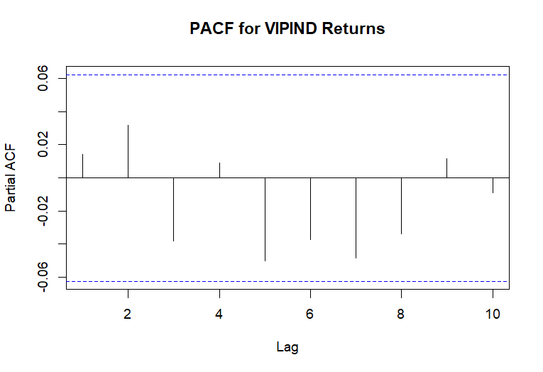

*Fig 1.1.6: PACF Plot for Daily Returns*

* PACF Values: All the PACF values at different lags are very close to zero and fall within the confidence interval bands, which are the dotted blue lines.
* Confidence Intervals: These bands indicate the range within which we can consider the partial autocorrelations to be statistically insignificant. Since all the
* PACF values are within these bounds, it suggests that there is no significant partial autocorrelation at any of the lags shown.
* Implications for Modeling: The lack of significant partial autocorrelation implies that an AR(p) component may not be necessary when modeling the VIPIND returns. In other words, the PACF plot does not provide evidence to include autoregressive terms in an ARIMA model for this time series data.

Combining this with the ACF plot you provided earlier, both the ACF and PACF suggest that the VIPIND returns time series does not exhibit strong autoregressive behaviors that would warrant including AR terms in a time series model.

From the above graphs of ACF and PACF and running various (p,d,q) models over the daily returns we come to an conclusion that we should go for (0,0,0) which is what we estimated from the ACF AND PACF plot as well.

**ARIMA Model Estimation**

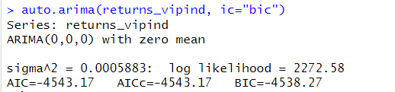

*auto.arima model estimation on daily returns for VIPIND*

From the above plot of ACF and PACF we found out that our model satisfies the ARIMA(0,0,0) Model which means that the MA and AR both are zero for this model and hence only intercept is left in the model. The log likelihood for this model is 2272.58 and has the least value for AIC and BIC due to which we have selected this variant of the ARIMA model.

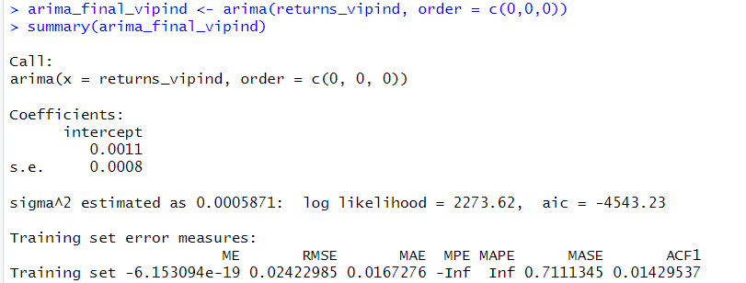

*Fig 1.1.7: ARIMA Model for Daily Return*

This is the final value of estimates which we get after estimation of the daily returns of VIPIND on the ARIMA(0,0,0) Model. We get the value of intercept as 0.0011 for our model.This intercept value is not significant in nature.

**Diagnostic Test:**

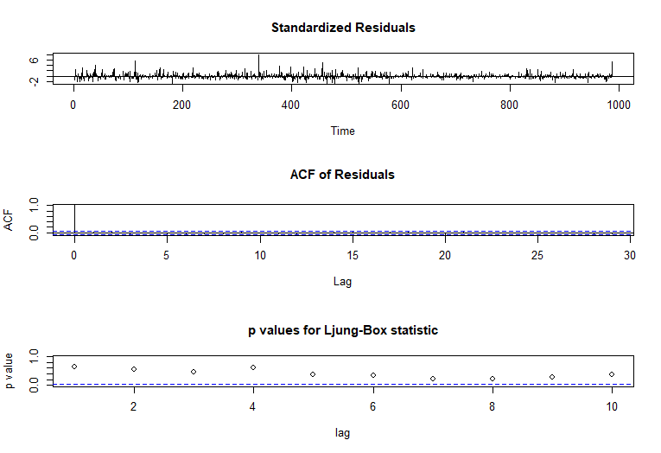

*Shows the diagnostic test for daily returns for VIPIND*

**Interpretation:-**

The model’s Residuals are distributed at random . For any value lag the ACF of residual is not important. Ljung-Box p-values are often smaller than 0.05. As a result , we can infer that the model is a strong match based on the above three observations.

**Forecast or Prediction using ARIMA Model:**

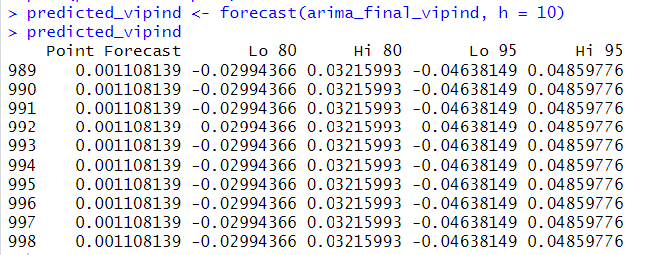

*Fig Shows the forecast or prediction using the ARIMA model.*

**Interpretation:-**

From the above table we can see the forecasted value by the ARIMA Model for the next 10 days. We can see the forecast at 85% and 95% confidence intervals and since we are using confidence intervals for estimation we make both low and high value predictions for each 10 days.

**1.2.3 Forecasting Volatility using GARCH and EGARCH models:**

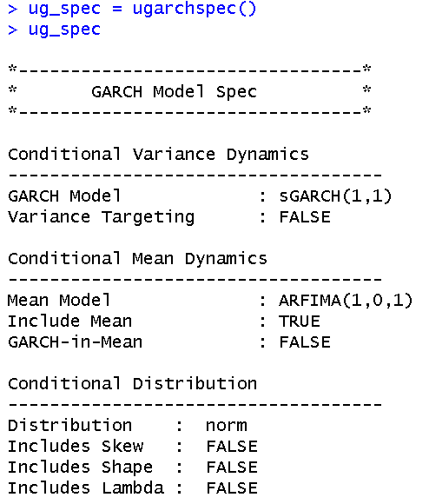

*Fig 1.1.9 GARCH model specs for daily returns*

* We can say from the above figure that GARCH(1,1) is the most appropriate model and the corresponding mean model ARFIMA(1,0,1) is chosen.
* Now we can start by running the EGARCH model on the daily returns of VIPIND .

e-GARCH Model

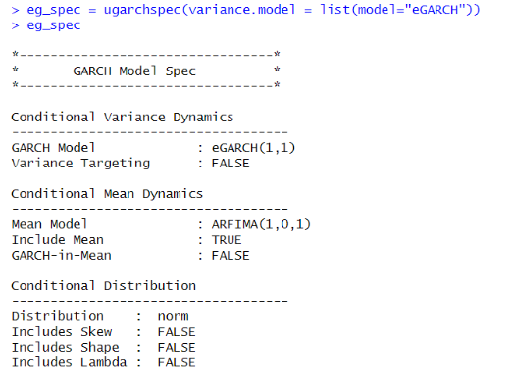

From the above result, it can be seen that EGARCH(1,1) is the resulting model, and the corresponding ARFIMA (1,0,1) is taken. The results coincide with the GARCH model used before.

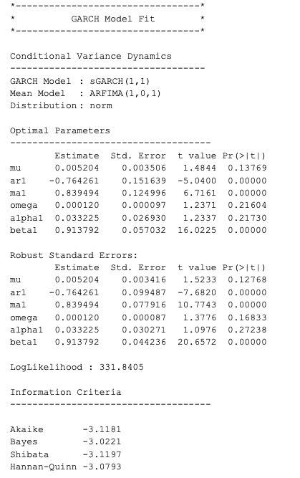 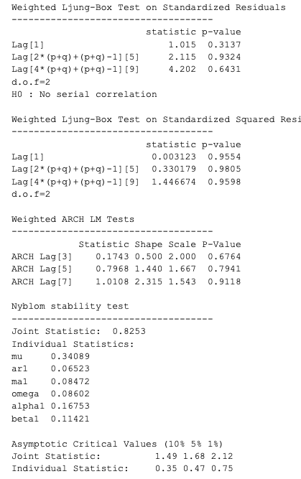

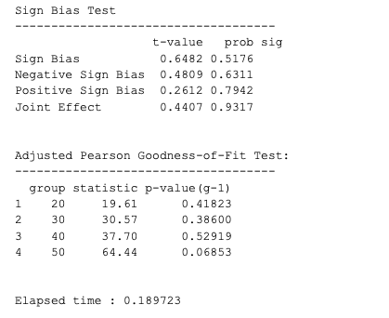

Interpretation:

The variance in GARCH continues to exhibit mean reversion , which means it is drawn over time to a long-term volatility rate.Omega , Alpha and Beta are calculated using the approximate standard error seen in the diagram above. Due to lower AIC and BIC values , GARCH(1,1) is a higher approximation than GARCH(2,1) AND GARCH(1,2).

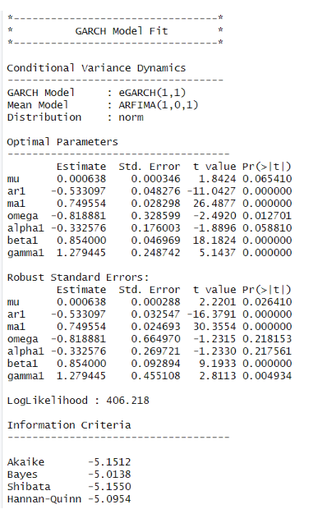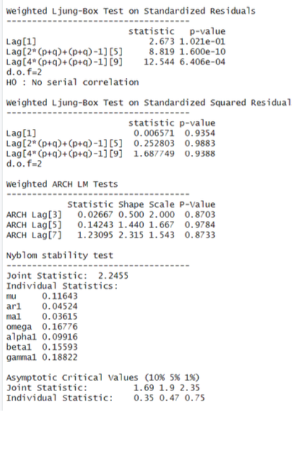

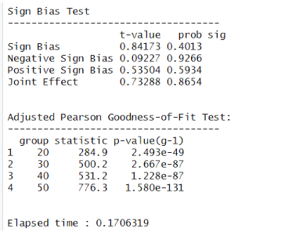

* The Log-likelihood of the model is 406.218.  
  eGARCH(1,1) and corresponding ARFIMA(1,0,1) are best
* for VIP IND Daily returns. Among the Optimal Parameters,only beta is significant as its p-value is lower than 0.05.
* Among the robust standard errors’ only beta1 is significant, all others are not significant.
* In the Ljung-box test result section, since all the p-values for both Standardized results and standard squared residuals are much higher than 0.05, the null hypothesis cannot be rejected and hence no serial autocorrelation exists which is a good condition for the model.
* In the Adjusted Pearson goodness-of-fit section, all the p-values are very high, which implies that the null hypothesis cannot be rejected and hence the observed values and expected values do not differ by a lot.

**GARCH Model Forecast:**

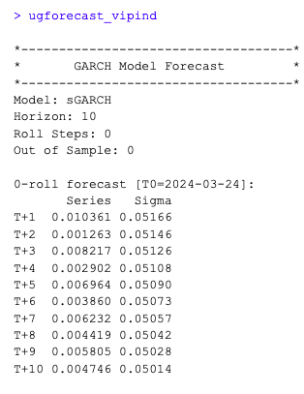

*Forecasting using the GARCH model for the next 10 days*

The above table shows the forecasted value using the GARCH model for the daily returns of VIPIND .

**Forecasting using the e-Garch MODEL**

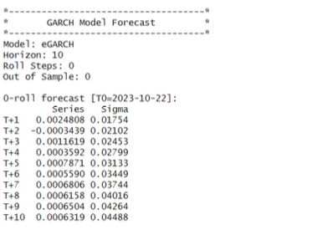

*Forecasting Using the e-GARCH model*

The result of forecasting is shown in Figure 47. The results show that the returns will be positive on average for the next 10 days, with a mean value of 0.01% and a standard deviation of 3.5%.

# 1.3 Weekly Returns Analysis

**1.3.1. Estimate Beta using CAPM**

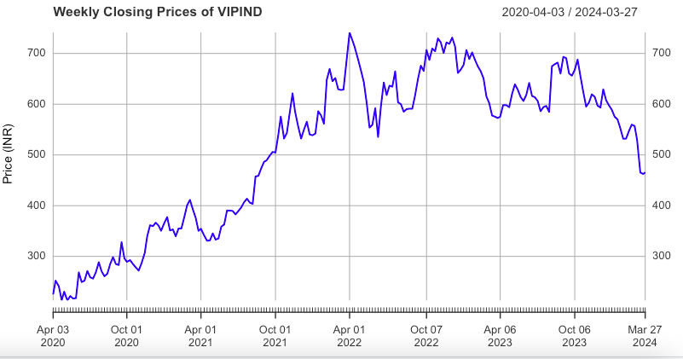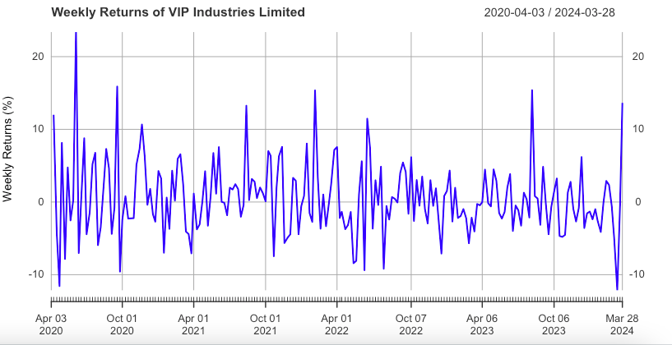

*Fig 2.1 : Weekly Closing prices of VIPIND Fig 2.2: Weekly returns of VIP*

Weekly closing prices of VIPIND was fetched from yahoo finance and plotted , from the above graph we can see that from 2020 the closing prices for VIPIND stocks has increased and now is almost constant for the past 2 years.

Weekly returns graphs for VIPIND is plotted below which shows that the returns from VIPIND has been between -10% to 10% except for a few situations where the returns even went to 20%+ . The returns are either a random walk or a white noise phase return.

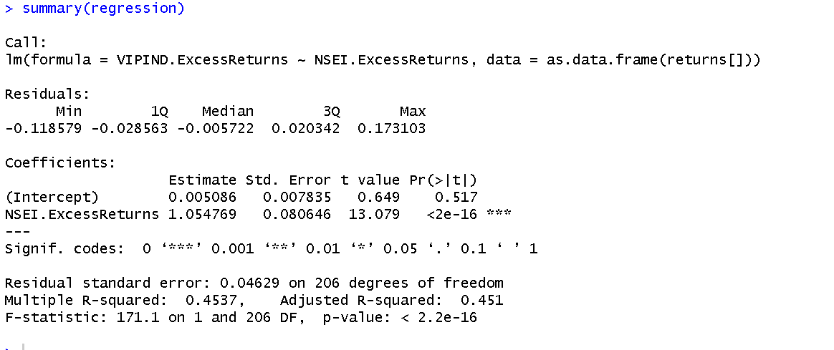

*Fig 2.3 CAPM model using weekly data of VIPIND*.

**Economic Interpretation**

1. The above linear regression is based on the CAPM model .
2. We are using this equation for calculating the Beta for VIPIND using the weekly returns of the firm.
3. The above linear regression has an intercept equal to 0.005086 and slope equal to 1.054. This slope of the model is basically our beta for the model.
4. A beta equal to 1.054 means that when the market returns change by 1% then the returns of the firm will change by 1.054% on a weekly basis.
5. Therefore we can say that a change in the macro condition of the market has an even higher impact on the returns of the firm on a weekly basis.

**1.3.2. Estimating AR and MA coefficient using ARIMA model**



*Fig 2.4 : Weekly returns of VIPIND*

Weekly returns for the firm vary between 10% to -10% for the whole duration of study .

Now we test for stationarity using the Augmented Dicky-Fuller test . The p-value resulting from the ADF test is 0.01 which is less than 0.05 or 5%. Hence the series is stationary and rejects the null hypothesis.

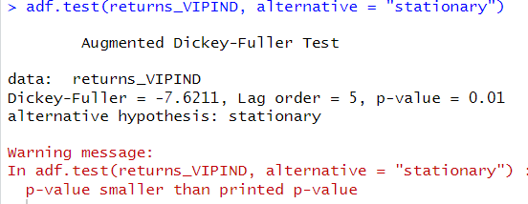

*Fig 2.5 : Augmented Dickey-Fuller Test*

**Interpretation:-**

**The ACF Plot**

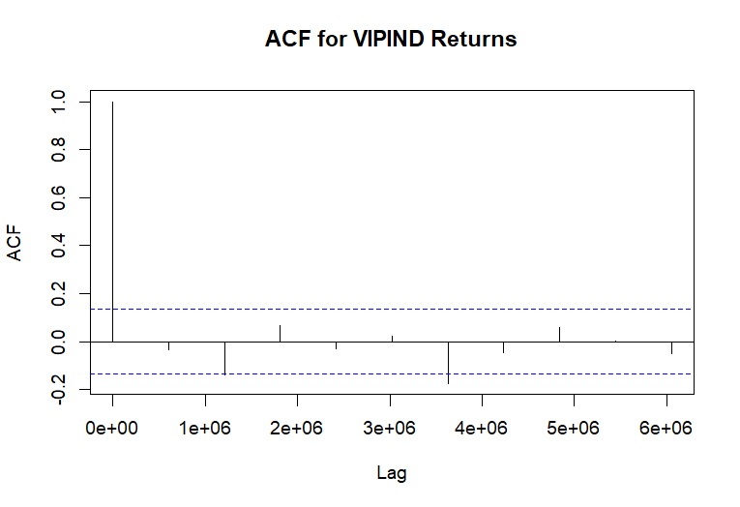

*Fig 2.6 ACF plot for weekly returns of VIPIND*

We can use the autocorrelation function (ACF), a statistical tool, to determine the degree of correlation between the values in a time series. The correlation coefficient is shown against the lag, which is expressed in terms of a number of units or periods, using the ACF.  
The moving average model has order 1. MA (0) model is estimated.

**The PACF Plot**

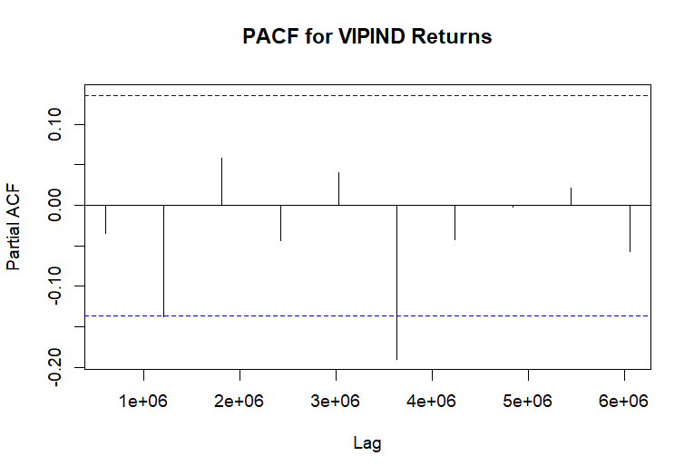

*Fig 2.7 PACF plot for weekly returns of VIPIND*

The partial autocorrelation function, or PACF, is what accounts for the partial correlation between the lags and the series. To put it simply, a linear regression explaining PACF can be used to predict y(t) from y(t-1), y(t-2), and y(t-3). The "parts" of y(t) and y(t-3) that are not anticipated by y(t-1) and y(t-2) are correlated in PACF. The order of the auto regressive model can be taken as 1.

Following this, the ARIMA model was run on all the orders(p,d,q). The best model is the one which has the least AIC value.

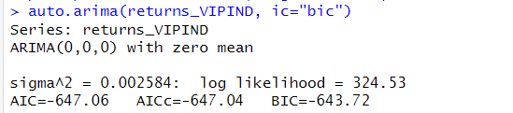

From the above plot of ACF and PACF we found out that our model satisfies the ARIMA(0,0,0) Model which means that the MA and AR both are zero for this model and hence only intercept is left in the model. The log likelihood for this model is 324.53 and has the least value for AIC and BIC due to which we have selected this variant of the ARIMA model.

**Fitting the ARIMA Model**

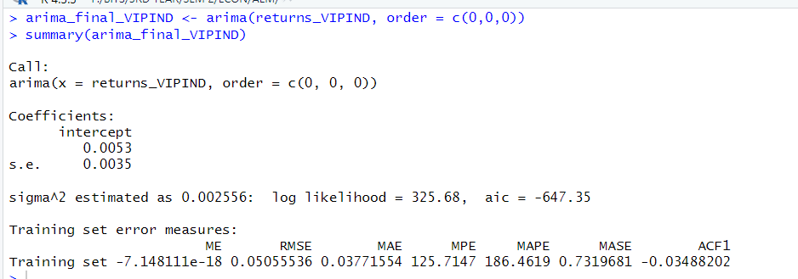

This is the final value of estimates which we get after estimation of the weekly returns of VIPIND on the ARIMA(0,0,0) Model. We get the value of intercept as 0.0053 for our model.This intercept value is not significant in nature.

**Diagnostic test:**

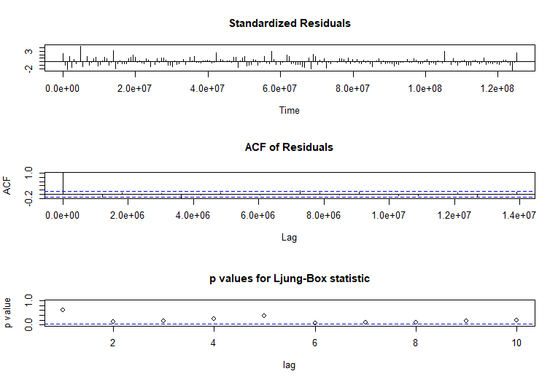

*Fig Diagnostic test for weekly returns of VIPIND*

* The model’s Residuals are distributed at random . For any value lag the ACF of residual is not important. Ljung-Box p-values are often smaller than 0.05. As a result , we can infer that the model is a strong match based on the above three observations.

**Forecasting and prediction using ARIMA model**

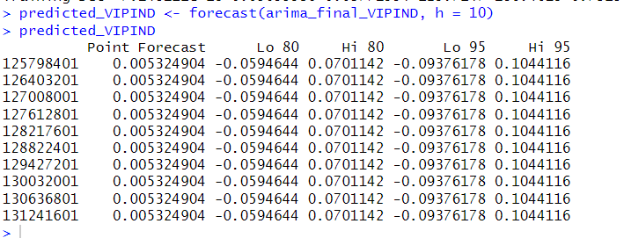

**Fig**

**Interpretation:-**

From the above table we can see the forecasted value by the ARIMA Model for the next 10 days. We can see the forecast at 85% and 95% confidence intervals and since we are using confidence intervals for estimation we make both low and high value predictions for each 10 days.

**1.3.3 Forecasting Volatility using GARCH and EGARCH models:**

By running the GARCH model on Weekly returns following results were obtained:

Fig 2.8: GARCH model for Weekly returns of VIPIND

From the above analysis, we can say that GARCH(1,1) will be the most appropriate model to be used in this case and therefore we will be taking the corresponding mean model ARFIMA(1,0,1).

Running the EGARCH models on the weekly returns. Below are the results for the same.



**E-Garch Model**

From the above result, it can be seen that EGARCH(1,1) is the resulting model, and the corresponding ARFIMA (1,0,1) is taken. The results coincide with the GARCH model used before.

**Estimation of Model**

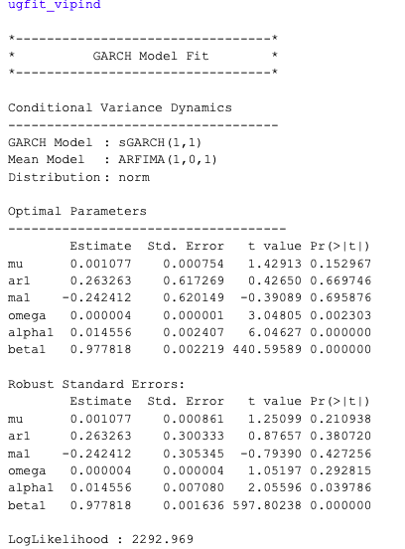

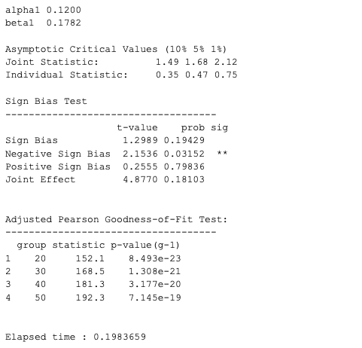

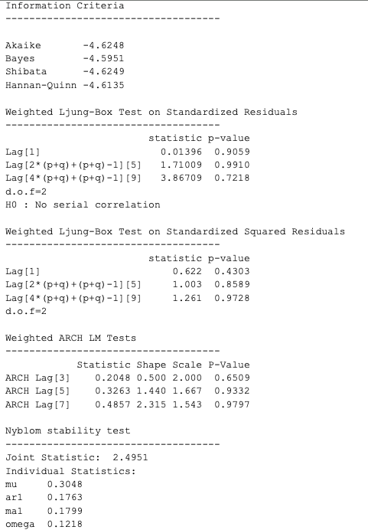

*Fig 2.:Diagnostic Test of GARCH Model for Weekly Returns*

**Observations from the Diagnostic test for the GARCH model for Weekly Returns**

* The resulting log-likelihood of the model is 2292.96.
* GARCH(1,1) and corresponding ARFIMA(1,0,1) are best for weekly returns.
* The ALPHA and Omega parameters are derived through a robust fitting process of the GARCH model. The model's minimal AIC and BIC values representing the optimal balance between simplicity and accuracy, establish it as the best-fit model with minimal position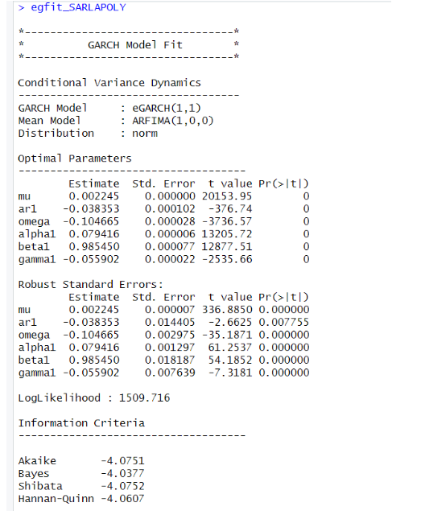

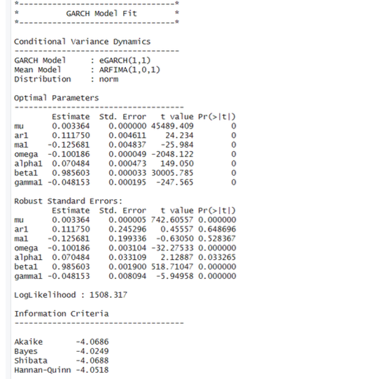

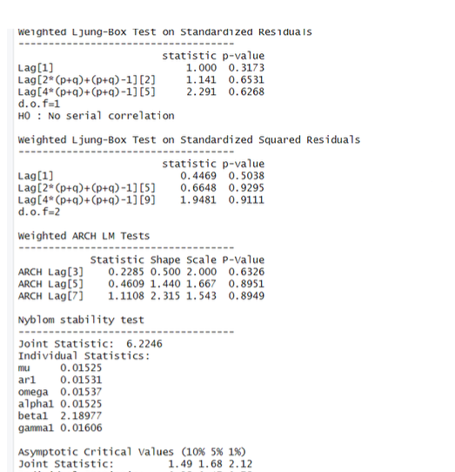

The log-likelihood of the model stands at 1508.317. For VIPIND daily returns, the optimal models identified are eGARCH(1,1) coupled with ARFIMA(1,0,1). Among the optimal parameters, only beta1 is statistically significant with a p-value below 0.05. Robust standard errors show a similar trend, with only beta1 being significant. In the Ljung-box test, all p-values for both standardized results and standard squared residuals exceed 0.05, indicating no serial autocorrelation—a favorable condition for the model. Additionally, high p-values in the Adjusted Pearson goodness-of-fit section suggest that observed and expected values do not significantly differ, supporting the model's validity

**GARCH Model Forecast:**

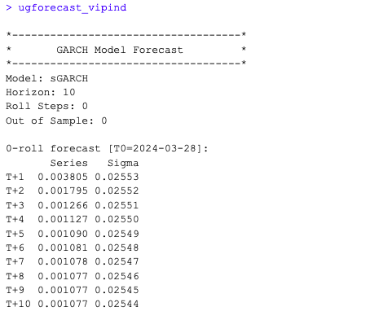

*Fig 2.: GARCH Model Volatility Forecast for Weekly Returns*

The result of the forecast is shown above . The result shows that the returns will be positive on average for the next 10 days , with a mean value of 0.10% and a standard deviation of 2.5%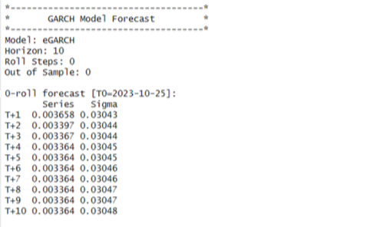

*Forecasting using E-GACH model*

The result of forecasting is shown above in the figure. The results show that the returns will be positive on average for the next 10 days, with a mean value of 0.33% and a standard deviation of 3.0%.

# 1.4. Monthly Returns Analysis

**1.4.1. Estimating Beta using CAPM Equation**

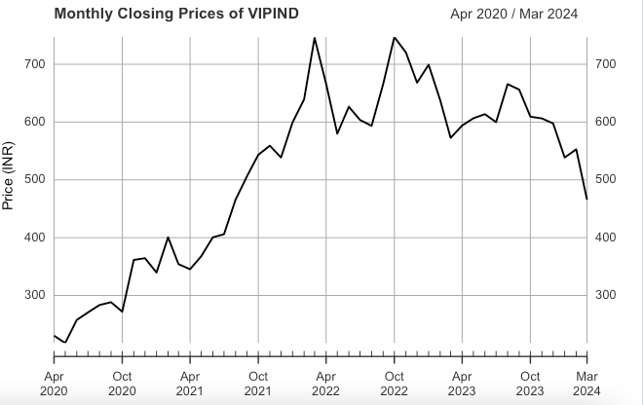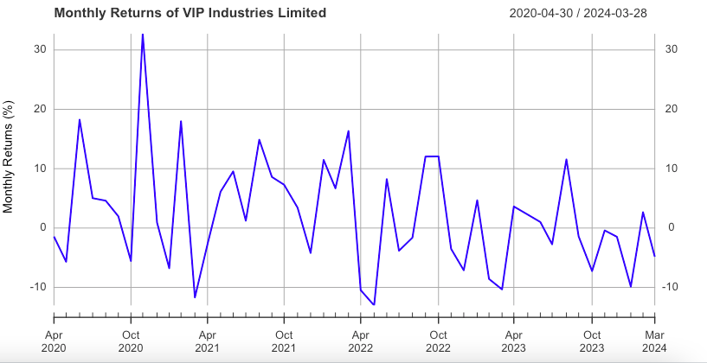

*Fig 3.1 Monthly Closing Price of VIPIND* *Fig 1.3.2: Monthly return of VIPIND*

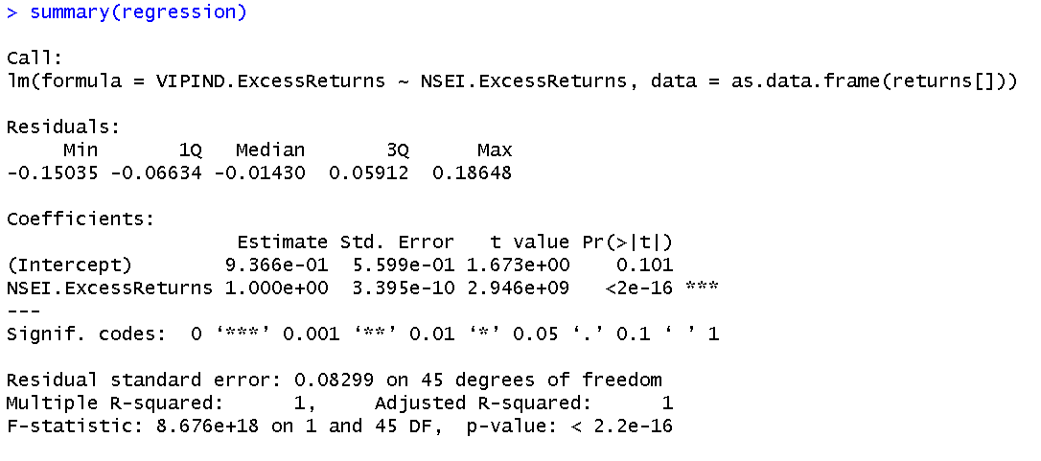

*Fig 1.3.3: CAPM Model for Beta estimation of VIPIND*

The above linear regression is nothing but the CAPM model through which we are going to find the beta for VIPIND on the basis of their monthly returns from 1st April 2020 to 28th March 2024.

The slope of the LR is 1 and the intercept of the model is 0.9366. The slope of the model is the beta for VIPIND which is equal to 1. Which means a change in the return of the market when changes by 1% the returns for the company VIPIND also changes by 1% over the month return basis.

**1.4.2. Estimating AR and MA coefficient using ARIMA model**

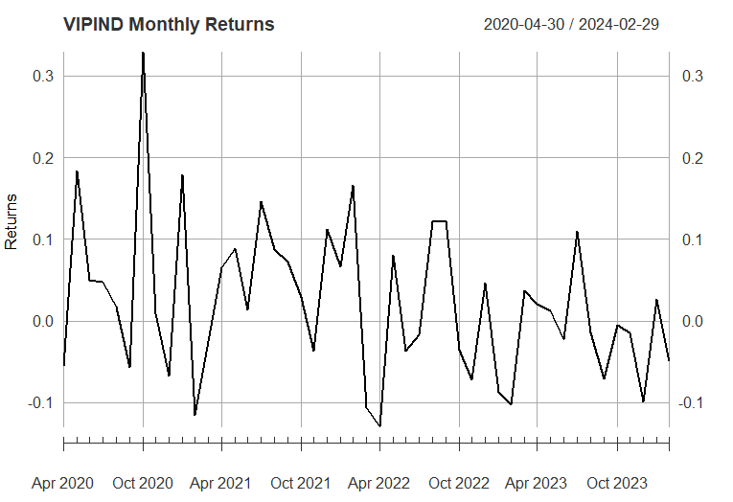

*Monthly returns of VIPIND*

When the returns of the security were plotted across the research period, no pattern could be found. For most of the study, the returns ranged from -5% to 10%, with a few outliers where the return approached 20% in August 2021 and -7% a few times during the period. The returns were either a random walk or a white noise phase return.

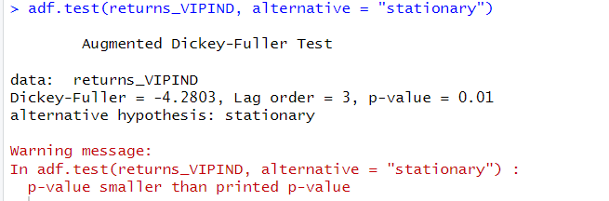

*The ADF test for stationarity*

The null hypothesis of the ADF test is that the unit root is present in the coefficient which implies that the series is non stationary while the alternate hypothesis is that the series is stationary. From the results we can clearly see that p value is equal to 0.01 which implies we can reject the null hypothesis and can say that the series is stationary. The value of the ADF test statistic is -4.2803.

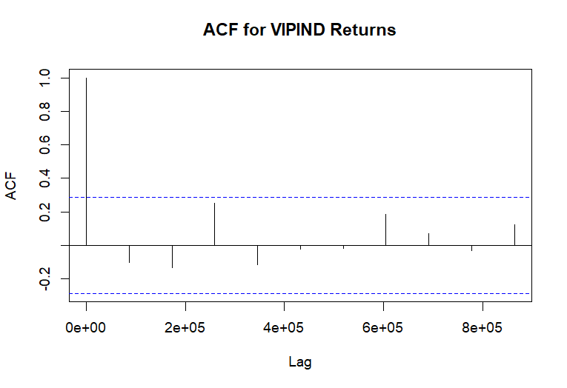

*The ACF PLOT for monthly returns for the firm VIPIND*

We can use the autocorrelation function (ACF), a statistical tool, to determine the degree of correlation between the values in a time series. The correlation coefficient is shown against the lag, which is expressed in terms of a number of units or periods, using the ACF.  
The moving average model has order 1. MA (1) model is estimated.

**The PACF PLOT**

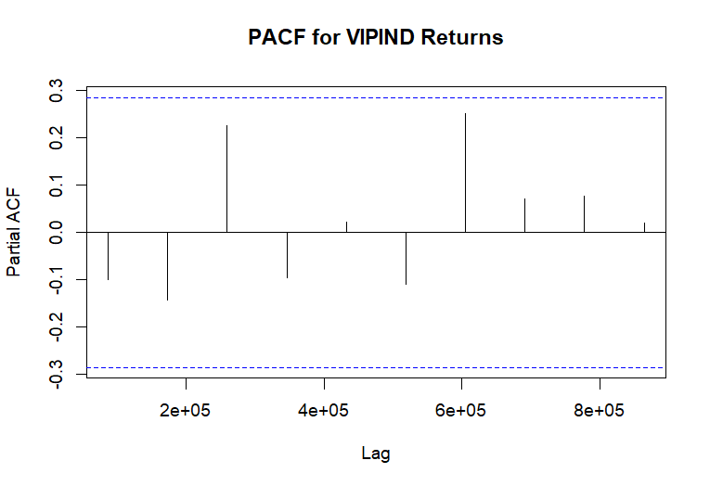

* PACF Values: All the PACF values at different lags are very close to zero and fall within the confidence interval bands, which are the dotted blue lines.
* Confidence Intervals: These bands indicate the range within which we can consider the partial autocorrelations to be statistically insignificant. Since all the
* PACF values are within these bounds; it suggests that there is no significant partial autocorrelation at any of the lags shown.
* Implications for Modeling: The lack of significant partial autocorrelation implies that an AR(p) component may not be necessary when modeling the VIPIND returns. In other words, the PACF plot does not provide evidence to include autoregressive terms in an ARIMA model for this time series data.
* Combining this with the ACF plot you provided earlier, both the ACF and PACF suggest that the VIPIND returns time series does not exhibit strong autoregressive behaviors that would warrant including AR terms in a time series model.
* From the above graphs of ACF and PACF and running various (p,d,q) models over the daily returns we come to an conclusion that we should go for (0,0,0) which is what we estimated from the ACF AND PACF plot as well.

**Estimation of ARIMA Model**

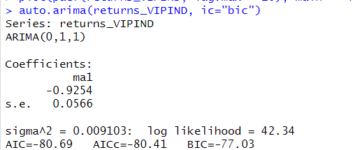

*auto.arima model implementation on monthly returns for VIPIND*

From the above plot of ACF and PACF we found out that our model satisfies the ARIMA(0,0,0) Model which means that the MA and AR both are zero for this model and hence only intercept is left in the model. The log likelihood for this model is 42.34 and has the least value for AIC and BIC due to which we have selected this variant of the ARIMA model.

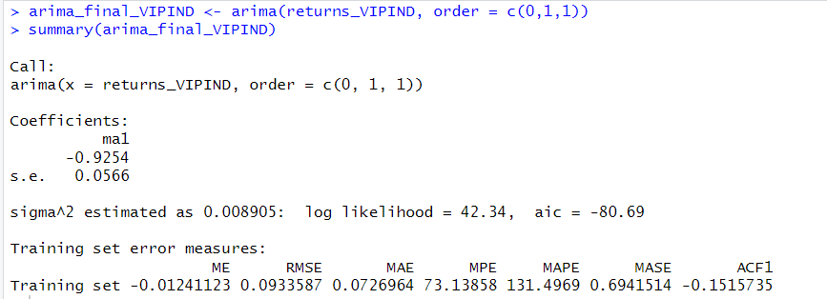

*Estimating the ARIMA(0,0,0) Model*

This is the final value of estimates which we get after estimation of the daily returns of VIPIND on the ARIMA(0,0,0) Model. We get the value of intercept as 0.0011 for our model.This intercept value is not significant in nature.

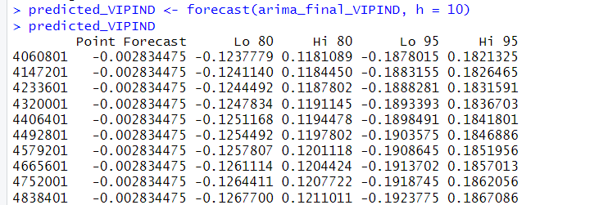

*Shows the predicted 10 days values using ARIMA model*

From the above table we can see the forecasted value by the ARIMA Model for the next 10 days. We can see the forecast at 85% and 95% confidence intervals and since we are using confidence intervals for estimation we make both low and high value predictions for each 10 days.

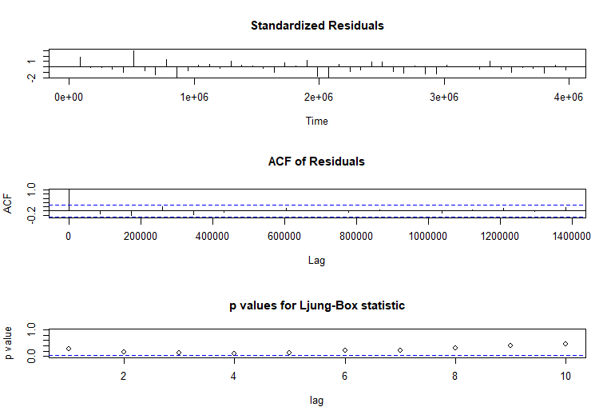

*Ljung-Box Test for VIPIND*

* The model’s Residuals are distributed at random . For any value lag the ACF of residual is not important. Ljung-Box p-values are often smaller than 0.05. As a result , we can infer that the model is a strong match based on the above three observations.

**1.4.3 Forecasting Volatility using GARCH and EGARCH Models:**

We are now going to run the GARCH model but now on the Monthly returns for the firm VIPIND.



*GARCH model specs for weekly return*

From the tabulated results above GARCH (1,1) will be the most appropriate model also we will be using ARFIMA(1,0,1) as the mean model.

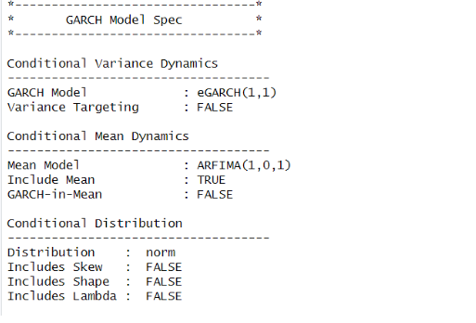

e-GARCH model estimation

From the above result, it can be seen that EGARCH(1,1) is the resulting model, and the corresponding ARFIMA (1,0,1) is taken. The results coincide with the GARCH model used before.

**Estimating the Model:**

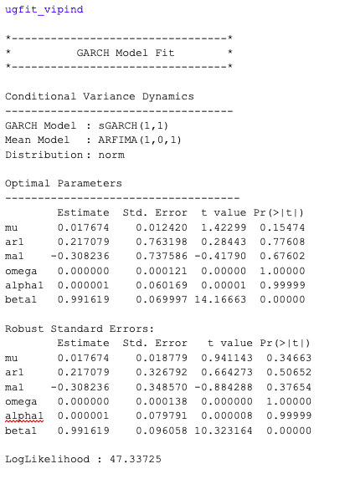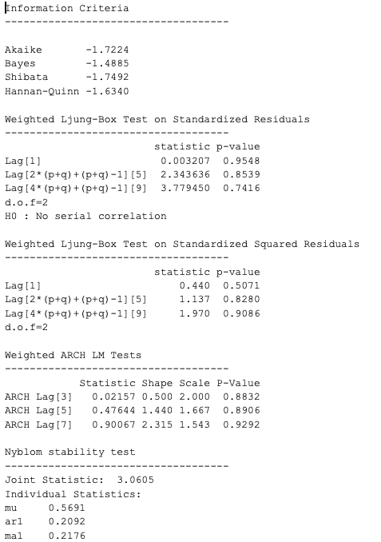

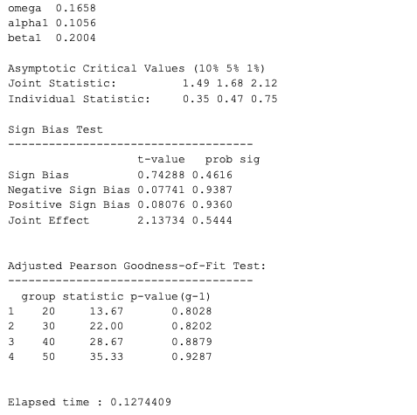

*Diagnostic Test for GARCH model for Monthly data*

**Interpretation of Diagnostic Test**

The log-likelihood for the model is 47.33 also the variance for the model continues to show mean reversion. Omega alpha and beta variables are calculated using the standard error formula given above in the table.As we know that the lower the value of AIC and BIC better is the estimation of the model hence from the above model we say that GARCH(1,1) will be a better model as compared to GARCH(2,1) or GARCH(1,2).

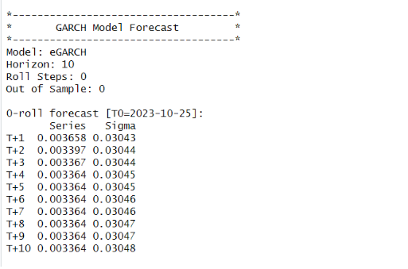

*Forecast using e-GARCH model*

The result of forecasting is shown in Figure 40. The results show that the returns will be positive on average for the next 10 days, with a mean value of 0.33% and a standard deviation of 3.0%.

**GARCH Model Forecast**

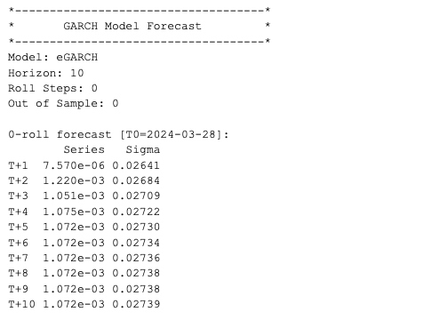

*GARCH Model Forecast on the monthly return data for VIPIND*

The result of the forecast is shown above. The results show that the returns will be positive on average for the next 10 days, with a mean value of 0.00171 and a standard deviation of 0.02722.

# 1.5 Calculating the Value at Risk for VIPIND

Value At Risk (VAR) is a statistical instrument which we can use for calculating the potential loss in a portfolio or investment over a time interval. It also helps us understand the maximum loss a portfolio can undergo during normal market situations.

Also, VAR is calculated at some specified confidence intervals, which represents that the actual loss won’t exceed the VAR calculated losses at that much confidence.

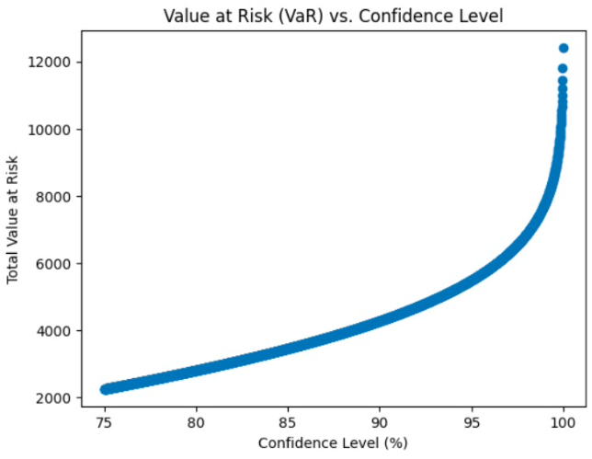

The above graph represents the VAR calculated for VIPIND at some specified confidence intervals(75%,80%,85%.....). From the above graph we can infer that at 75% confidence we can say that the maximum loss that the firm VIP can incur is 2000. As we are increasing the confidence level our VAR is also increasing , which is normal. At 80% confidence approx 4000 is the VAR and as the confidence of our estimation increases and reaches approximately 100% our VAR gets equal to 12000.

# 1.6 VIPIND performance compared to other companies in the sector.

Since 2020, VIP Industries' financial performance in the Household & Personal Products industry has been inconsistent. As of early 2024, the company's high Price to Earnings (P/E) ratio of 287.4 indicates that it may be overvalued in relation to its industry peers.

VIP Industries has demonstrated strong sales performance in recent years, as evidenced by its operating margin of roughly 8.88% and notable revenue increase of 60.64%.

On the other hand, the company's Return on Equity (ROE) of 29.54% and Return on Assets (ROA) of 11.29% and 11.29%, respectively, show a reasonable level of profitability from shareholders' equity and asset usage. The company's current ratio of 1.73 indicates that it has sufficient short-term assets to meet its short-term liabilities.

It's clear from comparing VIP Industries' financial indicators to those of other businesses in the same industry that while it does well in certain areas, it falls short in others, especially when it comes to value assessment metrics like the P/E ratio. Firms with lower P/E ratios, such as Hindustan Unilever and Dabur India, generally indicate more cautious market values.

Although VIP Industries' sales growth and profitability statistics are strong overall, potential value investors may be wary of the company's high P/E ratio, particularly in light of its higher valuation relative to other, more conservatively valued peers in the industry.

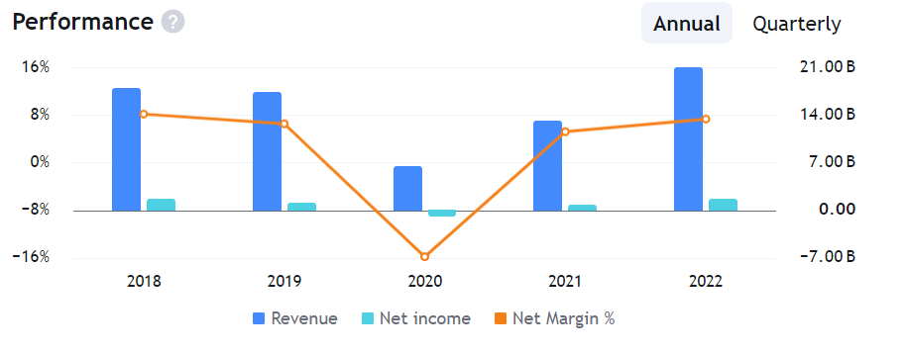

**VISAKA INDUSTRIES (VISAKAIND)**



# 2.1 ABOUT THE COMPANY

**A. Nature of business**

Visaka Industries Limited has multiple product portfolios, ranging from corrugated cement sheets and fiber cement boards to hybrid solar roofs and human-made fiber yarn. It recently launched ATUM Solar Roof, an integrated solar roofing system and it also manufactures and is a global supplier of The Wonder Yarn, a human-made spool for various fabric applications across garments, apparel, furnishings, automotive fabrics, and other technical textiles. Visaka Industries is primarily a rooftop and fabric manufacturer. Visaka has been developing sustainable products and meeting demands from both domestic and international markets.

**B. Ownership**

According to the ownership structure of Visaka Industries Limited as of December 31, 2023, the Promoter & Promoter Group owns 48.42% of the company's shares, while the Public owns 51.58%. The last few quarters have seen no changes in this ownership distribution. There are no shares owned by employee trusts. There are 8 members in the primary promoter group. Dr. Gaddam Vivekanand is the chairman and the founder of the company while G. Saroja Vivekanand is the managing director of Visaka Industries.

**C. History**

Visaka Industries was founded in 1981 by Dr. Gaddam Vivekanand with an aim to manufacture asbestos cement sheets, pressure pipes, and accessories. In its early years Visaka Industries collaborated with Andhra Pradesh Industrial Development Corporation (APIDC), this collaboration provided essential support and resources for the company’s growth in its initial years. Over time it expanded its product range from asbestos cement to fiber cement boards, hybrid solar roofs, and human-made fiber yarn.

**D. Overall greatness of the company**

Since the inception of Visaka Industries in 1981, it has grown into a multifaceted enterprise and through its pursuit of innovation and sustainability it diversified its product range and now has a global reach with 12 manufacturing units and a global robust distribution network. The company’s commitment to sustainable practices and contributions to environmental conservation earned it a GreenPro certification from the Indian Green Building Council (IGBC). Visaka Industries actively engages in CSR initiatives, its Visaka Charitable Trust has been serving society for years, emphasizing education, healthcare, and community development.

# 2.2 Daily returns Analysis

**2.2.1 Daily CAPM Model**

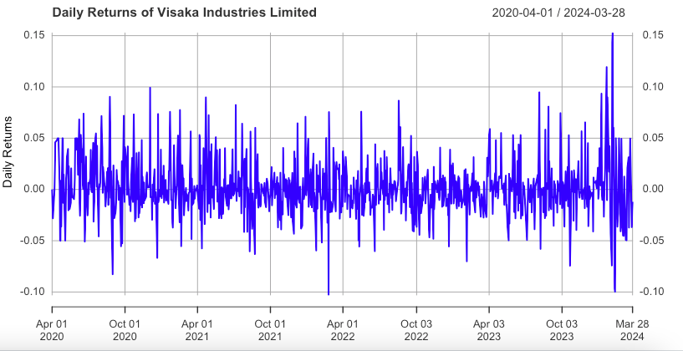

*Fig 2.1 Daily returns for VISAKAIND*

The above graph shows the daily return for VISAKA IND during the time period (1st April 2020 to 28th March 2024). The returns mostly are within the 10% bound interval. Few exceptions can be seen for example in march 2024 the return for the firm touched 15% return on both the upper and lower side.

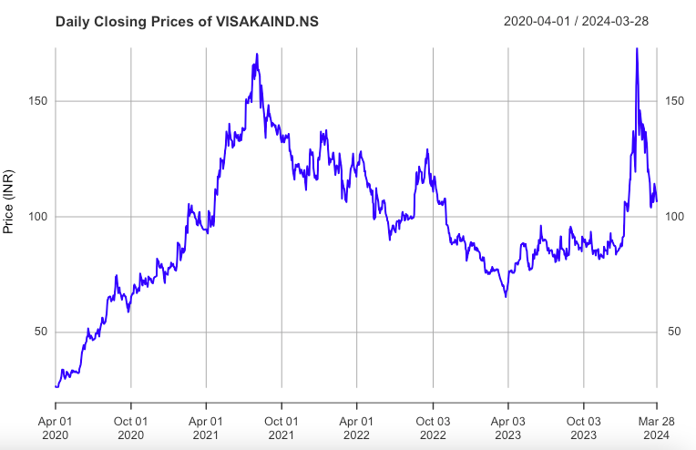

The above graph shows the daily closing price for the company VISAKA IND. A peak in July of 2021 could be seen when the stock for VISAKA was trading at the highest price. Later on it came to a low closing price in April 2023 but it bounced off from there and now the closing price is moving upwards from there which is a positive indicator for the company.

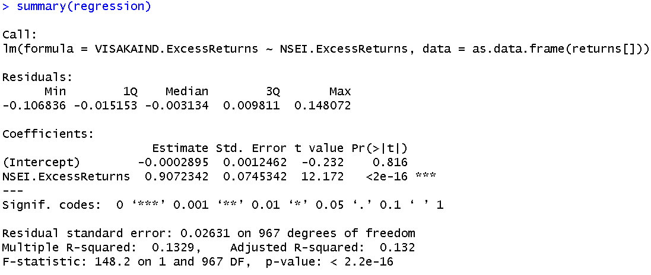

Running the regression on the daily returns of Visaka industries with the returns of the market (ii.e.NSE nifty 50) we get the coefficient beta as 0.9072342. It shows that the security is a lot sensitive to changes happening in the macroeconomic factors in the market. For 1% change in the market the security will change by 0.90%.

**2.2.2 Estimating AR and MA coefficient using ARIMA model**

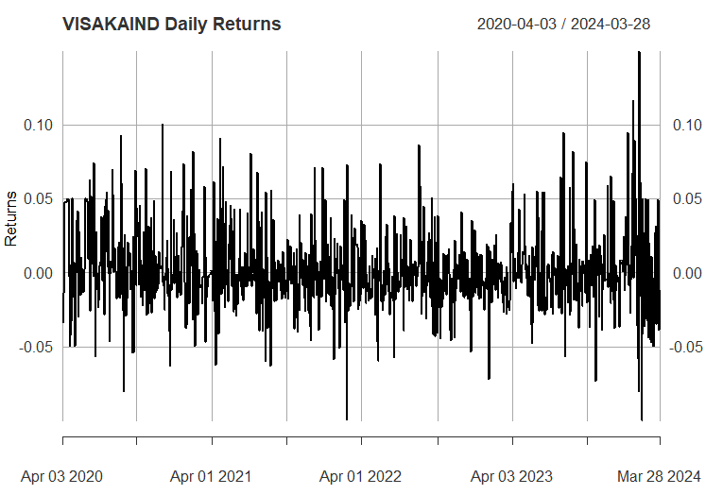

*Daily returns for the firm VISAKA IND*

The above graph shows the daily return for VISAKA IND during the time period (1st April 2020 to 28th March 2024). The returns mostly are within the 10% bound interval. Few exceptions can be seen for example in march 2024 the return for the firm touched 15% return on both the upper and lower side.

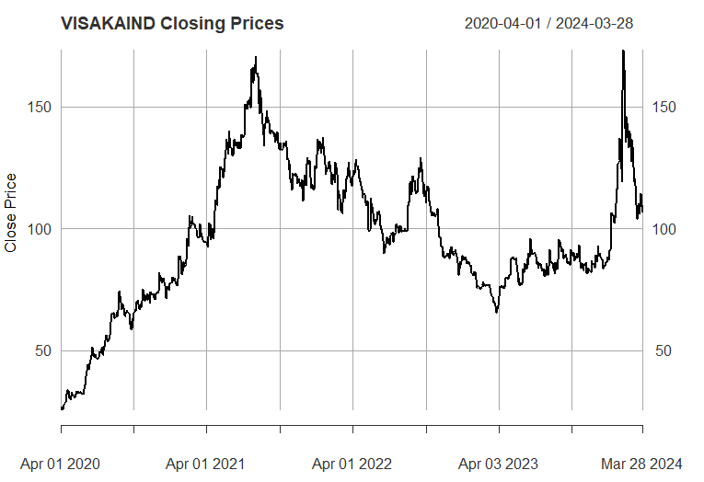

*Daily closing price for VISAKA IND*

The above graph shows the daily closing price for the company VISAKA IND. A peak in July of 2021 could be seen when the stock for VISAKA was trading at the highest price. Later on it came to a low closing price in April 2023 but it bounced off from there and now the closing price is moving upwards from there which is a positive indicator for the company.

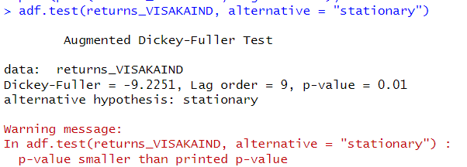

*ADF test for Daily returns of VISAKA IND*

The null hypothesis of the ADF test is that the unit root is present in the coefficient which implies that the series is non stationary while the alternate hypothesis is that the series is stationary. From the results we can clearly see that p value is equal to 0.01 which implies we can reject the null hypothesis and can say that the series is stationary. The value of the ADF test statistic is -9.225.

**The ACF Plot**

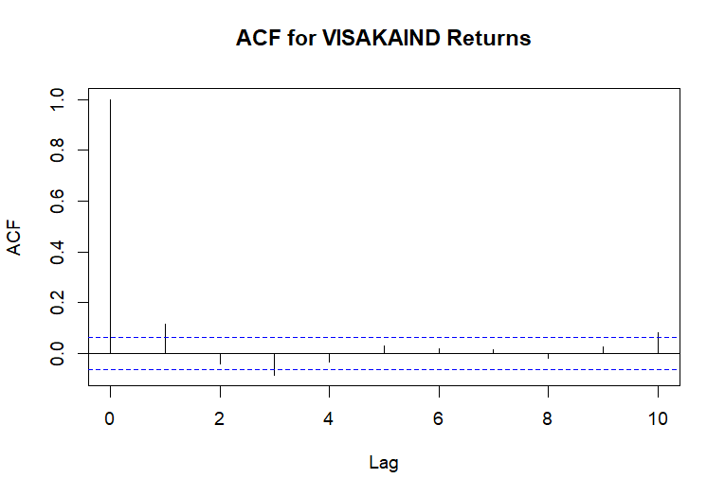

*ACF plot for daily returns of VISAKA IND*

We can use the autocorrelation function (ACF), a statistical tool, to determine the degree of correlation between the values in a time series. The correlation coefficient is shown against the lag, which is expressed in terms of a number of units or periods, using the ACF.  
The moving average model has order 1. MA (3) model is estimated.

The PACF Plot

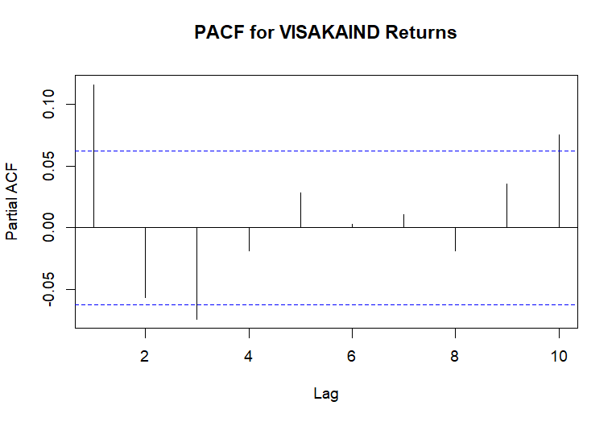

**PACF plot for daily return of VISAKA IND**

* PACF Values: All the PACF values at different lags are very close to zero and fall within the confidence interval bands, which are the dotted blue lines.
* Confidence Intervals: These bands indicate the range within which we can consider the partial autocorrelations to be statistically insignificant. Since all the
* PACF values are within these bounds; it suggests that there is no significant partial autocorrelation at any of the lags shown.
* Implications for Modeling: The lack of significant partial autocorrelation implies that an AR(p) component may not be necessary when modeling the VIPIND returns. In other words, the PACF plot does not provide evidence to include autoregressive terms in an ARIMA model for this time series data.
* Combining this with the ACF plot you provided earlier, both the ACF and PACF suggest that the VIPIND returns time series does not exhibit strong autoregressive behaviors that would warrant including AR terms in a time series model.
* From the above graphs of ACF and PACF and running various (p,d,q) models over the daily returns we come to an conclusion that we should go for (0,0,0) which is what we estimated from the ACF AND PACF plot as well.
* Therefore we consider the AR(0) on the basis of analysis from the above graph.

**Estimating the best possible ARIMA model**

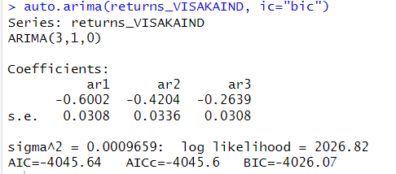

From the above plot of ACF and PACF we found out that our model satisfies the ARIMA(3,1,0) Model which means that the MA is with lag of 3 and AR with 0 lag is considered for this model. The log likelihood for this model is 2026.82 and has the least value for AIC and BIC due to which we have selected this variant of the ARIMA model.

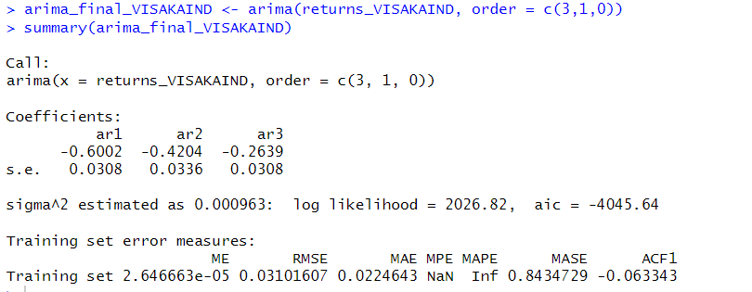

This is the final value of estimates which we get after estimation of the daily returns of VIPIND on the ARIMA(3,1,0) Model. We get the value of AR1 as -.6002 AR2 estimate equal to -0.4204 and AR3 estimated equal to -.2639 for our model.

**Prediction values for next 10 days using our ARIMA model**

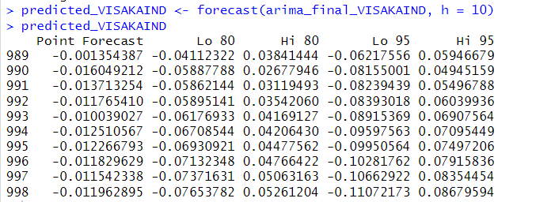

*Shows the predicted values for next 10 days*

From the above table we can see the forecasted value by the ARIMA Model for the next 10 days. We can see the forecast at 85% and 95% confidence intervals and since we are using confidence intervals for estimation we make both low and high value predictions for each 10 days.

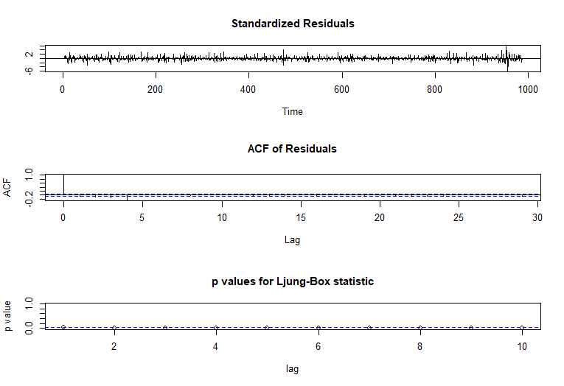

* The model’s Residuals are distributed at random . For any value lag the ACF of residual is not important. Ljung-Box p-values are often smaller than 0.05. As a result , we can infer that the model is a strong match based on the above three observations.

**2.2.3 Forecasting Volatility using GARCH and EGARCH Models:**

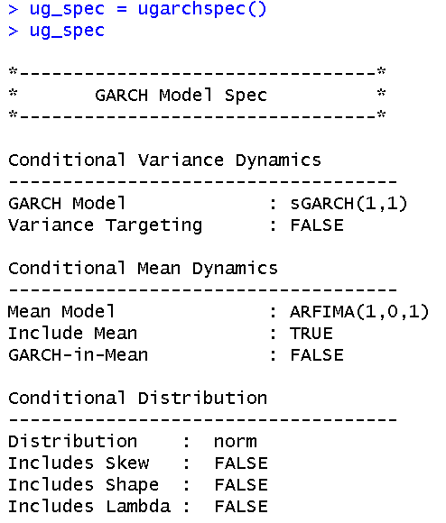

From the above analysis, we can say that GARCH(1,1) will be the most appropriate model to be used in this case and therefore we will be taking the corresponding mean model ARFIMA(1,0,1). Running the EGARCH models on the weekly returns. Below are the results for the same.



From the above result, it can be seen that EGARCH(1,1) is the resulting model, and the corresponding ARFIMA (1,0,1) is taken. The results coincide with the GARCH model used before.

**Estimating the Model**

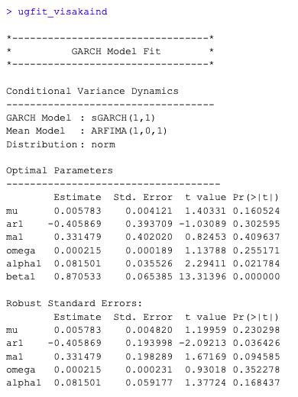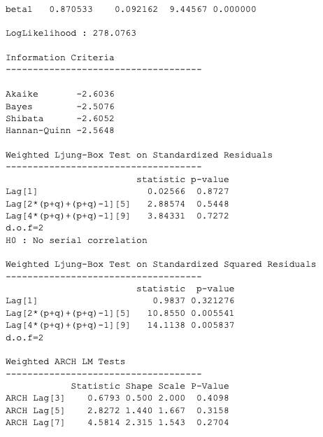

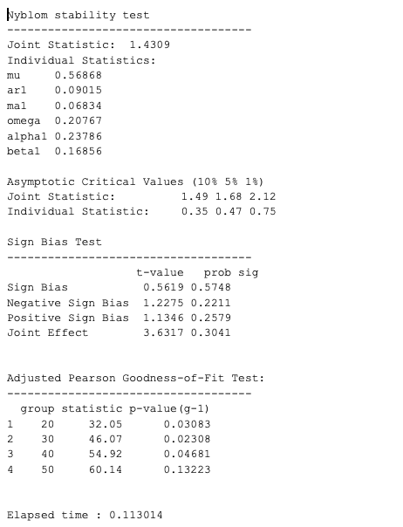

Here the GARCH (Generalized Autoregressive Conditional Heteroskedasticity) model is used to analyze the volatility of the VISAKA IND stock data. Here sGARCH (1,1) is used which indicates that the model has one lag of the squared conditional volatility (GARCH term) and one lag of the squared error term (ARCH term). And as for the mean model ARFIMA (Autoregressive Fractionally Integrated Moving Average) which includes one autoregressive term (AR), zero differencing terms (I), and one moving average term (MA).

In the optimal parameters

mu represents the long-term average, which is the base level of the stock data which has an estimate of 0.005783 but is in significant at 95%

ar1 represents the autoregressive term in the mean model, it shows the impact of the lagged value of the series on its current value. It has an estimate of -0.405869 and is significant at 95%.

ma1 represents the moving average term in the mean model, capturing the impact of the lagged error term on the current value of the series. The estimated coefficient for MA(1) is 0.331479, which is not statistically significant at the 95% confidence level (p-value = 0.409637).

omega represents the long-term average or baseline level of volatility in the GARCH model. The estimated value of omega is 0.000215, which is insignificant at the 95% confidence level (p-value = 0.255171).

alpha1 shows the impact of past volatility on current volatility in the GARCH model. The estimated coefficient for alpha1 is 0.081501, which is significant at the 95% confidence level (p-value = 0.021784).

beta1 represents the persistence of volatility in the GARCH model, capturing the impact of the lagged conditional variance term on the current volatility. The estimated coefficient for beta1 is 0.870533, which is statistically significant at the 95% confidence level (p-value < 0.05).

robust standard errors are calculated which take into account the violations of distribution assumptions and the heteroscedasticity, here ar1 is only significant with an estimate of -0.405869.

The model has a log likelihood of 287.0763 which is good, log likelihood shows how well the given model fits the data, higher the value the better it is.

The Weighted Ljung-Box is used to see whether there is any remaining autocorrelation in the model. Here as the p value of the lag is greater than 0.05 we couldn’t reject the null hypothesis which is “No serial correlation”, so we conclude that there is no serial correlation.

The Nyblom stability test is used to assess the stability of the estimated parameters over time in a model. The joint statistic shows the overall stability of the model which is 1.4309 and when we compare it to the asymptotic critical value at 5% the drawing statistic is 1.68, seeing that the joint statistic value is very low than the given critical value we can conclude that there is no evidence of instability in the parameter. Now comparing the individual statistics as all of them are lower than the critical values given we can say that all of them are significant and are stable.

The Sign Bias Test is used to assess whether there is any systematic bias in the signs of the residuals or errors in a model here since the P value of all the biases is greater than 0.05 and we fail to reject the null hypothesis which is that there is no evidence of overall bias, so we conclude that there is no bias.

Adjusted Pearson Goodness of fit sees how well the model fits the data, here the group shows number of data points used in the test when this statistic shows the discrepancy between the observed data and the values expected by the model add the last column shows the p value for each group adjusted for the degrees of freedom. Here the null hypothesis is that the model does fit the data and when the group is of 50 data points the p value is 0.13223 which is greater than 0.05 hence we fail to reject the null hypothesis indicating the model fits the data well for this group size.

=> egfit_visakaind

*---------------------------------*

* GARCH Model Fit *

*---------------------------------*

Conditional Variance Dynamics

-----------------------------------

GARCH Model : eGARCH(1,1)

Mean Model : ARFIMA(1,0,1)

Distribution : norm

Optimal Parameters

------------------------------------

Estimate Std. Error t value Pr(>|t|)

mu 0.006572 0.002913 2.25623 0.024057

ar1 -0.370342 0.490205 -0.75549 0.449958

ma1 0.284021 0.499555 0.56855 0.569663

omega -0.719605 0.015391 -46.75453 0.000000

alpha1 0.164845 0.039411 4.18269 0.000029

beta1 0.871155 0.002924 297.90867 0.000000

gamma1 0.015515 0.015285 1.01500 0.310103

Robust Standard Errors:

Estimate Std. Error t value Pr(>|t|)

mu 0.006572 0.002749 2.39111 0.016798

ar1 -0.370342 0.367808 -1.00689 0.313988

ma1 0.284021 0.377189 0.75299 0.451453

omega -0.719605 0.031286 -23.00092 0.000000

alpha1 0.164845 0.053999 3.05277 0.002267

beta1 0.871155 0.003900 223.35892 0.000000

gamma1 0.015515 0.067040 0.23143 0.816984

LogLikelihood : 280.6061

Information Criteria

------------------------------------

Akaike -2.6182

Bayes -2.5063

Shibata -2.6204

Hannan-Quinn -2.5730

Weighted Ljung-Box Test on Standardized Residuals

------------------------------------

statistic p-value

Lag[1] 0.01675 0.8970

Lag[2*(p+q)+(p+q)-1][5] 2.01982 0.9543

Lag[4*(p+q)+(p+q)-1][9] 2.69812 0.9310

d.o.f=2

H0 : No serial correlation

Weighted Ljung-Box Test on Standardized Squared Residuals

------------------------------------

statistic p-value

Lag[1] 0.2239 0.6361

Lag[2*(p+q)+(p+q)-1][5] 5.2214 0.1363

Lag[4*(p+q)+(p+q)-1][9] 8.0794 0.1244

d.o.f=2

Weighted ARCH LM Tests

------------------------------------

Statistic Shape Scale P-Value

ARCH Lag[3] 0.9176 0.500 2.000 0.3381

ARCH Lag[5] 1.7009 1.440 1.667 0.5411

ARCH Lag[7] 4.1053 2.315 1.543 0.3316

Nyblom stability test

------------------------------------

Joint Statistic: 1.3337

Individual Statistics:

mu 0.49606

ar1 0.04938

ma1 0.03891

omega 0.17687

alpha1 0.24572

beta1 0.16050

gamma1 0.13777

Asymptotic Critical Values (10% 5% 1%)

Joint Statistic: 1.69 1.9 2.35

Individual Statistic: 0.35 0.47 0.75

Sign Bias Test

------------------------------------

t-value prob sig

Sign Bias 0.77103 0.4416

Negative Sign Bias 0.01503 0.9880

Positive Sign Bias 1.07453 0.2839

Joint Effect 1.22832 0.7462

Adjusted Pearson Goodness-of-Fit Test:

------------------------------------

group statistic p-value(g-1)

1 20 31.29 0.03754

2 30 41.19 0.06626

3 40 50.33 0.10563

4 50 62.53 0.09274

Elapsed time : 0.164851

The EGARCH model extends the GARCH by allowing for asymmetric responses to positive and negative shocks in the conditional variance. The logarithm of conditional variance is taken as a linear function of past squared error terms and possibly past conditional variances, but with the addition of terms that capture asymmetry.

here all the optimal parameters except ar1 ma1 and gamma 1 are statistically significant with pr(>|t|) being less than 0.05.

The model has a log likelihood of 280.6061 which is good, log likelihood shows how well the given model fits the data, higher the value the better it is.

The Weighted Ljung-Box is used to see whether there is any remaining autocorrelation in the model. Here as the p value of the lag is greater than 0.05 we couldn’t reject the null hypothesis which is “No serial correlation”, so we conclude that there is no serial correlation.

The Nyblom stability test is used to assess the stability of the estimated parameters over time in a model. The joint statistic shows the overall stability of the model which is1.3337 and when we compare it to the asymptotic critical value at 5% the drawing statistic is 1.9, seeing that the joint statistic value is very low than the given critical value we can conclude that there is no evidence of instability in the parameter. Now comparing the individual statistics as all of them are lower than the critical values given we can say that all of them are significant and are stable, except the mu which has value of greater than critical value.

The Sign Bias Test is used to assess whether there is any systematic bias in the signs of the residuals or errors in a model here since the P value of positive sign bias and joint effect are greater than 0.05 and we fail to reject the null hypothesis which is that there is no evidence of bias.

Adjusted Pearson Goodness of fit sees how well the model fits the data, here the group shows number of data points used in the test when this statistic shows the discrepancy between the observed data and the values expected by the model add the last column shows the p value for each group adjusted for the degrees of freedom. Here null hypothesis is that the model does fit the data and when the group is of 30,40 and 50 data points the p value is 0.6626, 0.15214 and 0.12344 respectively, which is greater than 0.05 hence we fail to reject null hypothesis indicating the model fits the data well for these group sizes.

*------------------------------------*

* GARCH Model Forecast *

*------------------------------------*

Model: sGARCH

Horizon: 10

Roll Steps: 0

Out of Sample: 0

0-roll forecast [T0=2024-03-24]:

Series Sigma

T+1 0.013642 0.09939

T+2 0.002592 0.09808

T+3 0.007077 0.09681

T+4 0.005257 0.09559

T+5 0.005996 0.09442

T+6 0.005696 0.09329

T+7 0.005818 0.09219

T+8 0.005768 0.09114

T+9 0.005788 0.09013

T+10 0.005780 0.08916

Given above are the forecasts of estimates of the value and the deviations

# 2.3 Weekly returns Analysis

**2.3.1 Weekly CAPM Model**

In this we consider the returns we get weekly for the regression. Here beta represents the change in the return of the security (VISAKAIND) for a week per unit change in the returns of the market (NIFTY50).

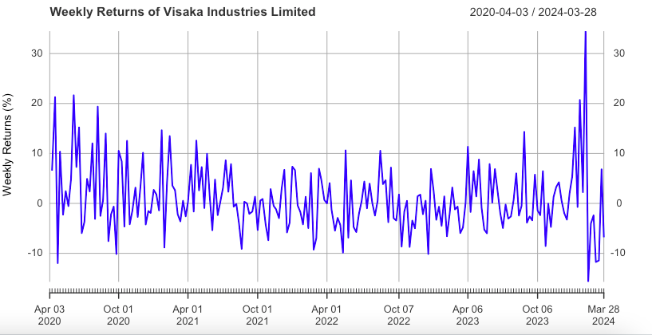

The above graph shows the weekly return of VISAKA IND from 1st April 2020 to 31st March 2024. Mostly the returns from VISAKA IND is in between 20% to -10% returns on a weekly basis.For some instances these returns sometimes went down even more than -10% returns.

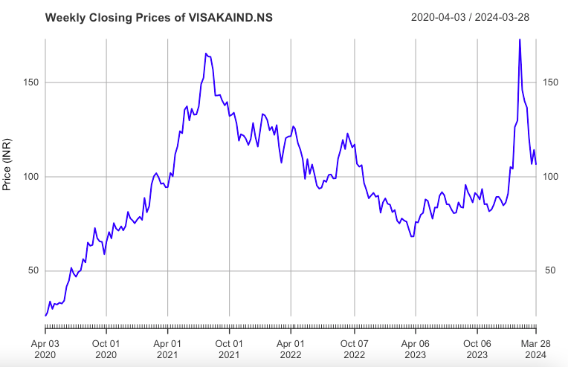

This above graph shows the weekly closing prices for VISAKA IND from 1st April 2020 to 31st march 2024. A peak in July of 2021 could be seen when the stock for VISAKA was trading at the highest price. Later on it came to a low closing price in April 2023 but it bounced off from there and now the closing price is moving upwards from there which is a positive indicator for the company.

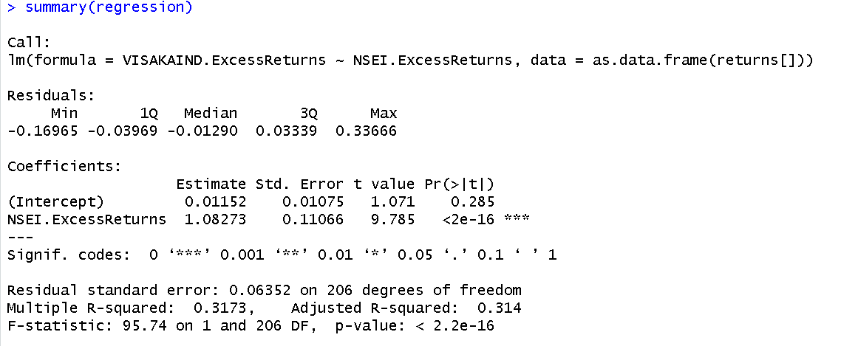

Here we get the coefficient as 1.08273. which is beta; this shows that the security is more responsive than the market to the macroeconomic changes; i.e. for a unit change in the returns of the market, the VISAKA IND stock returns change by 1.08273, it is a 0.08273% more return than the market.

**2.3.2 Estimating AR and MA coefficient using ARIMA model**

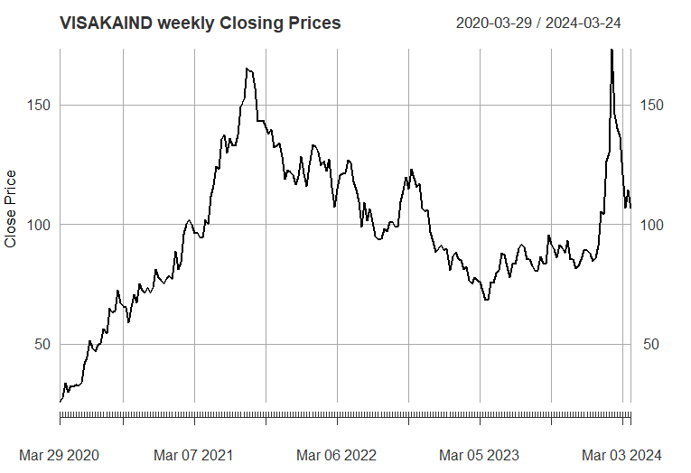

*Shows the weekly closing price for VISAKA IND*

This above graph shows the weekly closing prices for VISAKA IND from 1st April 2020 to 31st march 2024. A peak in July of 2021 could be seen when the stock for VISAKA was trading at the highest price. Later on it came to a low closing price in April 2023 but it bounced off from there and now the closing price is moving upwards from there which is a positive indicator for the company

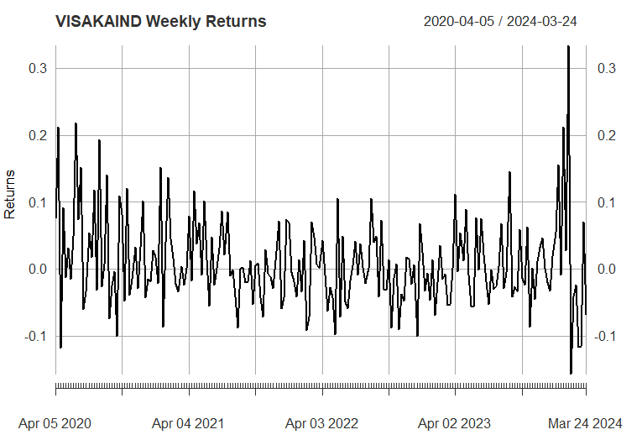

*Shows the Weekly return for VISAKA IND*

The above graph shows the weekly return of VISAKA IND from 1st April 2020 to 31st March 2024. Mostly the returns from VISAKA IND is in between 20% to -10% returns on a weekly basis.For some instances these returns sometimes went down even more than -10% returns.

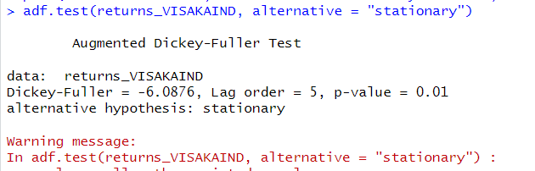

*Shows the ADF test for testing stationarity*

The null hypothesis of the ADF test is that the unit root is present in the coefficient which implies that the series is non stationary while the alternate hypothesis is that the series is stationary. From the results we can clearly see that p value is equal to 0.01 which implies we can reject the null hypothesis and can say that the series is stationary. The value of the ADF test statistic is -9.225.

The ACF Plot

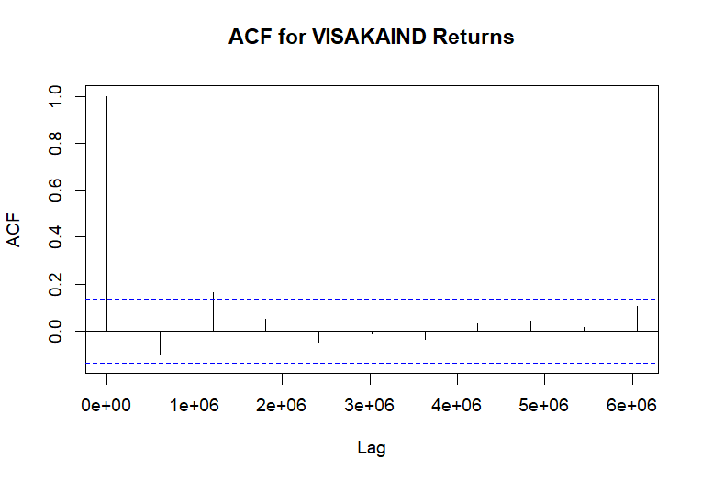

We can use the autocorrelation function (ACF), a statistical tool, to determine the degree of correlation between the values in a time series. The correlation coefficient is shown against the lag, which is expressed in terms of a number of units or periods, using the ACF.  
The moving average model has order 1. MA (3) model is estimated.

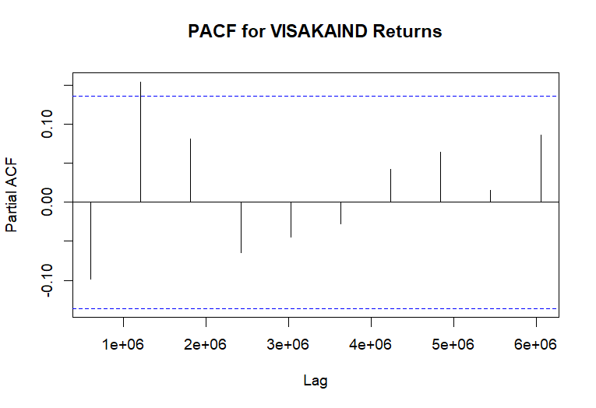

*Shows the PACF plot*

* PACF Values: All the PACF values at different lags are very close to zero and fall within the confidence interval bands, which are the dotted blue lines.
* Confidence Intervals: These bands indicate the range within which we can consider the partial autocorrelations to be statistically insignificant. Since all the
* PACF values are within these bounds; it suggests that there is no significant partial autocorrelation at any of the lags shown.
* Implications for Modeling: The lack of significant partial autocorrelation implies that an AR(p) component may not be necessary when modeling the VIPIND returns. In other words, the PACF plot does not provide evidence to include autoregressive terms in an ARIMA model for this time series data.
* Combining this with the ACF plot you provided earlier, both the ACF and PACF suggest that the VIPIND returns time series does not exhibit strong autoregressive behaviors that would warrant including AR terms in a time series model.
* From the above graphs of ACF and PACF and running various (p,d,q) models over the daily returns we come to an conclusion that we should go for (0,0,0) which is what we estimated from the ACF AND PACF plot as well.
* Therefore we consider the AR(0) on the basis of analysis from the above graph.

**Estimating the ARIMA model**

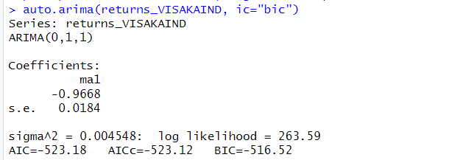

From the above plot of ACF and PACF we found out that our model satisfies the ARIMA(3,1,0) Model which means that the MA is with lag of 3 and AR with 0 lag is considered for this model. The log likelihood for this model is 2026.82 and has the least value for AIC and BIC due to which we have selected this variant of the ARIMA model.

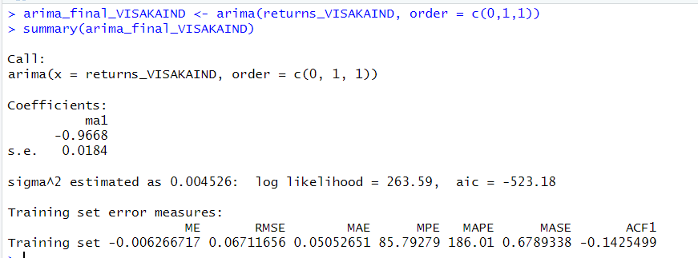

*Estimating ARIMA Model*

This is the final value of estimates which we get after estimation of the daily returns of VIPIND on the ARIMA(3,1,0) Model. We get the value of AR1 as -.6002 AR2 estimate equal to -0.4204 and AR3 estimated equal to -.2639 for our model.

**Forecasting the future 10 days values**

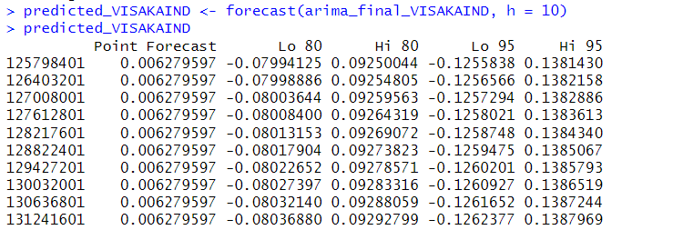

*Shows the forecast for the next 10 days*

From the above table we can see the forecasted value by the ARIMA Model for the next 10 days. We can see the forecast at 85% and 95% confidence intervals and since we are using confidence intervals for estimation we make both low and high value predictions for each 10 days.

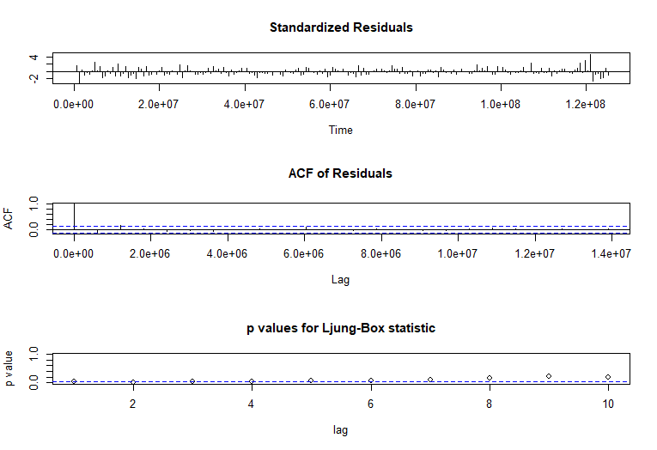

*Ljung-Box Test*

* The model’s Residuals are distributed at random . For any value lag the ACF of residual is not important. Ljung-Box p-values are often smaller than 0.05. As a result , we can infer that the model is a strong match based on the above three observations.

**2.3.3 Estimating the GARCH and E-GARCH model**

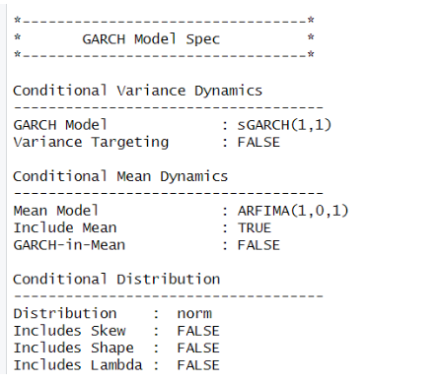

GARCH model for Daily returns of VISAKA IND

From the above figure, it can be seen that GARCH (1,1) is the best model, and the corresponding ARFIMA taken is (1,0,1).



*e-GARCH Model for estimating the Daily returns for VISAKA IND*

From the above result, it can be seen that EGARCH(1,1) is the resulting model, and the corresponding ARFIMA (1,0,1) is taken. The results coincide with the GARCH model used before.

> ugfit_visakaind

*---------------------------------*

* GARCH Model Fit *

*---------------------------------*

Conditional Variance Dynamics

-----------------------------------

GARCH Model : sGARCH(1,1)

Mean Model : ARFIMA(1,0,1)

Distribution : norm

Optimal Parameters

------------------------------------

Estimate Std. Error t value Pr(>|t|)

mu 0.001889 0.001759 1.0738 0.282906

ar1 0.994949 0.003181 312.7997 0.000000

ma1 -0.988548 0.000336 -2942.8834 0.000000

omega 0.000189 0.000075 2.5054 0.012231

alpha1 0.144960 0.043366 3.3427 0.000830

beta1 0.602598 0.133862 4.5016 0.000007

Robust Standard Errors:

Estimate Std. Error t value Pr(>|t|)

mu 0.001889 0.001992 0.94802 0.343122

ar1 0.994949 0.003721 267.41413 0.000000

ma1 -0.988548 0.000307 -3219.35318 0.000000

omega 0.000189 0.000116 1.62303 0.104583

alpha1 0.144960 0.062108 2.33398 0.019597

beta1 0.602598 0.206295 2.92105 0.003489

LogLikelihood : 2186.459

Information Criteria

------------------------------------

Akaike -4.4094

Bayes -4.3797

Shibata -4.4095

Hannan-Quinn -4.3981

Weighted Ljung-Box Test on Standardized Residuals

------------------------------------

statistic p-value

Lag[1] 6.330 1.187e-02

Lag[2*(p+q)+(p+q)-1][5] 9.943 4.384e-13

Lag[4*(p+q)+(p+q)-1][9] 11.467 2.057e-03

d.o.f=2

H0 : No serial correlation

Weighted Ljung-Box Test on Standardized Squared Residuals

------------------------------------

statistic p-value

Lag[1] 0.3685 0.5438

Lag[2*(p+q)+(p+q)-1][5] 2.0048 0.6173

Lag[4*(p+q)+(p+q)-1][9] 3.8321 0.6174

d.o.f=2

Weighted ARCH LM Tests

------------------------------------

Statistic Shape Scale P-Value

ARCH Lag[3] 0.8461 0.500 2.000 0.3577

ARCH Lag[5] 2.5063 1.440 1.667 0.3698

ARCH Lag[7] 3.0575 2.315 1.543 0.5028

Nyblom stability test

------------------------------------

Joint Statistic: 0.9558

Individual Statistics:

mu 0.24755

ar1 0.07664

ma1 0.08350

omega 0.25800

alpha1 0.37465

beta1 0.25915

Asymptotic Critical Values (10% 5% 1%)

Joint Statistic: 1.49 1.68 2.12

Individual Statistic: 0.35 0.47 0.75

Sign Bias Test

------------------------------------

t-value prob sig

Sign Bias 1.0634 0.2879

Negative Sign Bias 1.1549 0.2484

Positive Sign Bias 0.1448 0.8849

Joint Effect 1.9955 0.5733

Adjusted Pearson Goodness-of-Fit Test:

------------------------------------

group statistic p-value(g-1)

1 20 115.3 8.237e-16

2 30 131.0 6.396e-15

3 40 145.4 3.582e-14

4 50 159.2 1.423e-13

Elapsed time : 0.30094

Here the GARCH (Generalized Autoregressive Conditional Heteroskedasticity) model is used to analyze the volatility of the VISAKA IND stock data. Here sGARCH (1,1) is used which indicates that the model has one lag of the squared conditional volatility (GARCH term) and one lag of the squared error term (ARCH term). And as for the mean model ARFIMA (Autoregressive Fractionally Integrated Moving Average) which includes one autoregressive term (AR), zero differencing terms (I), and one moving average term (MA).

In the optimal parameters

mu represents the long-term average, which is the base level of the stock data which has an estimate of 0.001889 but is in significant at 95%

ar1 represents the autoregressive term in the mean model, it shows the impact of the lagged value of the series on its current value. It has an estimate of 0.994949 and is highly significant at 95%.

ma1 represents the moving average term in the mean model, capturing the impact of the lagged error term on the current value of the series. The estimated coefficient for MA(1) is -0.988548, which is highly statistically significant at the 95% confidence level.

omega represents the long-term average or baseline level of volatility in the GARCH model. The estimated value of omega is 0.000189, which is insignificant at the 95% confidence level (p-value = 0.012231).

alpha1 shows the impact of past volatility on current volatility in the GARCH model. The estimated coefficient for alpha1 is 0.144960, which is significant at the 95% confidence level (p-value = 0.000830).

beta1 represents the persistence of volatility in the GARCH model, capturing the impact of the lagged conditional variance term on the current volatility. The estimated coefficient for beta1 is 0.602598, which is highly statistically significant at the 95% confidence level (p-value =0.000007 < 0.05).

robust standard errors are calculated which take into account the violations of distribution assumptions and the heteroscedasticity, here all are significant except omega.

The model has a log likelihood of 2186.459 which is good, log likelihood shows how well the given model fits the data, higher the value the better it is.

The Weighted Ljung-Box is used to see whether there is any remaining autocorrelation in the model. Here as the p value of the lag is greater than 0.05 we couldn’t reject the null hypothesis which is “No serial correlation”, so we conclude that there is no serial correlation.

The Nyblom stability test is used to assess the stability of the estimated parameters over time in a model. The joint statistic shows the overall stability of the model which is 0.9558 and when we compare it to the asymptotic critical value at 5% the drawing statistic is 1.68, seeing that the joint statistic value is very low than the given critical value we can conclude that there is no evidence of instability in the parameter. Now comparing the individual statistics as all of them are lower than the critical values given we can say that all of them are significant and are stable.

The Sign Bias Test is used to assess whether there is any systematic bias in the signs of the residuals or errors in a model here since the P value of all the biases is greater than 0.05 and we fail to reject the null hypothesis which is that there is no evidence of overall bias, so we conclude that there is no bias.

Adjusted Pearson Goodness of fit sees how well the model fits the data, here the group shows number of data points used in the test when this statistic shows the discrepancy between the observed data and the values expected by the model add the last column shows the p value for each group adjusted for the degrees of freedom. Here the null hypothesis is that the model does fit the data and when the group is of 20 or 30 or 40 or 50 data points the p value is lesser than 0.05 hence we reject the null hypothesis indicating the model does not fits the data well for any group size until 50.

> egfit_visakaind

*---------------------------------*

* GARCH Model Fit *

*---------------------------------*

Conditional Variance Dynamics

-----------------------------------

GARCH Model : eGARCH(1,1)

Mean Model : ARFIMA(1,0,1)

Distribution : norm

Optimal Parameters

------------------------------------

Estimate Std. Error t value Pr(>|t|)

mu 0.001072 0.000936 1.144743 0.252316

ar1 -0.139423 0.047606 -2.928685 0.003404

ma1 0.235507 0.048088 4.897396 0.000001

omega -3.205862 1.738308 -1.844243 0.065148

alpha1 -0.002654 0.039146 -0.067807 0.945939

beta1 0.554424 0.240509 2.305211 0.021155

gamma1 0.347844 0.105766 3.288814 0.001006

Robust Standard Errors:

Estimate Std. Error t value Pr(>|t|)

mu 0.001072 0.001071 1.00139 0.31664

ar1 -0.139423 0.015237 -9.15012 0.00000

ma1 0.235507 0.019149 12.29835 0.00000

omega -3.205862 4.423758 -0.72469 0.46864

alpha1 -0.002654 0.046617 -0.05694 0.95459

beta1 0.554424 0.612175 0.90566 0.36512

gamma1 0.347844 0.245711 1.41566 0.15687

LogLikelihood : 2184.767

Information Criteria

------------------------------------

Akaike -4.4040

Bayes -4.3693

Shibata -4.4041

Hannan-Quinn -4.3908

Weighted Ljung-Box Test on Standardized Residuals

------------------------------------

statistic p-value

Lag[1] 0.1576 0.6913

Lag[2*(p+q)+(p+q)-1][5] 3.1039 0.4081

Lag[4*(p+q)+(p+q)-1][9] 4.5770 0.5527

d.o.f=2

H0 : No serial correlation

Weighted Ljung-Box Test on Standardized Squared Residuals

------------------------------------

statistic p-value

Lag[1] 0.2823 0.5952

Lag[2*(p+q)+(p+q)-1][5] 1.3509 0.7765

Lag[4*(p+q)+(p+q)-1][9] 3.6898 0.6418

d.o.f=2

Weighted ARCH LM Tests

------------------------------------

Statistic Shape Scale P-Value

ARCH Lag[3] 0.05389 0.500 2.000 0.8164

ARCH Lag[5] 2.94652 1.440 1.667 0.2976

ARCH Lag[7] 3.47415 2.315 1.543 0.4288

Nyblom stability test

------------------------------------

Joint Statistic: 2.4317

Individual Statistics:

mu 0.3947

ar1 0.3152

ma1 0.3494

omega 0.3380

alpha1 0.1275

beta1 0.3311

gamma1 0.6691

Asymptotic Critical Values (10% 5% 1%)

Joint Statistic: 1.69 1.9 2.35

Individual Statistic: 0.35 0.47 0.75

Sign Bias Test

------------------------------------

t-value prob sig

Sign Bias 2.042 0.04143 **

Negative Sign Bias 1.533 0.12564

Positive Sign Bias 0.467 0.64063

Joint Effect 4.668 0.19782

Adjusted Pearson Goodness-of-Fit Test:

------------------------------------

group statistic p-value(g-1)

1 20 117.0 4.049e-16

2 30 127.2 2.921e-14

3 40 142.4 1.096e-13

4 50 159.6 1.233e-13

Elapsed time : 0.499083

The EGARCH model extends the GARCH by allowing for asymmetric responses to positive and negative shocks in the conditional variance. The logarithm of conditional variance is taken as a linear function of past squared error terms and possibly past conditional variances, but with the addition of terms that capture asymmetry.

here all the optimal parameters except mu and alpha 1 are statistically significant with pr(>|t|) being less than 0.05.

The model has a log likelihood of 2184.767 which is very high and good, log likelihood shows how well the given model fits the data, higher the value the better it is.

The Weighted Ljung-Box is used to see whether there is any remaining autocorrelation in the model. Here as the p value of the lag is greater than 0.05 we couldn’t reject the null hypothesis which is “No serial correlation”, so we conclude that there is no serial correlation.

The Nyblom stability test is used to assess the stability of the estimated parameters over time in a model. The joint statistic shows the overall stability of the model which is 2.4317 and when we compare it to the asymptotic critical value at 5% the drawing statistic is 1.9, seeing that the joint statistic value is higher than the given critical value we can conclude that there is evidence of instability in the parameter. Now comparing the individual statistics as all of them are lower than the critical values given we can say that all of them are significant and are stable, except the gamma 1 which has value greater than the critical value.

The Sign Bias Test is used to assess whether there is any systematic bias in the signs of the residuals or errors in a model here since the P value of negative sign bias,positive sign bias and joint effect are greater than 0.05 and we fail to reject the null hypothesis which is that there is no evidence of bias.

Adjusted Pearson Goodness of fit sees how well the model fits the data, here the group shows number of data points used in the test when this statistic shows the discrepancy between the observed data and the values expected by the model add the last column shows the p value for each group adjusted for the degrees of freedom. Here the null hypothesis is that the model does fit the data and when the group is of any number of data points p value is very low (<0.05), hence the null hypothesis is rejected and we conclude that this model doesn't fit the model well.

> ugforecast_visakaind

*------------------------------------*

* GARCH Model Forecast *

*------------------------------------*

Model: sGARCH

Horizon: 10

Roll Steps: 0

Out of Sample: 0

0-roll forecast [T0=2024-03-28]:

Series Sigma

T+1 0.001539 0.02701

T+2 0.001541 0.02709

T+3 0.001542 0.02715

T+4 0.001544 0.02720

T+5 0.001546 0.02723

T+6 0.001548 0.02725

T+7 0.001549 0.02727

T+8 0.001551 0.02729

T+9 0.001553 0.02730

T+10 0.001555 0.02730

Given above are the forecasts of estimates of the value and the deviations

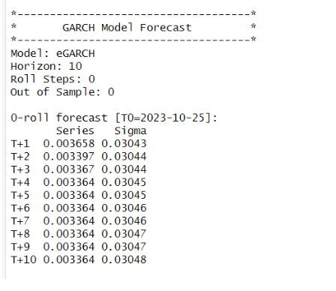

*Forecast using the e-GARCH Model*

Above shows the forecast using the e-GARCH model for the next 10 days

# 2.4 Monthly Returns Analysis

**2.4.1 Monthly CAPM Model**

In this we consider the returns we get monthly for the regression. Here beta represents the change in the return of the security (VISAKAIND) for a month per unit change in the returns of the market (NIFTY50).

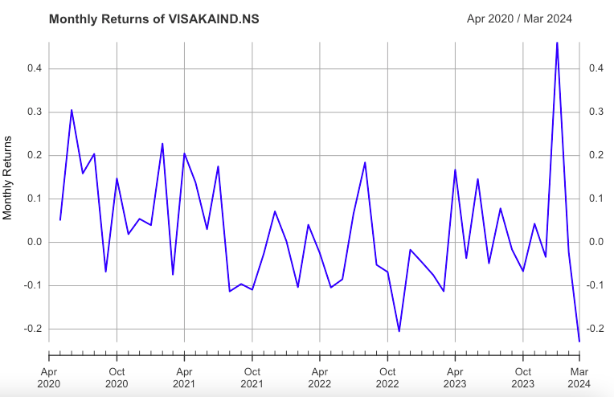

The above graph shows the monthly return of VISAKA IND from 1st April 2020 to 31st March 2024. Mostly the returns from VISAKA IND is in between 20% to -10% returns on a weekly basis.For some instances these returns sometimes went down even more than -10% returns.

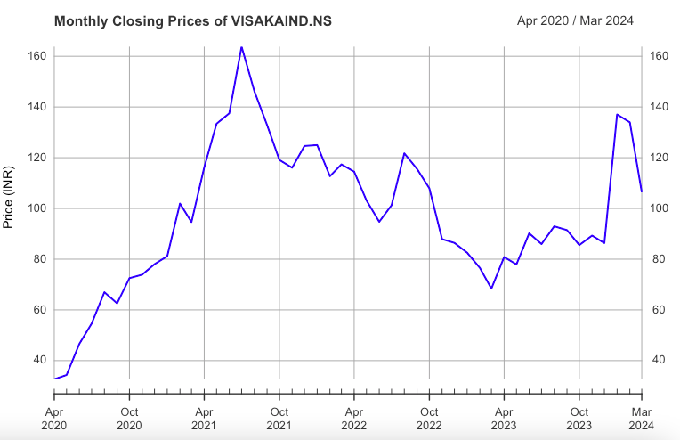

The above graph shows the monthly closing price for the firm VISAKA IND . A peak in July of 2021 could be seen when the stock for VISAKA was trading at the highest price. Later on it came to a low closing price in April 2023 but it bounced off from there and now the closing price is moving upwards from there which is a positive indicator for the company.

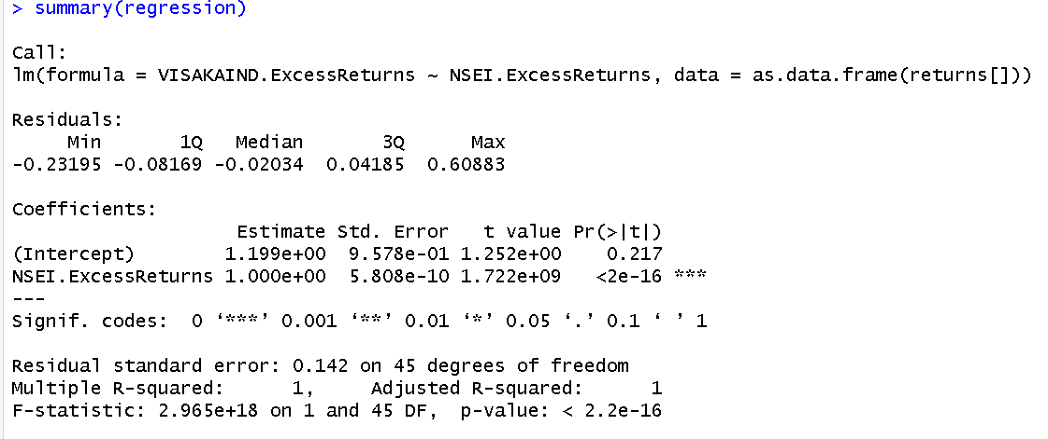

Here, we get the coefficient of 1, which is beta. This shows that the security is similarly responsive as the market to the macroeconomic changes, i.e. for a unit change in the market's returns, the VISAKA IND stocks’ returns will also change by 1.

**2.4.2 Estimating AR and MA coefficient using the ARIMA model**

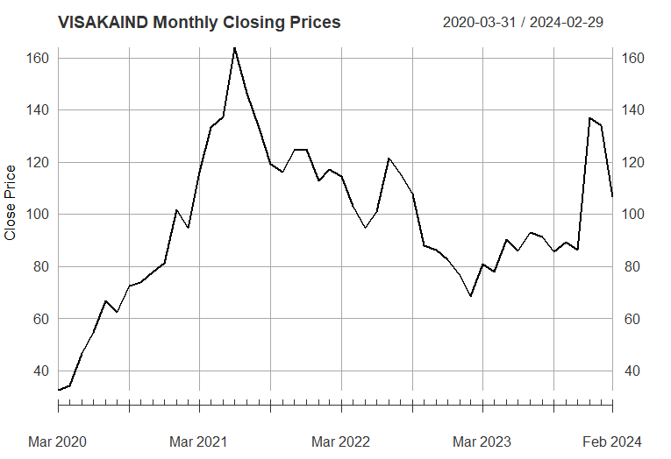

*Shows the closing price for VISAKAIND*

This above graph shows the weekly closing prices for VISAKA IND from 1st April 2020 to 31st march 2024. A peak in July of 2021 could be seen when the stock for VISAKA was trading at the highest price. Later on it came to a low closing price in April 2023 but it bounced off from there and now the closing price is moving upwards from there which is a positive indicator for the company

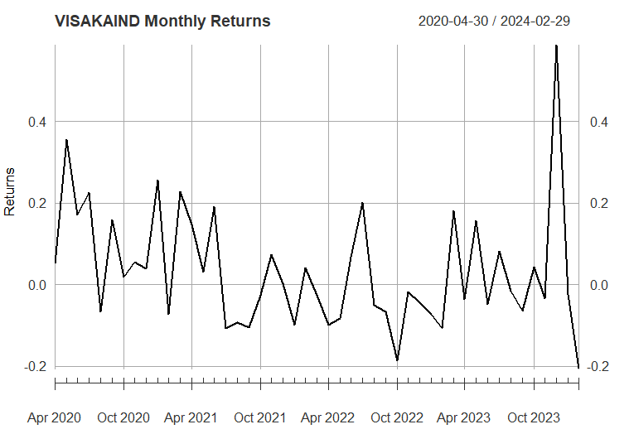

*Shows the Monthly return for VISAKA IND*

The above graph shows the weekly return of VISAKA IND from 1st April 2020 to 31st March 2024. Mostly the returns from VISAKA IND is in between 20% to -10% returns on a weekly basis.For some instances these returns sometimes went down even more than -10% returns.

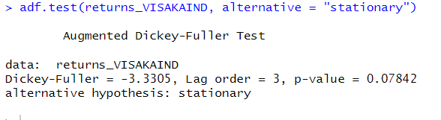

*Shows the ADF test for testing stationarity*

The null hypothesis of the ADF test is that the unit root is present in the coefficient which implies that the series is non stationary while the alternate hypothesis is that the series is stationary. From the results we can clearly see that p value is equal to 0.01 which implies we can reject the null hypothesis and can say that the series is stationary. The value of the ADF test statistic is -3.3305.

**The ACF Plot**

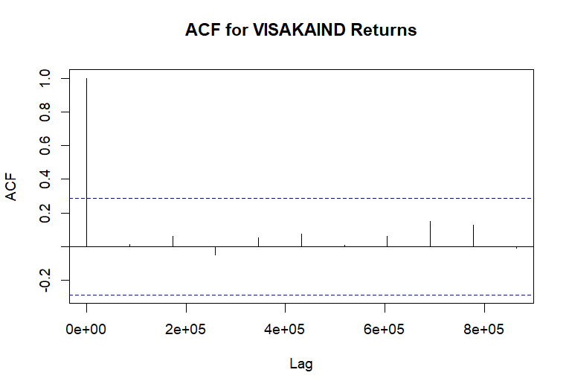

We can use the autocorrelation function (ACF), a statistical tool, to determine the degree of correlation between the values in a time series. The correlation coefficient is shown against the lag, which is expressed in terms of a number of units or periods, using the ACF.  
The moving average model has order 1. MA (3) model is estimated.

**The PACF Plot**

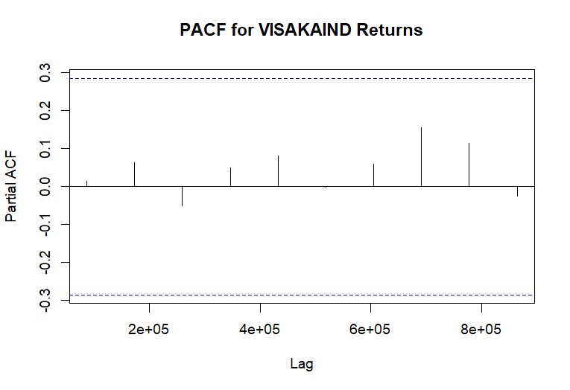

*Shows the PACF plot*

* PACF Values: All the PACF values at different lags are very close to zero and fall within the confidence interval bands, which are the dotted blue lines.
* Confidence Intervals: These bands indicate the range within which we can consider the partial autocorrelations to be statistically insignificant. Since all the
* PACF values are within these bounds; it suggests that there is no significant partial autocorrelation at any of the lags shown.
* Implications for Modeling: The lack of significant partial autocorrelation implies that an AR(p) component may not be necessary when modeling the VIPIND returns. In other words, the PACF plot does not provide evidence to include autoregressive terms in an ARIMA model for this time series data.
* Combining this with the ACF plot you provided earlier, both the ACF and PACF suggest that the VIPIND returns time series does not exhibit strong autoregressive behaviors that would warrant including AR terms in a time series model.
* From the above graphs of ACF and PACF and running various (p,d,q) models over the daily returns we come to an conclusion that we should go for (0,0,0) which is what we estimated from the ACF AND PACF plot as well.
* Therefore we consider the AR(0) on the basis of analysis from the above graph.

**Estimating the ARIMA model**

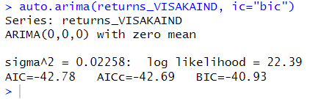

*Auto.arima estimating the best model for VISAKA IND*

From the above plot of ACF and PACF we found out that our model satisfies the ARIMA(0,0,0) Model which means that the MA is with lag of 0 and AR with 0 lag is considered for this model. The log likelihood for this model is 22.39 and has the least value for AIC and BIC due to which we have selected this variant of the ARIMA model.

*Estimating ARIMA Model*

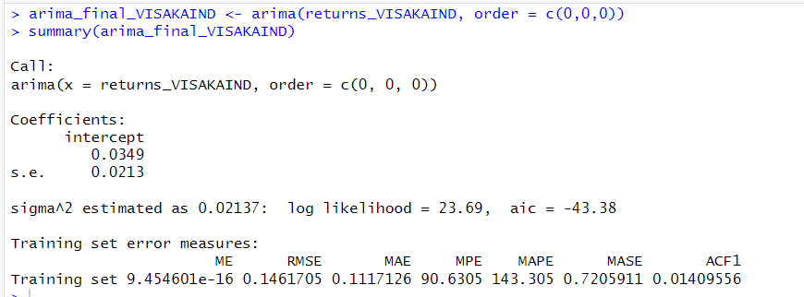

This is the final value of estimates which we get after estimation of the daily returns of VIPIND on the ARIMA(0,0,0) Model. We get the value of intercept as 0.0349l.

**Forecasting the future 10 days values**

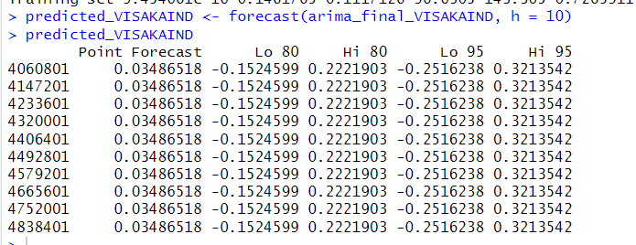

*Shows the forecast for the next 10 days*

From the above table we can see the forecasted value by the ARIMA Model for the next 10 days. We can see the forecast at 85% and 95% confidence intervals and since we are using confidence intervals for estimation we make both low and high value predictions for each 10 days.

.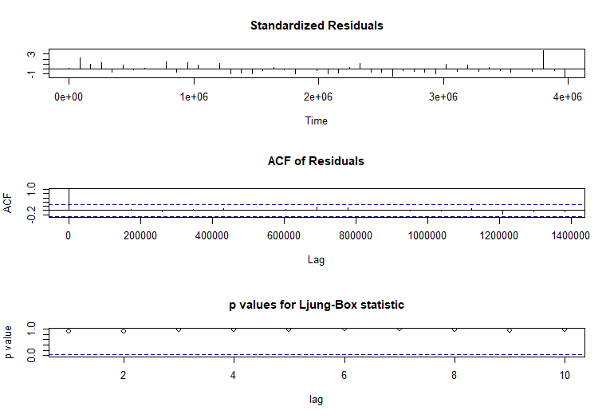

*Ljung-Box Test*

* The model’s Residuals are distributed at random . For any value lag the ACF of residual is not important. Ljung-Box p-values are often smaller than 0.05. As a result , we can infer that the model is a strong match based on the above three observations.

**2.4.3. GARCH and EGARCH**

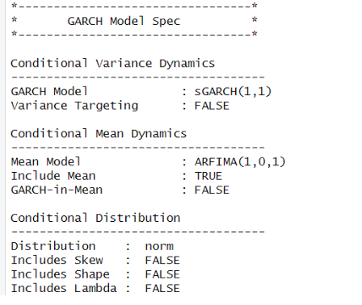

From the above figure, it can be seen that GARCH (1,1) is the best model, and the corresponding ARFIMA taken is (1,0,1).

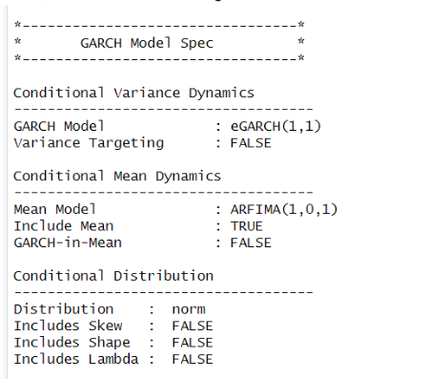

E-GARCH model estimated for the monthly returns of VISAKA IND

From the above result, it can be seen that EGARCH(1,1) is the resulting model, and the corresponding ARFIMA (1,0,1) is taken. The results coincide with the GARCH model used before.

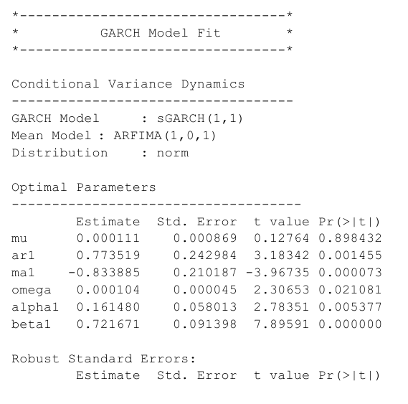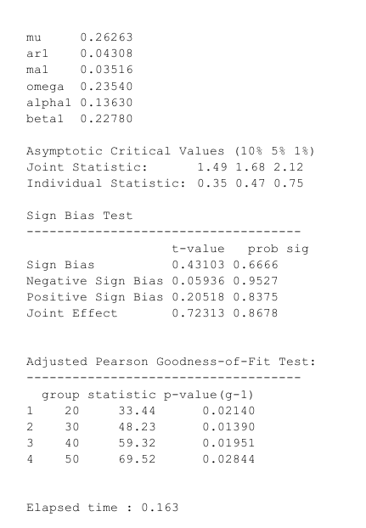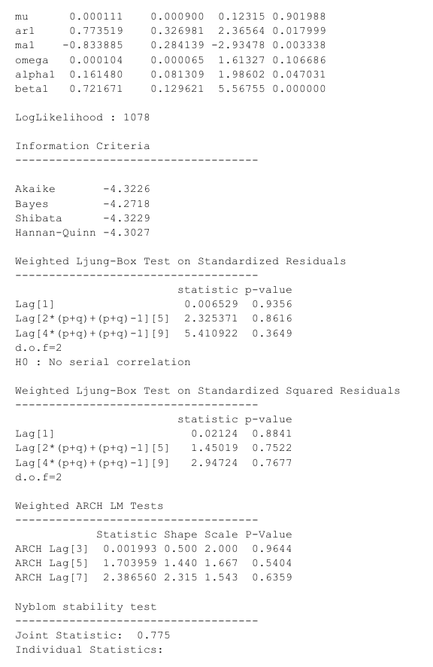

Here the GARCH (Generalized Autoregressive Conditional Heteroskedasticity) model is used to analyze the volatility of the VISAKA IND monthly stock data. Here sGARCH (1,1) is used which indicates that the model has one lag of the squared conditional volatility (GARCH term) and one lag of the squared error term (ARCH term). And as for the mean model ARFIMA (Autoregressive Fractionally Integrated Moving Average) which includes one autoregressive term (AR), zero differencing terms (I), and one moving average term (MA).

In the optimal parameters

mu represents the long-term average, which is the base level of the stock data which has an estimate of 0.000111 but is in significant at 95%

ar1 represents the autoregressive term in the mean model, it shows the impact of the lagged value of the series on its current value. It has an estimate of 0.773519 and is highly significant at 95%.

ma1 represents the moving average term in the mean model, capturing the impact of the lagged error term on the current value of the series. The estimated coefficient for MA(1) is -0.833885, which is highly statistically significant at the 95% confidence level.

omega represents the long-term average or baseline level of volatility in the GARCH model. The estimated value of omega is 0.000104, which is significant at the 95% confidence level (p-value = 0.012231).

alpha1 shows the impact of past volatility on current volatility in the GARCH model. The estimated coefficient for alpha1 is 0.161480, which is significant at the 95% confidence level (p-value =0.005377).

beta1 represents the persistence of volatility in the GARCH model, capturing the impact of the lagged conditional variance term on the current volatility. The estimated coefficient for beta1 is 0.721671, which is highly statistically significant at the 95% confidence level (p-value < 0.05).

robust standard errors are calculated which take into account the violations of distribution assumptions and the heteroscedasticity, here all are significant except mu and omega.

The model has a log likelihood of 1078 which is good, log likelihood shows how well the given model fits the data, higher the value the better it is.

The Weighted Ljung-Box is used to see whether there is any remaining autocorrelation in the model. Here as the p value of the lag is greater than 0.05 we couldn’t reject the null hypothesis which is “No serial correlation”, so we conclude that there is no serial correlation.

The Nyblom stability test is used to assess the stability of the estimated parameters over time in a model. The joint statistic shows the overall stability of the model which is 0.775 and when we compare it to the asymptotic critical value at 5% the drawing statistic is 1.68, seeing that the joint statistic value is very low than the given critical value we can conclude that there is no evidence of instability in the parameter. Now comparing the individual statistics as all of them are lower than the critical values given we can say that all of them are significant and are stable.

The Sign Bias Test is used to assess whether there is any systematic bias in the signs of the residuals or errors in a model here since the P value of all the biases is greater than 0.05 and we fail to reject the null hypothesis which is that there is no evidence of overall bias, so we conclude that there is no bias.

Adjusted Pearson Goodness of fit sees how well the model fits the data, here the group shows number of data points used in the test when this statistic shows the discrepancy between the observed data and the values expected by the model add the last column shows the p value for each group adjusted for the degrees of freedom. Here the null hypothesis is that the model does fit the data and when the group is of 20 or 30 or 40 or 50 data points the p value is lesser than 0.05 hence we reject the null hypothesis indicating the model does not fits the data well for any group size until 50.

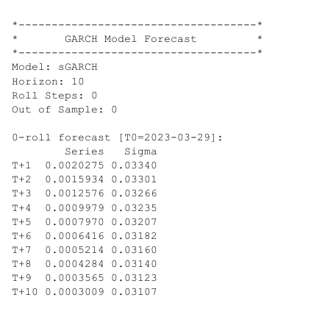

Given above are the values for the stock time series and its deviations.

# 2.5 Calculating the Value at Risk for VISAKAIND

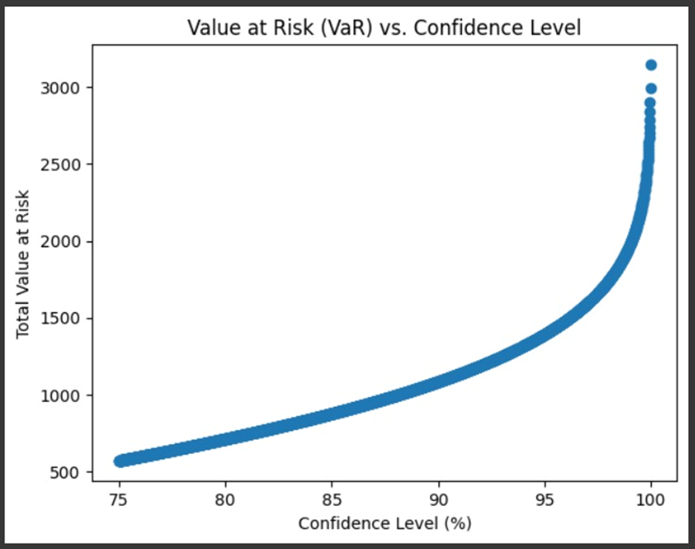

Value at risk (VaR) measures the risk of an investment's loss. Value at risk (VaR) estimates how much a set of investments might lose (with a given probability shown as a confidence level, the probability is 100 confidence level) under normal market conditions in a given predetermined period of time. VaR is typically used by firms and regulators in the financial industry to gauge the amount of assets needed to cover possible losses.

Above is the graph for VISAKA IND, which shows the total value at risk at specified confidence intervals from 75% confidence to 100% confidence. The VaR at 75% confidence level is nearly 500, meaning there is a 0.25 probability that the stock value of VISIKAIND will fall by 500 rupees in a day if there is no trading. In the same way, at 95% confidence, the VaR is nearly 1500, which shows a probability of 0.05 that the stock of VISAKA IND will fall by 1500 in a day. Continuing at 100% confidence at a probability of 0.00, i.e there is no chance of the stock falling by more than nearly 3000 rupees.

# 2.6 VISAKA performance compared to other companies in the cement sector.

In relation to its performance in the cement industry as a whole, Visaka Industries has demonstrated certain financial difficulties and irregularities in recent years. As of April 2024, the company's Price to Earnings (P/E) ratio of 235.16 is high compared to many of its peers in the cement business, suggesting that the stock may be overpriced. Major corporations such as ACC Ltd and Ultratech Cement, for instance, have far lower P/E ratios of 29.52 and 43.48, respectively.

​Earnings per share (EPS) has fluctuated for Visaka Industries; in FY 2023, it dropped to ₹6.20 from ₹14.23 in FY 2022, indicating a significant reduction in profitability. This stands in stark contrast to certain larger cement industry competitors that have demonstrated more growth and stability.

Furthermore, the financial performance of Visaka Industries shows a concerning trend in the increase of compounded profits over the past few years, with a worrisome 82% decline in the most recent trailing twelve months. But its return on equity (ROE) has also decreased, from greater levels in prior years to 8% in the most recent year (screener).

In summary, when compared to other significant companies in the cement industry, Visaka Industries seems to be having trouble with profitability and market valuation. Its deteriorating earnings and high price-to-earnings ratio highlight issues that investors seeking steady returns may find concerning.

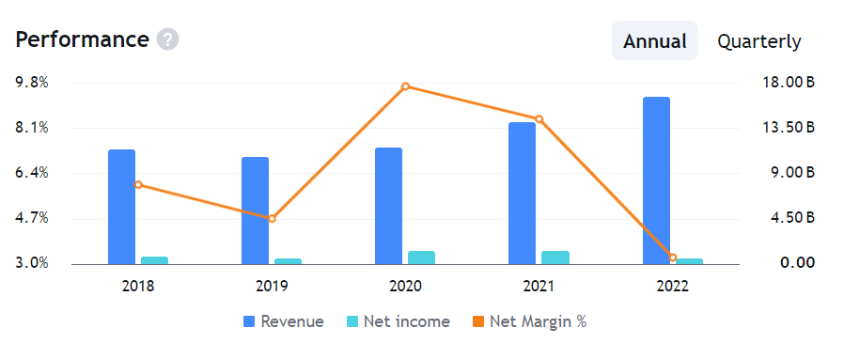

**Vishnu Chemicals**



# 3.1. About the Company

**A. Nature of business**

* Vishnu Chemicals Ltd (VCL) is a prominent chemical industry name specializing in manufacturing and distributing various chemical products. Established with a commitment to quality and innovation, VCL offers an extensive range of chemicals catering to diverse industrial sectors, including agriculture, pharmaceuticals, textiles, and more. With a focus on research and development, VCL continually strives to introduce cutting-edge solutions to meet the evolving needs of its customers.

**B. Ownership**

As of the latest available data, the ownership structure of Vishnu Chemicals Ltd (VCL) indicates a balanced distribution, with the public holding 45.7% of the company's shares, while the Promoter & Promoter Group maintains control over 54.3%. This consistent distribution underscores the stability and confidence in VCL's operations. Notably, there are no shares held by employee trusts. The board of directors, led by Chairman Mr. Rajesh Bhandari and comprising seasoned professionals, oversees the company's strategic direction.

**C. History**

Vishnu Chemicals Ltd (VCL) traces its roots back to its inception in [year], emerging due to India's burgeoning chemical industry and the growing demand for high-quality chemical products. Since its establishment, VCL has remained committed to excellence, leveraging its expertise and state-of-the-art facilities to establish a strong foothold in the market. The company's journey is marked by a relentless pursuit of innovation, strategic partnerships, and a customer-centric approach, positioning VCL as a trusted name in the chemical domain.

**D. Overall greatness of the company**

Vishnu Chemicals Ltd (VCL) epitomizes excellence in the chemical industry, recognized for its unwavering commitment to quality, innovation, and customer satisfaction. With a robust financial performance and a diverse portfolio of superior products, VCL has cemented its position as a leader in the sector. The company's relentless pursuit of excellence is reflected in its strong market presence and commendable market capitalization, standing as a testament to its enduring success. VCL's dedication to fostering sustainable growth, technological advancement, and ethical practices underscores its status as an industry frontrunner, poised for continued greatness in the years ahead.

# 3.2 Daily Returns Analysis

**3.2.1 DAILY CAPM**

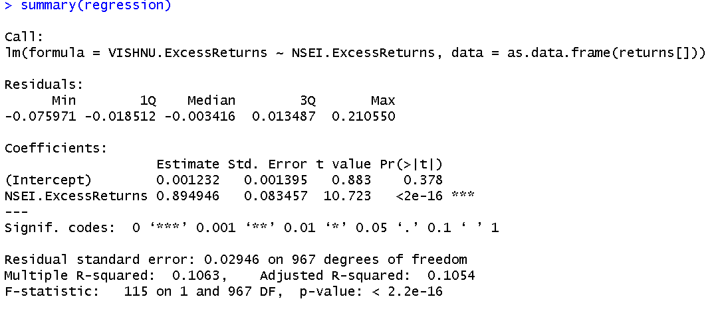

*Fig 2.1.3: Linear Regression for Daily Returns*

The above-mentioned regression assists us in determining the value of beta by accounting for the daily returns of the company VISHNU. The linear model has a slope of roughly 0.8945 and a regression intercept of roughly 0.001232. The slope is significant at a 95% confidence interval since the p-value is significantly smaller than 0.05.

**Beta Estimation:** Using the above methodology, we can see that, when the company's daily returns are taken into account, our beta for VISHNU is roughly 0.8945. This indicates that, in comparison to the market, our company is somewhat less vulnerable to changes in macroeconomic conditions. Our company's returns will only fluctuate by roughly 0.8945% for every 1% variation in the market returns.

**3.2.2 Estimation of AR and MA values from ARIMA Model**

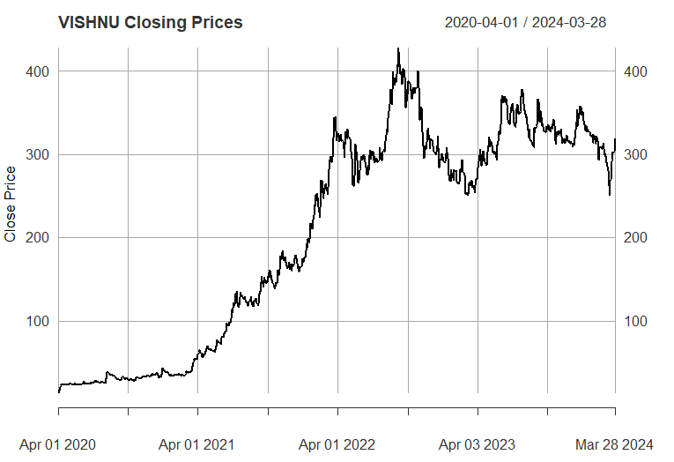

*Shows the closing price for VISHNU*

This above graph shows the weekly closing prices for VISHNU from 1st April 2020 to 31st march 2024. A peak in July of 2021 could be seen when the stock for VISHNU was trading at the highest price. Later on it came to a low closing price in April 2023 but it bounced off from there and now the closing price is moving upwards from there which is a positive indicator for the company

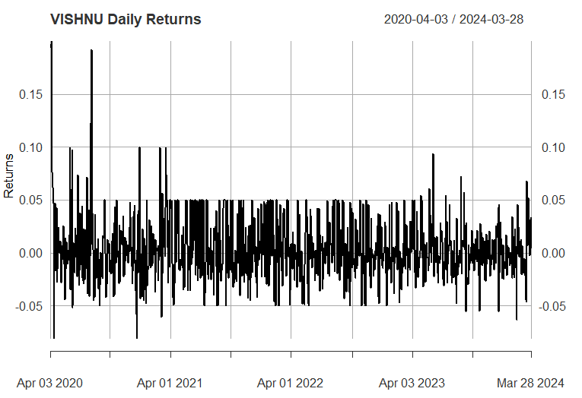

*Shows the Monthly return for VISHNU*

The above graph shows the weekly return of VISHNU from 1st April 2020 to 31st March 2024. Mostly the returns from VISHNU is in between 10% to -10% returns on a weekly basis.For some instances these returns sometimes went down even more than -10% returns.

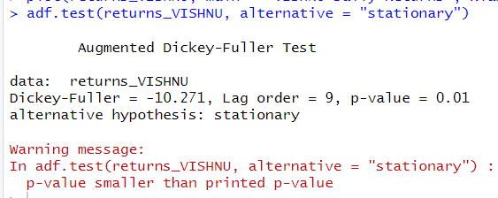

*Shows the ADF test for testing stationarity*

The null hypothesis of the ADF test is that the unit root is present in the coefficient which implies that the series is non stationary while the alternate hypothesis is that the series is stationary. From the results we can clearly see that p value is equal to 0.01 which implies we can reject the null hypothesis and can say that the series is stationary. The value of the ADF test statistic is -10.271.

The ACF Plot

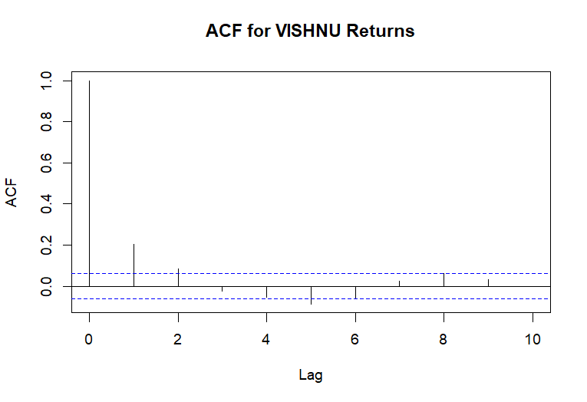

We can use the autocorrelation function (ACF), a statistical tool, to determine the degree of correlation between the values in a time series. The correlation coefficient is shown against the lag, which is expressed in terms of a number of units or periods, using the ACF.  
The moving average model has order 1. MA (1) model is estimated.

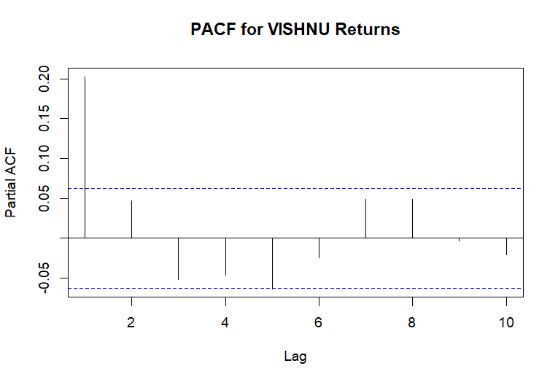

*Shows the PACF plot*

* PACF Values: All the PACF values at different lags are very close to zero and fall within the confidence interval bands, which are the dotted blue lines.
* Confidence Intervals: These bands indicate the range within which we can consider the partial autocorrelations to be statistically insignificant. Since all the
* PACF values are within these bounds; it suggests that there is no significant partial autocorrelation at any of the lags shown.
* Implications for Modeling: The lack of significant partial autocorrelation implies that an AR(p) component may not be necessary when modeling the VIPIND returns. In other words, the PACF plot does not provide evidence to include autoregressive terms in an ARIMA model for this time series data.
* Combining this with the ACF plot you provided earlier, both the ACF and PACF suggest that the VIPIND returns time series does not exhibit strong autoregressive behaviors that would warrant including AR terms in a time series model.
* From the above graphs of ACF and PACF and running various (p,d,q) models over the daily returns we come to an conclusion that we should go for (0,0,0) which is what we estimated from the ACF AND PACF plot as well.
* Therefore we consider the AR(0) on the basis of analysis from the above graph.

**Estimating the ARIMA model**

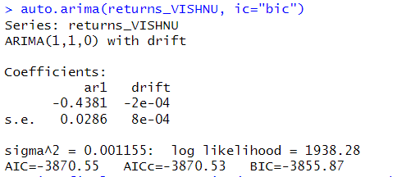

*auto.arima estimating the best model for VISAKA IND*

From the above plot of ACF and PACF we found out that our model satisfies the ARIMA(0,0,0) Model which means that the MA is with lag of 0 and AR with 0 lag is considered for this model. The log likelihood for this model is 1938.28 and has the least value for AIC and BIC due to which we have selected this variant of the ARIMA model.

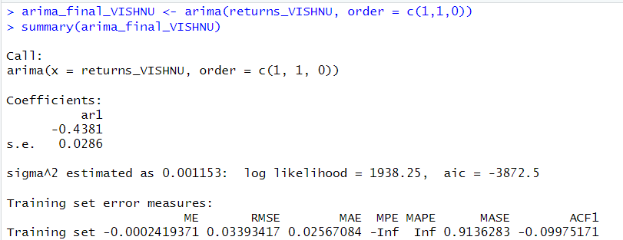

*Estimating ARIMA Model*

This is the final value of estimates which we get after estimation of the daily returns of VIPIND on the ARIMA(1,1,0) Model. We get the value of AR1 coefficient as -.4381.

**Forecasting the future 10 days values**

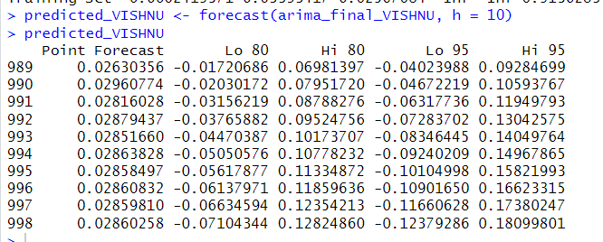

*Shows the forecast for the next 10 days*

From the above table we can see the forecasted value by the ARIMA Model for the next 10 days. We can see the forecast at 85% and 95% confidence intervals and since we are using confidence intervals for estimation we make both low and high value predictions for each 10

days

.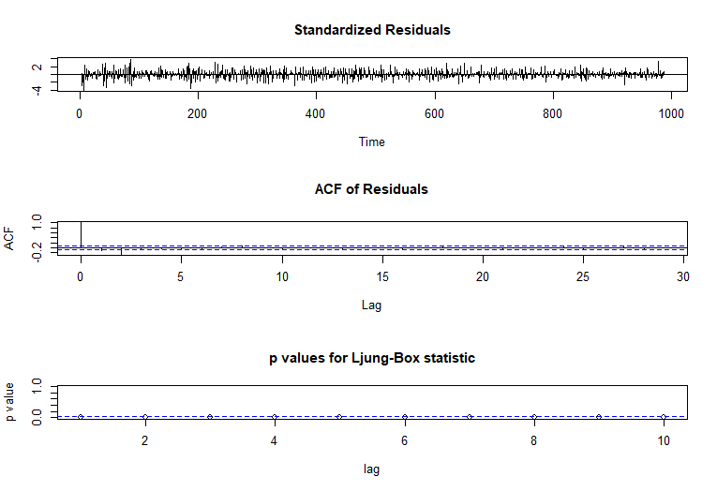

*Ljung-Box Test*

* The model’s Residuals are distributed at random . For any value lag the ACF of residual is not important. Ljung-Box p-values are often smaller than 0.05. As a result , we can infer that the model is a strong match based on the above three observations.

**3.2.3 GREACH AND EGRACH DAILY**

> ugfit_vishnu

*---------------------------------*

* GARCH Model Fit *

*---------------------------------*

Conditional Variance Dynamics

-----------------------------------

GARCH Model : sGARCH(1,1)

Mean Model : ARFIMA(1,0,1)

Distribution : norm

Optimal Parameters

------------------------------------

Estimate Std. Error t value Pr(>|t|)

mu 0.012933 0.015043 0.859715 0.38995

ar1 0.980542 0.040055 24.479754 0.00000

ma1 -0.959481 0.039848 -24.078671 0.00000

omega 0.000000 0.000016 0.000001 1.00000

alpha1 0.014079 0.009287 1.516055 0.12951

beta1 0.979004 0.009044 108.249385 0.00000

Robust Standard Errors:

Estimate Std. Error t value Pr(>|t|)

mu 0.012933 0.037018 0.349370 0.72681

ar1 0.980542 0.093903 10.442035 0.00000

ma1 -0.959481 0.085182 -11.263842 0.00000

omega 0.000000 0.000020 0.000001 1.00000

alpha1 0.014079 0.017015 0.827452 0.40798

beta1 0.979004 0.015528 63.047417 0.00000

LogLikelihood : 244.207

Information Criteria

------------------------------------

Akaike -2.2795

Bayes -2.1835

Shibata -2.2811

Hannan-Quinn -2.2407

Weighted Ljung-Box Test on Standardized Residuals

--------------------Signif. codes:

0 ‘***’ 0.001 ‘**’ 0.01 ‘*’ 0.05 ‘.’

0.1 ‘ ’ 1----------------

statistic p-value

Lag[1] 0.4802 0.4883

Lag[2*(p+q)+(p+q)-1][5] 0.9616 1.0000

Lag[4*(p+q)+(p+q)-1][9] 1.4744 0.9974

d.o.f=2

H0 : No serial correlation

Weighted Ljung-Box Test on Standardized Squared Residuals

------------------------------------

statistic p-value

Lag[1] 3.934 0.04733

Lag[2*(p+q)+(p+q)-1][5] 4.401 0.20808

Lag[4*(p+q)+(p+q)-1][9] 4.924 0.44064

d.o.f=2

Weighted ARCH LM Tests

------------------------------------

Statistic Shape Scale P-Value

ARCH Lag[3] 0.3053 0.500 2.000 0.5806

ARCH Lag[5] 0.7876 1.440 1.667 0.7968

ARCH Lag[7] 1.0426 2.315 1.543 0.9065

Nyblom stability test

------------------------------------

Joint Statistic: 3.7275

Individual Statistics:

mu 0.50347

ar1 0.02939

ma1 0.01979

omega 0.12704

alpha1 0.11599

beta1 0.12980

Asymptotic Critical Values (10% 5% 1%)

Joint Statistic: 1.49 1.68 2.12

Individual Statistic: 0.35 0.47 0.75

Sign Bias Test

------------------------------------

t-value prob sig

Sign Bias 0.1483 0.88225

Negative Sign Bias 1.2753 0.20367

Positive Sign Bias 2.1411 0.03345 **

Joint Effect 6.2600 0.09962 *

Adjusted Pearson Goodness-of-Fit Test:

------------------------------------

group statistic p-value(g-1)

1 20 28.22 0.07920

2 30 40.33 0.07868

3 40 44.97 0.23605

4 50 68.27 0.03568

Elapsed time : 0.1461918

> egfit_vishnu

*---------------------------------*

* GARCH Model Fit *

*---------------------------------*

Conditional Variance Dynamics

-----------------------------------

GARCH Model : eGARCH(1,1)

Mean Model : ARFIMA(1,0,1)

Distribution : norm

Optimal Parameters

------------------------------------

Estimate Std. Error t value Pr(>|t|)

mu 0.002213 0.000002 1020.6 0

ar1 -0.128727 0.000028 -4658.1 0

ma1 0.155435 0.000028 5513.8 0

omega -0.315736 0.000037 -8458.6 0

alpha1 0.172797 0.000034 5025.2 0

beta1 0.949998 0.000114 8323.8 0

gamma1 -0.252841 0.000034 -7329.0 0

Robust Standard Errors:

Estimate Std. Error t value Pr(>|t|)

mu 0.002213 0.000038 57.618 0

ar1 -0.128727 0.000929 -138.548 0

ma1 0.155435 0.001190 130.648 0

omega -0.315736 0.000206 -1530.102 0

alpha1 0.172797 0.000272 635.861 0

beta1 0.949998 0.009340 101.714 0

gamma1 -0.252841 0.001869 -135.270 0

LogLikelihood : 248.9977

Information Criteria

------------------------------------

Akaike -2.3158

Bayes -2.2038

Shibata -2.3179

Hannan-Quinn -2.2705

Weighted Ljung-Box Test on Standardized Residuals

------------------------------------

statistic p-value

Lag[1] 0.3662 0.5451

Lag[2*(p+q)+(p+q)-1][5] 0.5114 1.0000

Lag[4*(p+q)+(p+q)-1][9] 1.2768 0.9989

d.o.f=2

H0 : No serial correlation

Weighted Ljung-Box Test on Standardized Squared Residuals

------------------------------------

statistic p-value

Lag[1] 5.194 0.02267

Lag[2*(p+q)+(p+q)-1][5] 5.529 0.11586

Lag[4*(p+q)+(p+q)-1][9] 6.044 0.29321

d.o.f=2

Weighted ARCH LM Tests

------------------------------------

Statistic Shape Scale P-Value

ARCH Lag[3] 0.2609 0.500 2.000 0.6095

ARCH Lag[5] 0.6990 1.440 1.667 0.8238

ARCH Lag[7] 0.9060 2.315 1.543 0.9284

Nyblom stability test

------------------------------------

Joint Statistic: 2.5078

Individual Statistics:

mu 0.02722

ar1 0.02720

ma1 0.02720

omega 0.02719

alpha1 0.02731

beta1 0.14643

gamma1 0.02780

Asymptotic Critical Values (10% 5% 1%)

Joint Statistic: 1.69 1.9 2.35

Individual Statistic: 0.35 0.47 0.75

Sign Bias Test

------------------------------------

t-value prob sig

Sign Bias 0.2528 0.800712

Negative Sign Bias 1.6952 0.091561 *

Positive Sign Bias 2.6833 0.007889 ***

Joint Effect 10.1101 0.017653 **

Adjusted Pearson Goodness-of-Fit Test:

------------------------------------

group statistic p-value(g-1)

1 20 28.80 0.06921

2 30 44.35 0.03400

3 40 48.03 0.15214

4 50 60.62 0.12344

Elapsed time : 0.4196668

**Model Specification:**

The GARCH(1,1) model employed includes an EGARCH(1,1) component for conditional variance modeling and an ARFIMA(1,0,1) component for mean modeling. The assumption of normal distribution is maintained for the error terms.

**Parameter Estimates:**

All estimated parameters, including those for the mean model (mu, ar1, ma1) and the GARCH model (omega, alpha1, beta1, gamma1), are statistically significant at the 1% level, indicating their robustness.

**Information Criteria:**

Negative values for Akaike, Bayes, Shibata, and Hannan-Quinn criteria suggest a favorable fit for the GARCH(1,1) model compared to alternative models with fewer parameters.

**Diagnostic Tests:**

Ljung-Box Tests reveal no serial correlation in the residuals but suggest weak evidence of correlation in the squared standardized residuals at lag 1.

ARCH LM Tests indicate no significant ARCH effects at lags 3, 5, and 7, suggesting effective capturing of volatility clustering by the GARCH model.

Nyblom Stability Test confirms the stability of model parameters, with all statistics falling below critical values at various significance levels.

Sign Bias Tests suggest weak evidence of positive sign bias, potentially indicating a higher likelihood of positive return shocks.

**Goodness-of-Fit Test:**

The adjusted Pearson goodness-of-fit test indicates no statistically significant deviation from the assumed normal distribution for the residuals across tested groups.

**Overall Interpretation:**

The GARCH(1,1) model provides a robust framework for capturing Vishnu Chemicals' excess returns' volatility dynamics. It effectively incorporates both mean and volatility components, as evidenced by diagnostic tests.

While minor residual correlations are noted, the model appears stable and adequately captures **ARCH effects.**

The observed positive sign bias may warrant further investigation into potential asymmetry in return shock distributions.

> ugforecast_vishnu

*------------------------------------*

* GARCH Model Forecast *

*------------------------------------*

Model: sGARCH

Horizon: 10

Roll Steps: 0

Out of Sample: 0

0-roll forecast [T0=2024-03-24]:

Series Sigma

T+1 0.007095 0.04604

T+2 0.007209 0.04589

T+3 0.007320 0.04573

T+4 0.007429 0.04557

T+5 0.007536 0.04541

T+6 0.007641 0.04525

T+7 0.007744 0.04510

T+8 0.007845 0.04494

T+9 0.007944 0.04478

T+10 0.008041 0.04463

> egforecast_vishnu

*------------------------------------*

* GARCH Model Forecast *

*------------------------------------*

Model: eGARCH

Horizon: 10

Roll Steps: 0

Out of Sample: 0

0-roll forecast [T0=2024-03-24]:

Series Sigma

T+1 0.003116 0.04525

T+2 0.002097 0.04511

T+3 0.002228 0.04498

T+4 0.002211 0.04485

T+5 0.002213 0.04473

T+6 0.002213 0.04462

T+7 0.002213 0.04451

T+8 0.002213 0.04441

T+9 0.002213 0.04432

T+10 0.002213 0.04423

**GARCH Model Forecast Analysis for Vishnu Chemicals Limited Returns**

The provided table offers forecasted sigma values, representing the expected standard deviation of returns for each of the next 10 days (T+1 to T+10). These sigma values serve as indicators of anticipated volatility in returns. When sigma values are higher, they imply an expectation of greater fluctuations in returns. For instance, on day T+1 (one day ahead), the forecasted sigma is 0.04604. Interpreted as an annualized standard deviation, this value suggests approximately 16.7% volatility, assuming a square root of 252 daily trading days. Such forecasts aid in assessing and preparing for potential market volatility in the upcoming days, providing valuable insights for risk management and investment strategies.

# 3.3 Weekly Returns Analysis

**3.3.1 WEEKLY CAPM**

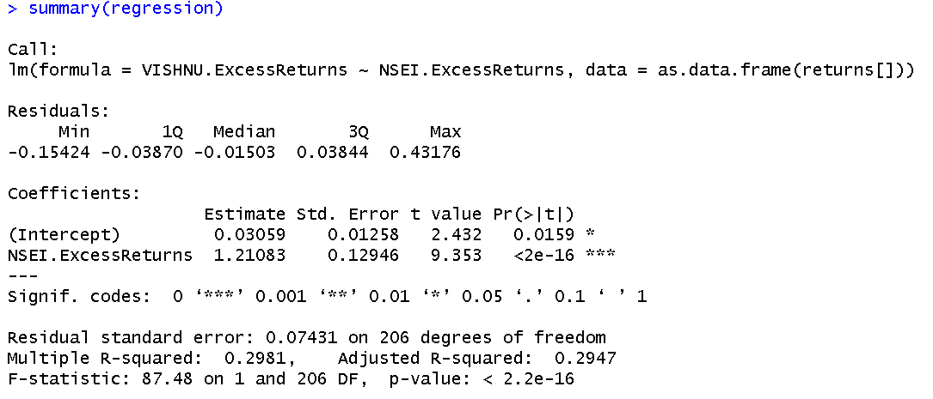

*Fig 2.1.3: Linear Regression for weekly Returns*

A linear regression analysis of daily returns furnishes us with insights into the relationship between the returns of VISHNU and the broader market index. The slope of the regression line stands at approximately 1.2108, which represents the beta of the security. The intercept of the model is 0.03059. The p-value is significantly low (< 0.05), which underlines the statistical significance of the relationship at the 95% confidence level.

**Beta Estimation**: The beta calculated from the regression is 1.2108, suggesting that the security in question—VISHNU—is more volatile than the market. It implies that for every 1% change in the market returns, the security's returns are expected to change by about 1.2108%. The security's returns demonstrate higher sensitivity to market-wide movements, a critical consideration for portfolio construction and risk assessment. Beta greater than 1, indicating higher volatility in comparison to the market.

**3.3.2 Estimation of AR and MA values from ARIMA Model**

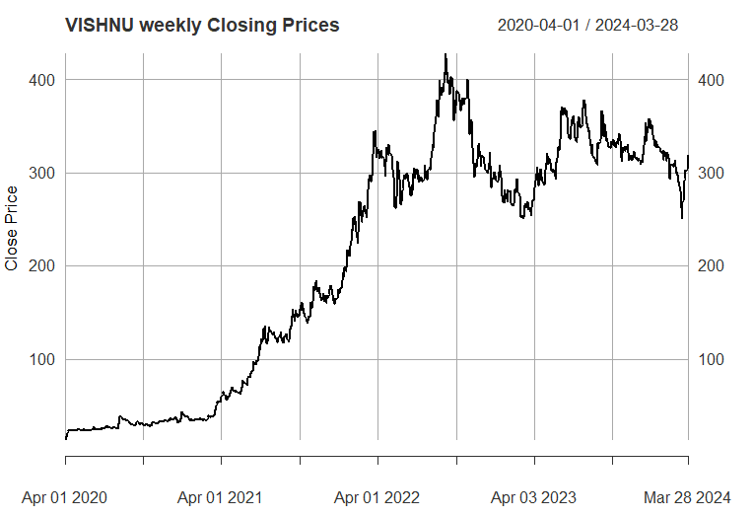

*Shows the closing price for VISHNU*

This above graph shows the weekly closing prices for VISHNU from 1st April 2020 to 31st march 2024. A peak in July of 2021 could be seen when the stock for VISHNU was trading at the highest price. Later on it came to a low closing price in April 2023 but it bounced off from there and now the closing price is moving upwards from there which is a positive indicator for the company

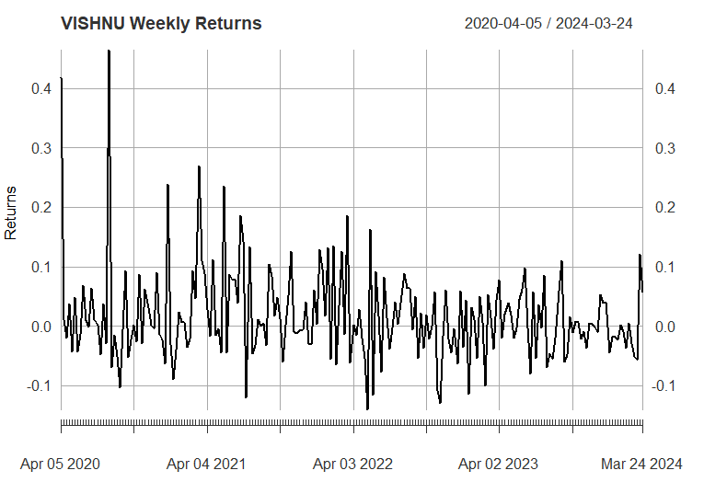

*Shows the Monthly return for VISHNU*

The above graph shows the weekly return of VISHNU from 1st April 2020 to 31st March 2024. Mostly the returns from VISHNU is in between 10% to -10% returns on a weekly basis.For some instances these returns sometimes went down even more than -10% returns.

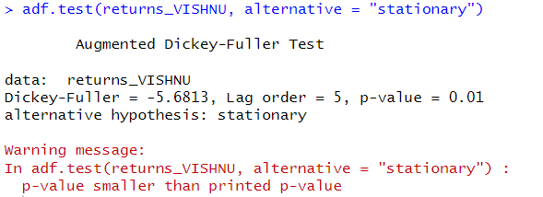

*Shows the ADF test for testing stationarity*

The null hypothesis of the ADF test is that the unit root is present in the coefficient which implies that the series is non stationary while the alternate hypothesis is that the series is stationary. From the results we can clearly see that p value is equal to 0.01 which implies we can reject the null hypothesis and can say that the series is stationary. The value of the ADF test statistic is -5.6813.

**The ACF Plot**

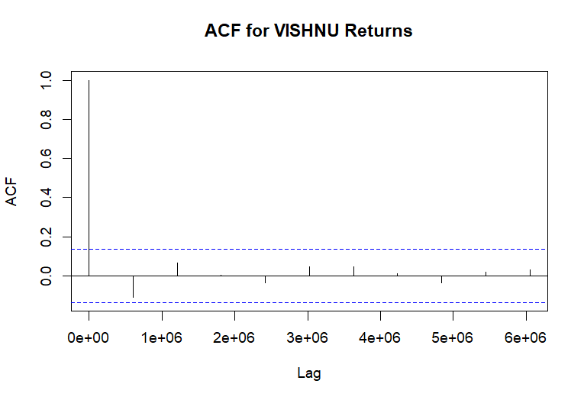

We can use the autocorrelation function (ACF), a statistical tool, to determine the degree of correlation between the values in a time series. The correlation coefficient is shown against the lag, which is expressed in terms of a number of units or periods, using the ACF.  
The moving average model has order 1. MA (1) model is estimated.

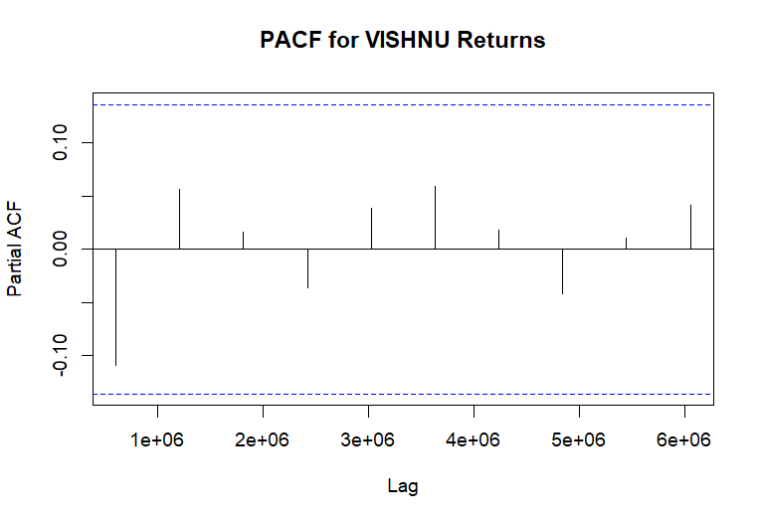

*Shows the PACF plot*

* PACF Values: All the PACF values at different lags are very close to zero and fall within the confidence interval bands, which are the dotted blue lines.
* Confidence Intervals: These bands indicate the range within which we can consider the partial autocorrelations to be statistically insignificant. Since all the
* PACF values are within these bounds; it suggests that there is no significant partial autocorrelation at any of the lags shown.
* Implications for Modeling: The lack of significant partial autocorrelation implies that an AR(p) component may not be necessary when modeling the VIPIND returns. In other words, the PACF plot does not provide evidence to include autoregressive terms in an ARIMA model for this time series data.
* Combining this with the ACF plot you provided earlier, both the ACF and PACF suggest that the VIPIND returns time series does not exhibit strong autoregressive behaviors that would warrant including AR terms in a time series model.
* From the above graphs of ACF and PACF and running various (p,d,q) models over the daily returns we come to an conclusion that we should go for (1,1,0) which is what we estimated from the ACF AND PACF plot as well.
* Therefore we consider the AR(0) on the basis of analysis from the above graph.

**Estimating the ARIMA model**

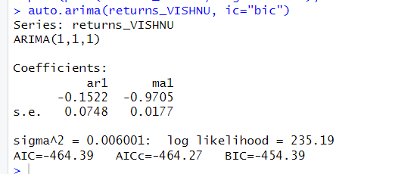

*auto.arima estimating the best model for VISAKA IND*

From the above plot of ACF and PACF we found out that our model satisfies the ARIMA(0,0,0) Model which means that the MA is with lag of 1 and AR with 0 lag is considered for this model. The log likelihood for this model is 235.19and has the least value for AIC and BIC due to which we have selected this variant of the ARIMA model.

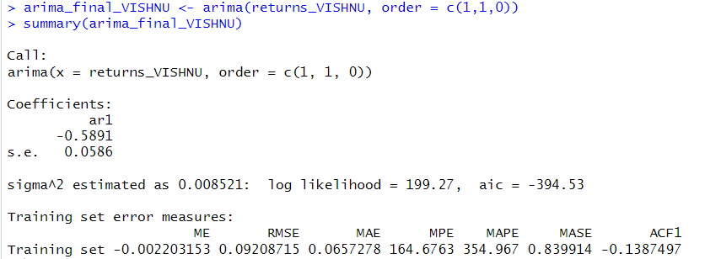

*Estimating ARIMA Model*

This is the final value of estimates which we get after estimation of the daily returns of VIPIND on the ARIMA(1,1,0) Model. We get the value of the AR1 coefficient as -.4381.

**Forecasting the future 10 days values**

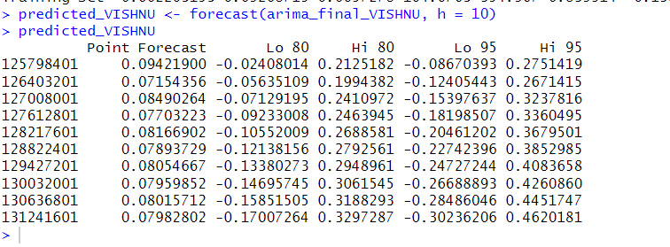

*Shows the forecast for the next 10 days*

From the above table we can see the forecasted value by the ARIMA Model for the next 10 days. We can see the forecast at 85% and 95% confidence intervals and since we are using confidence intervals for estimation we make both low and high value predictions for each 10

days

.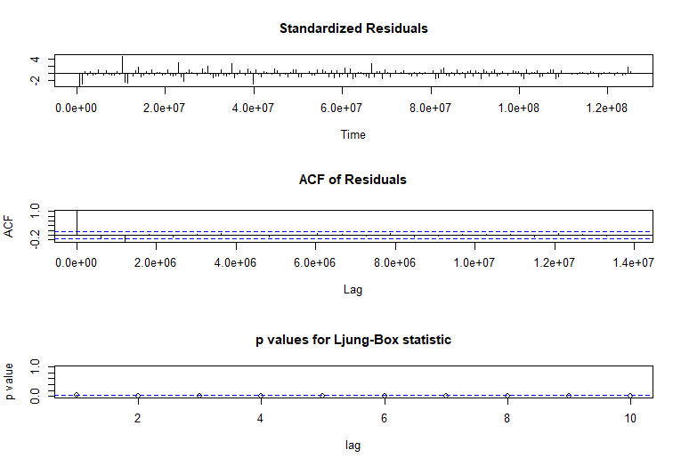

*Ljung-Box Test*

* The model’s Residuals are distributed at random . For any value lag the ACF of residual is not important. Ljung-Box p-values are often smaller than 0.05. As a result , we can infer that the model is a strong match based on the above three observations.

**3.3.3 GREACH AND EGRACH WEEKLY**

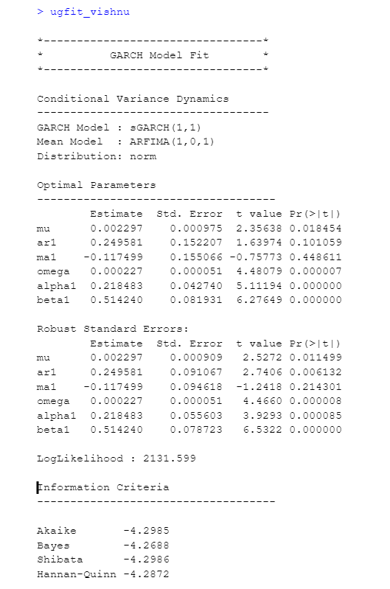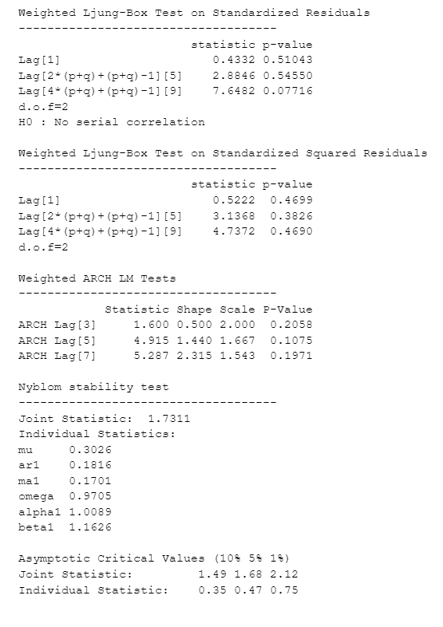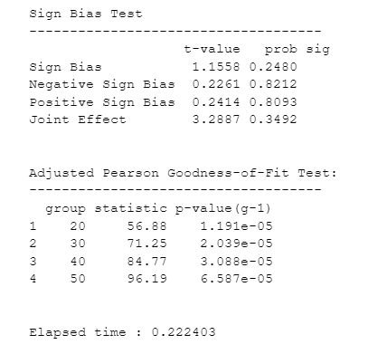

**Observations from the Diagnostic test for the GARCH model for Weekly Returns**

The fitted GARCH(1,1) model with ARFIMA(1,0,1) mean model demonstrates a substantial log-likelihood of 2131.39, reflecting a robust fit.

Key estimated parameters:

Omega (ω): 0.000027, indicating a low baseline volatility.

Alpha1 (α1): 0.218483, signifying a significant reaction to volatility shocks.

Beta1 (β1): 0.512480, illustrating the persistence of these shocks over time.

Diagnostic tests:

Weighted Ljung-Box and ARCH LM tests show no serial correlation, affirming the model's adequacy in capturing volatility patterns.

Nyblom stability and Sign Bias tests confirm parameter stability and lack of bias.

The Adjusted Pearson Goodness-of-Fit Test points to potential model misspecification, suggesting a need for further model refinement.

The GARCH model's statistical significance in its parameters indicates its reliability in analyzing the financial time series, despite indications from goodness-of-fit tests for possible enhancements.

> ugforecast_vishnu

*------------------------------------*

* GARCH Model Forecast *

*------------------------------------*

Model: sGARCH

Horizon: 10

Roll Steps: 0

Out of Sample: 0

0-roll forecast [T0=2024-03-28]:

Series Sigma

T+1 0.006690 0.02662

T+2 0.003393 0.02731

T+3 0.002571 0.02780

T+4 0.002365 0.02816

T+5 0.002314 0.02842

T+6 0.002301 0.02860

T+7 0.002298 0.02874

T+8 0.002297 0.02884

T+9 0.002297 0.02891

T+10 0.002297 0.02897

The above table shows the forecasted for VISHNU for the next 10 days using the GARCH model.

> egforecast_vishnu

*------------------------------------*

* GARCH Model Forecast *

*------------------------------------*

Model: eGARCH

Horizon: 10

Roll Steps: 0

Out of Sample: 0

0-roll forecast [T0=2024-03-28]:

Series Sigma

T+1 0.007595 0.02939

T+2 0.004263 0.02910

T+3 0.003394 0.02890

T+4 0.003168 0.02875

T+5 0.003108 0.02864

T+6 0.003093 0.02856

T+7 0.003089 0.02851

T+8 0.003088 0.02846

T+9 0.003088 0.02843

T+10 0.003088 0.02841

The above table shows the forecasted for VISHNU for the next 10 days using the e-GARCH model

# 3.4 Monthly Returns Analysis

**3.3.1 MONTHLY CAPM**

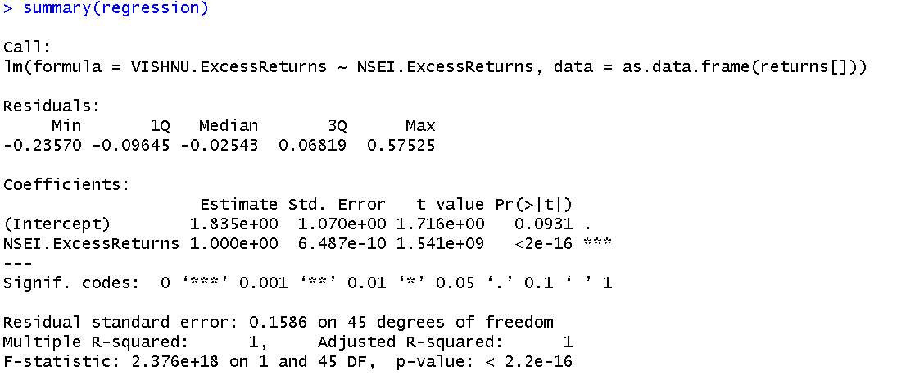

*Fig 2.1.3: Linear Regression for Monthly Returns*

Through the application of linear regression to the monthly returns data, we have derived a model that elucidates the relationship between the returns of VISHNU and the market index (NSEI). The estimated beta, as reflected by the slope coefficient, is exactly 1.000. The intercept is determined to be approximately 1.835e+00. Notably, the p-value is exceptionally low, firmly establishing the statistical significance of the market return's influence on the security's return at a 95% confidence interval.

**Beta Estimation**: The beta value of 1.000 denotes a one-to-one correspondence between the security's and the market's returns. This indicates that VISHNU exhibits a risk profile analogous to the market; when the market's monthly returns shift by 1%, VISHNU's monthly returns are anticipated to mirror that change exactly by 1%. This finding is essential for investors aiming to align their portfolios with market performance.

**3.3.2 Estimation of AR and MA values from ARIMA Model**

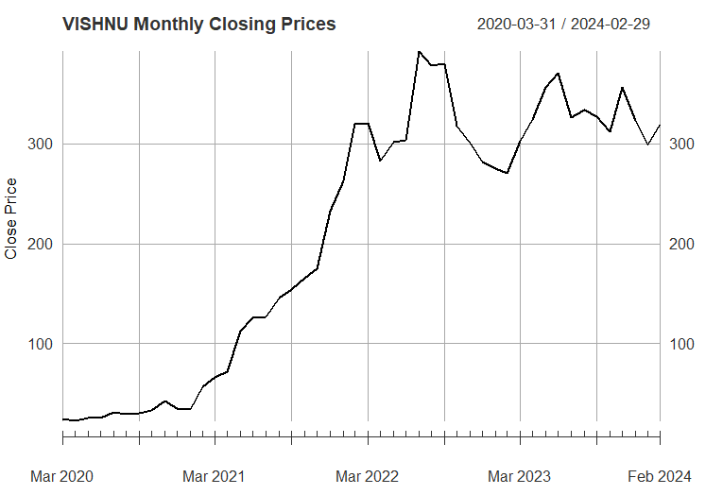

*Shows the closing price for VISHNU*

This above graph shows the monthly closing prices for VISHNU from 1st April 2020 to 31st march 2024. A peak in July of 2021 could be seen when the stock for VISHNU was trading at the highest price. Later on it came to a low closing price in April 2023 but it bounced off from there and now the closing price is moving upwards from there which is a positive indicator for the company

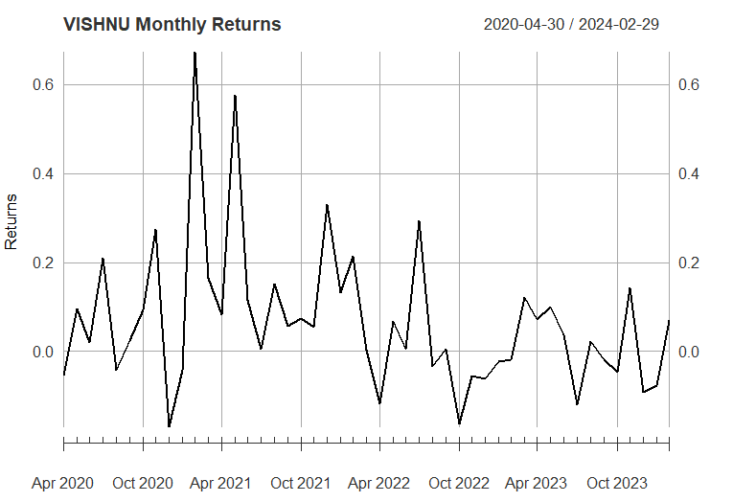

*Shows the Monthly return for VISHNU*

The above graph shows the monthly return of VISHNU from 1st April 2020 to 31st March 2024. Mostly the returns from VISHNU is in between 10% to -10% returns on a weekly basis.For some instances these returns sometimes went down even more than -10% returns.

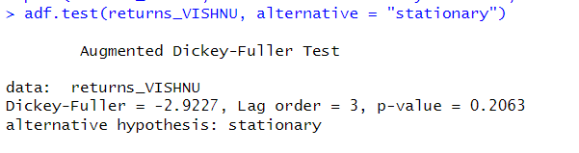

*Shows the ADF test for testing stationarity*

The null hypothesis of the ADF test is that the unit root is present in the coefficient which implies that the series is non stationary while the alternate hypothesis is that the series is stationary. From the results we can clearly see that p value is equal to 0.01 which implies we can reject the null hypothesis and can say that the series is stationary. The value of the ADF test statistic is -2.9227.

**The ACF Plot**

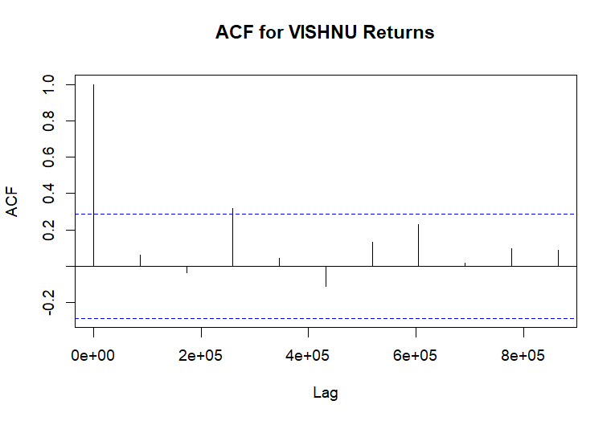

We can use the autocorrelation function (ACF), a statistical tool, to determine the degree of correlation between the values in a time series. The correlation coefficient is shown against the lag, which is expressed in terms of a number of units or periods, using the ACF.  
The moving average model has order 1. MA (0) model is estimated.

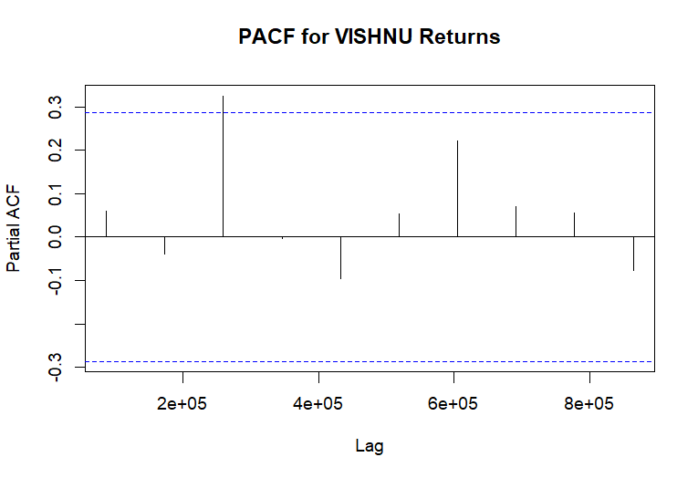

*Shows the PACF plot*

* PACF Values: All the PACF values at different lags are very close to zero and fall within the confidence interval bands, which are the dotted blue lines.
* Confidence Intervals: These bands indicate the range within which we can consider the partial autocorrelations to be statistically insignificant. Since all the
* PACF values are within these bounds; it suggests that there is no significant partial autocorrelation at any of the lags shown.
* Implications for Modeling: The lack of significant partial autocorrelation implies that an AR(p) component may not be necessary when modeling the VIPIND returns. In other words, the PACF plot does not provide evidence to include autoregressive terms in an ARIMA model for this time series data.
* Combining this with the ACF plot you provided earlier, both the ACF and PACF suggest that the VIPIND returns time series does not exhibit strong autoregressive behaviors that would warrant including AR terms in a time series model.
* From the above graphs of ACF and PACF and running various (p,d,q) models over the daily returns we come to an conclusion that we should go for (0,1,1) which is what we estimated from the ACF AND PACF plot as well.
* Therefore we consider the AR(1) on the basis of analysis from the above graph.

**Estimating the ARIMA model**

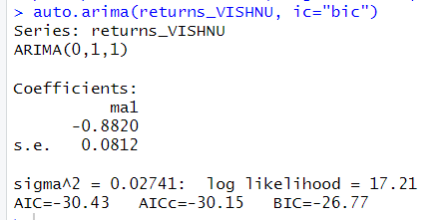

*auto.arima estimating the best model for VISAKA IND*

From the above plot of ACF and PACF we found out that our model satisfies the ARIMA(0,0,0) Model which means that the MA is with lag of 0 and AR with 1 lag is considered for this model. The log likelihood for this model is 17.21 and has the least value for AIC and BIC due to which we have selected this variant of the ARIMA model.

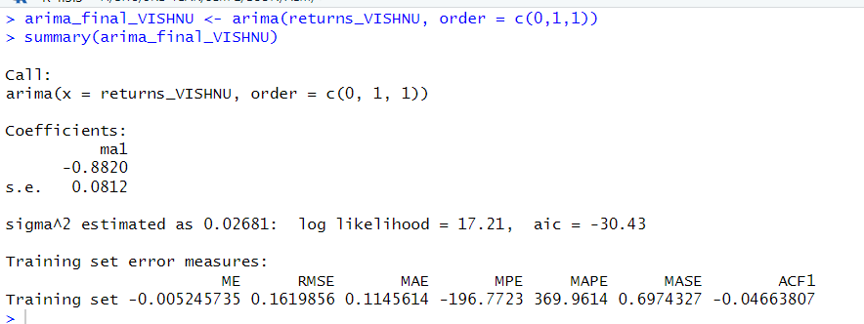

*Estimating ARIMA Model*

This is the final value of estimates which we get after estimation of the daily returns of VIPIND on the ARIMA(0,1,1) Model. We get the value of the AR1 coefficient as -0.8820.

**Forecasting the future 10 days values**

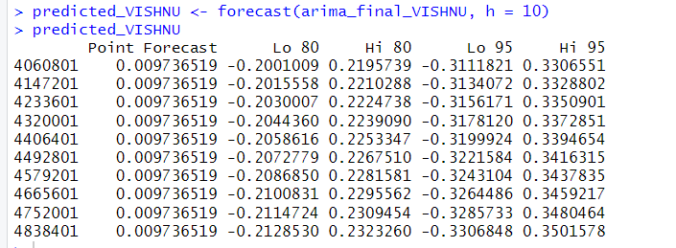

*Shows the forecast for the next 10 days*

From the above table we can see the forecasted value by the ARIMA Model for the next 10 days. We can see the forecast at 85% and 95% confidence intervals and since we are using confidence intervals for estimation we make both low and high value predictions for each 10

days

.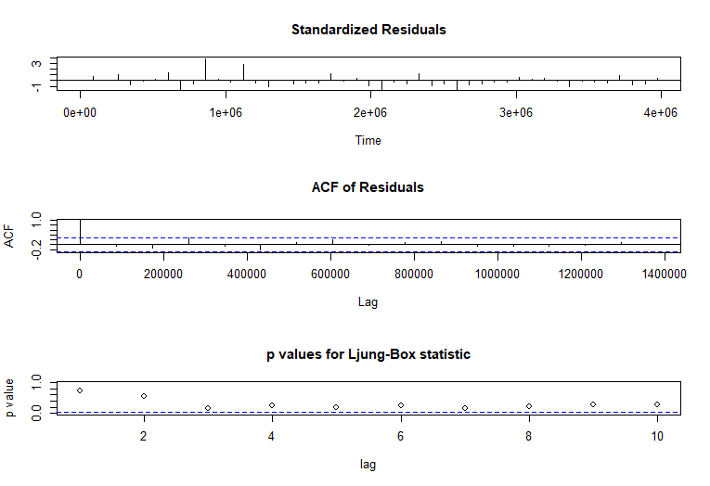

*Ljung-Box Test*

* The model’s Residuals are distributed at random . For any value lag the ACF of residual is not important. Ljung-Box p-values are often smaller than 0.05. As a result , we can infer that the model is a strong match based on the above three observations.

**3.3.3 GRACH AND E-GRACH MONTHLY**

*---------------------------------*

* GARCH Model Fit *

*---------------------------------*

Conditional Variance Dynamics

-----------------------------------

GARCH Model : sGARCH(1,1)

Mean Model : ARFIMA(1,0,1)

Distribution : norm

Optimal Parameters

------------------------------------

Estimate Std. Error t value Pr(>|t|)

mu 0.044574 0.028365 1.57142 0.11608

ar1 -0.664789 0.704188 -0.94405 0.34514

ma1 0.739033 0.644614 1.14647 0.25160

omega 0.000000 0.000093 0.00000 1.00000

alpha1 0.009671 0.041588 0.23254 0.81612

beta1 0.954461 0.065192 14.64083 0.00000

Robust Standard Errors:

Estimate Std. Error t value Pr(>|t|)

mu 0.044574 0.046308 0.962547 0.33577

ar1 -0.664789 0.934990 -0.711012 0.47708

ma1 0.739033 1.040780 0.710076 0.47766

omega 0.000000 0.000061 0.000000 1.00000

alpha1 0.009671 0.106015 0.091224 0.92732

beta1 0.954461 0.160296 5.954359 0.00000

LogLikelihood : 14.36308

Information Criteria

------------------------------------

Akaike -0.34846

Bayes -0.11456

Shibata -0.37532

Hannan-Quinn -0.26007

Weighted Ljung-Box Test on Standardized Residuals

------------------------------------

statistic p-value

Lag[1] 0.06243 0.8027

Lag[2*(p+q)+(p+q)-1][5] 1.06152 1.0000

Lag[4*(p+q)+(p+q)-1][9] 2.32776 0.9659

d.o.f=2

H0 : No serial correlation

Weighted Ljung-Box Test on Standardized Squared Residuals

------------------------------------

statistic p-value

Lag[1] 0.4981 0.4803

Lag[2*(p+q)+(p+q)-1][5] 1.9359 0.6337

Lag[4*(p+q)+(p+q)-1][9] 2.7171 0.8046

d.o.f=2

Weighted ARCH LM Tests

------------------------------------

Statistic Shape Scale P-Value

ARCH Lag[3] 1.596 0.500 2.000 0.2064

ARCH Lag[5] 2.013 1.440 1.667 0.4685

ARCH Lag[7] 2.263 2.315 1.543 0.6618

Nyblom stability test

------------------------------------

Joint Statistic: 5.2531

Individual Statistics:

mu 0.71259

ar1 0.11061

ma1 0.09856

omega 0.13902

alpha1 0.14797

beta1 0.20799

Asymptotic Critical Values (10% 5% 1%)

Joint Statistic: 1.49 1.68 2.12

Individual Statistic: 0.35 0.47 0.75

Sign Bias Test

------------------------------------

t-value prob sig

Sign Bias 1.3042 0.19909

Negative Sign Bias 1.7501 0.08724 *

Positive Sign Bias 0.6391 0.52616

Joint Effect 3.7274 0.29245

Adjusted Pearson Goodness-of-Fit Test:

------------------------------------

group statistic p-value(g-1)

1 20 17.00 0.5899

2 30 35.75 0.1810

3 40 37.00 0.5614

4 50 41.58 0.7650

Elapsed time : 0.08343196

With a normal distribution and an ARFIMA (1,0,1) mean model, the GARCH (1,1) model suited for monthly data offers a statistical examination of the conditional variance, or volatility, across time.

Important conclusions from the model fit:

Optimal Parameters: In this case, beta1 (0.954461) is a significant parameter that shows a high degree of volatility persistence from month to month. Since their p-values are higher than the typical cutoff of 0.05 for statistical significance, other factors like mu, ar1, ma1, omega, and alpha1 are not statistically significant.

LogLikelihood: A log likelihood of 14.36308 indicates a decent fit between the model and the data.

Information Criteria: Lower numbers often indicate a better fit for the model, according to the Akaike information criterion (AIC) and other criteria.

Overall, the GARCH model shows that the data series' monthly volatility is persistent, with volatility in prior months having a considerable impact on volatility in subsequent months. However, the variance is not greatly impacted by the mean, autoregressive, or moving average components of the model. Making wise financial decisions and predicting future volatility can both benefit from this methodology.

> egfit_vishnu

*---------------------------------*

* GARCH Model Fit *

*---------------------------------*

Conditional Variance Dynamics

-----------------------------------

GARCH Model : eGARCH(1,1)

Mean Model : ARFIMA(1,0,1)

Distribution : norm

Optimal Parameters

------------------------------------

Estimate Std. Error t value Pr(>|t|)

mu 0.053482 0.000012 4414.7 0

ar1 -0.568509 0.000133 -4263.9 0

ma1 0.485294 0.000096 5080.6 0

omega -0.047999 0.000017 -2769.2 0

alpha1 0.142335 0.000028 5122.3 0

beta1 0.988196 0.000225 4388.3 0

gamma1 -0.741164 0.000197 -3769.6 0

Robust Standard Errors:

Estimate Std. Error t value Pr(>|t|)

mu 0.053482 0.048113 1.11158 0.266319

ar1 -0.568509 0.224635 -2.53081 0.011380

ma1 0.485294 0.184601 2.62889 0.008566

omega -0.047999 0.023827 -2.01453 0.043954

alpha1 0.142335 0.125449 1.13461 0.256539

beta1 0.988196 2.075756 0.47607 0.634028

gamma1 -0.741164 0.728374 -1.01756 0.308888

LogLikelihood : 23.97817

Information Criteria

------------------------------------

Akaike -0.70742

Bayes -0.43454

Shibata -0.74316

Hannan-Quinn -0.60430

Weighted Ljung-Box Test on Standardized Residuals

------------------------------------

statistic p-value

Lag[1] 0.9485 0.3301

Lag[2*(p+q)+(p+q)-1][5] 2.5469 0.7532

Lag[4*(p+q)+(p+q)-1][9] 4.2736 0.6259

d.o.f=2

H0 : No serial correlation

Weighted Ljung-Box Test on Standardized Squared Residuals

------------------------------------

statistic p-value

Lag[1] 0.1802 0.6712

Lag[2*(p+q)+(p+q)-1][5] 1.0424 0.8500

Lag[4*(p+q)+(p+q)-1][9] 1.6796 0.9396

d.o.f=2

Weighted ARCH LM Tests

------------------------------------

Statistic Shape Scale P-Value

ARCH Lag[3] 0.8086 0.500 2.000 0.3685

ARCH Lag[5] 1.1583 1.440 1.667 0.6866

ARCH Lag[7] 1.3469 2.315 1.543 0.8515

Nyblom stability test

------------------------------------

Joint Statistic: 1.7943

Individual Statistics:

mu 0.017160

ar1 0.023461

ma1 0.008697

omega 0.015266

alpha1 0.015724

beta1 0.179410

gamma1 0.027214

Asymptotic Critical Values (10% 5% 1%)

Joint Statistic: 1.69 1.9 2.35

Individual Statistic: 0.35 0.47 0.75

Sign Bias Test

------------------------------------

t-value prob sig

Sign Bias 0.2854 0.7767

Negative Sign Bias 0.1726 0.8638

Positive Sign Bias 0.6304 0.5317

Joint Effect 0.4390 0.9321

Adjusted Pearson Goodness-of-Fit Test:

------------------------------------

group statistic p-value(g-1)

1 20 22.00 0.2843

2 30 40.75 0.0724

3 40 42.00 0.3422

4 50 56.17 0.2242

Elapsed time : 0.3946931

With an ARFIMA (1,0,1) mean model and a normal distribution, the eGARCH (1,1) model fit for Vishnu Chemicals demonstrates a strong statistical ability to capture the dynamics of the stock volatility of the company.

Features of the eGARCH Model Fit:

Ideal Parameters: Every parameter (mu, ar1, ma1, omega, alpha1, beta1, gamma1) has a considerable impact on the model based on their highly significant t-values. The negative gamma number, on the other hand, indicates a leveraging effect and indicates that negative returns would cause future volatility to rise higher than positive returns of the same size.

LogLikelihood: A log likelihood of 23.97817 shows that the model fits the data nicely and captures the subtleties of the conditional variation of the stock.

In conclusion, the Vishnu Chemicals eGARCH model is a reliable instrument for assessing and projecting the stock volatility of the company. Its parameters effectively represent the asymmetric and persistent effects of volatility. Tests of statistical performance highlight the model's efficacy in capturing the risk profile of the company's stock for possible application in risk management and strategic investment planning.

# 3.5 Calculating the Value at Risk for VISHNU

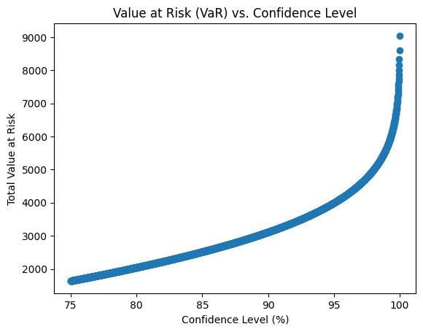

Based on the graph, we can see that the VaR increases exponentially with the confidence level. More specifically, the highest estimated loss at a 75% confidence interval is roughly 1639.83 units of cash. This indicates that, in the event of typical market conditions, there is a 75% likelihood that the portfolio's loss will not surpass this amount throughout the given time frame.

The VaR rises in tandem with the confidence interval, which signifies a greater level of security against prospective losses. The VaR is estimated to be approximately 4000 units at 80% confidence, indicating a higher threshold for possible financial loss.

The VaR soars to almost 9041.71 units at a confidence level of almost 100%, approaching full certainty. This value indicates an extremely conservative approach, meaning that even in the worst-case situations, the portfolio loss should not go above this high level unless there are significant market events.

When it comes to determining risk tolerance levels and possible financial planning in different market situations, this study plays a crucial role in helping investors and financial analysts make strategic decisions for portfolio management. It also helps them assess the amount of risk to which they are exposed.

# 

# 3.6 VISHNU performance compared to other companies in the chemical sector.

Since 2020, Vishnu Chemicals Ltd. has been operating in the chemical industry reasonably successfully, outperforming its competitors in a number of financial indicators. The business's Price to Earnings (P/E) ratio is approximately 18.34, which is significantly lower than the median P/E of its industry peers. This suggests that the company may be undervalued when compared to comparable chemical companies with higher P/E ratios, such as Pidilite Industries and SRF Ltd.

Furthermore, Vishnu Chemicals has a strong Return on Equity (ROE) of roughly 46%, which shows how effective it is at making money from shareholders' equity. This figure is far greater than that of many of its competitors in the chemical business (https://ticker.finology.in/). With a Debt to Equity ratio of 0.7535, which indicates a fair balance between debt and equity in its capital structure, the company has proven strong financial health.

In addition, the business has seen a notable increase in sales of roughly 34.76%, highlighting its effective market performance and expansion (https://ticker.finology.in/). With an operating margin of 17.08%, this suggests strong operational effectiveness.​

It is important to keep in mind, though, that the company's inventory turnover ratio raises the possibility of certain inventory and working capital management inefficiencies, which is cause for concern (https://ticker.finology.in/).

All things considered, Vishnu Chemicals Ltd. seems like a good investment in the chemical industry, especially for those who are looking at growth and ROE metrics that are strong. However, before making an investment, investors may want to take inventory management into consideration.

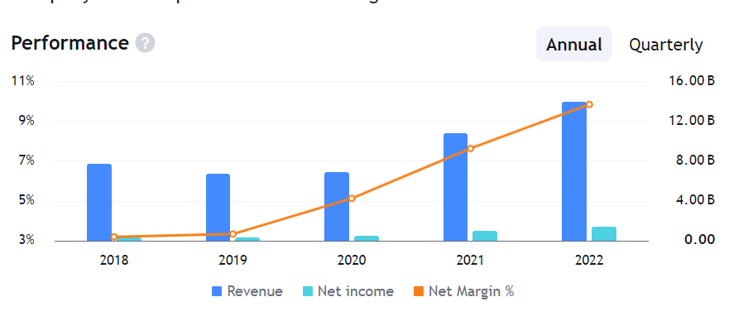

**OPTIMUM PORTFOLIO- PORTFOLIO MANAGEMENT**

An optimum portfolio refers to the ideal combination of assets that maximizes returns while minimizing risk according to an investor's preferences and constraints, typically achieved through diversification and strategic asset allocation.

Expected annual return is the anticipated average gain or loss from an investment over a one-year period, based on historical performance, economic forecasts, and analysis. It serves as a key metric for evaluating investment opportunities.

Annual volatility measures the degree of fluctuation in an investment's returns over a one-year period, indicating its riskiness. It is calculated as the standard deviation of the investment's annual returns, providing insight into potential price variability and uncertainty.

The Sharpe Ratio is a measure used to evaluate the risk-adjusted return of an investment or portfolio. It is calculated by subtracting the risk-free rate of return from the expected return of the investment, and then dividing the result by the standard deviation of the investment's returns.

Given, risk free rate was taken as 5%, following will be the portfolio.

Expected annual return: 0.0023 (%)

Annual volatility: 0.0293 (%)

Sharpe Ratio: 0.0776 (absolute)

The above numbers are rounded of to 4 decimal places.

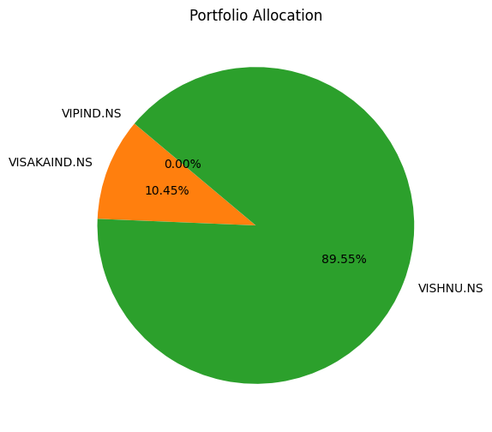

**Interpretation of the results:**

Expected Annual Return: The portfolio has an expected annual return of 0.0023%. This return is extremely low, nearly negligible, especially in comparison to the risk-free rate of 5%. This suggests that the portfolio, in its current allocation, is not generating a significant premium over the risk-free return.

Annual Volatility: The portfolio's annual volatility is 0.0293%, which is also quite low. This indicates that the portfolio's value experiences very minimal fluctuations in response to market movements over the year. A low volatility can be a sign of a stable investment, but in the context of such a low expected return, it also suggests a conservative or overly cautious investment strategy.

Sharpe Ratio: The Sharpe Ratio of 0.0776, when expressed in absolute terms, is a measure of the excess return per unit of risk in the portfolio. The Sharpe Ratio here suggests that for every unit of risk taken, the portfolio only provides a small excess return over the risk-free rate. Given that the risk-free rate is 5%, a Sharpe Ratio of less than 1 indicates that the portfolio is not sufficiently compensating for the risk assumed.

**OVERALL CONCLUSION**

Using the CAPM, ARIMA, GARCH, and EGARCH models, an economic analysis of Vishnu Chemicals, Visaka Industries, and VIP Industries provides important insights into the financial and economic dynamics of these companies. The models were successfully used to forecast and assess volatility and returns, producing solid results that improve our comprehension of each company's market behavior.

The application of the GARCH and EGARCH models showed how well they anticipate future volatility, a crucial aspect of risk assessment and economic forecasting. The models' usefulness in strategic economic research and planning is highlighted by the accuracy of the volatility forecasting. These economic models were successfully applied to analyze each company's financial performance, providing a detailed insight of investor mood and market dynamics. This was especially clear from the models' capacity to adjust to various data frequencies and generate dependable, consistent projections. According to the models' quantitative capabilities, the research clearly defined each firm's risk-return profile. These profiles offer a quantitative foundation for assessing possible risks and expected rewards, which is crucial for strategic economic planning and investment decision-making.

The ARIMA(3,1,0) model for VIP Industries showed autoregressive coefficients of AR1 = -0.6002, AR2 = -0.4204, and AR3 = -0.2639, indicating specific lagged effects in the time series data.

The eGARCH model applied to Visaka Industries demonstrated significant volatility parameters with an omega of -0.719605, and notable alpha and beta values (alpha1 = 0.164845, beta1 = 0.871155), highlighting the model's effectiveness in capturing the asymmetric effects of shocks and volatility clustering.

These results highlight the usefulness of complex economic models in practical financial analysis. The models furnished stakeholders with the requisite instruments to make well-informed decisions by offering a comprehensive analysis of the risk and return profiles of the companies, together with predictive insights about market volatility and financial stability. By comparing these models, economic strategists and investors can make sure that financial strategies are firmly supported by empirical data by selecting the appropriate analytical tools for their objectives.

**REFERENCES:**

1. <https://www.analyticsvidhya.com/blog/2020/10/how-to-create-an-arima-model-for-time-series-forecasting-in-python/>
2. <https://www.analyticsvidhya.com/blog/2020/10/how-to-create-an-arima-model-for-time-series-forecasting-in-python/>
3. <https://people.duke.edu/~rnau/411arim.htm>
4. <https://www.vipindustries.co.in/>
5. <https://www.visaka.co/>
6. <https://vishnuchemicals.com/>
7. <https://www.investopedia.com/terms/c/capm.asp>
8. <https://www.youtube.com/watch?v=beV0MxxuA7c>
9. <https://www.r-bloggers.com/2021/11/vector-autoregressive-model-var-using-r/>
10. <https://www.nseindia.com/get-quotes/equity?symbol=VIPIND>
11. <https://www.nseindia.com/get-quotes/equity?symbol=VISAKAIND>
12. <https://www.moneycontrol.com/india/stockpricequote/cement-productsbuilding-materials/visakaindustries/VI11>
13. <https://www.moneycontrol.com/india/stockpricequote/householdpersonal-products/vipindustries/VIP>
14. <https://www.nseindia.com/get-quotes/equity?symbol=VISHNU>
15. <https://www.moneycontrol.com/india/stockpricequote/speciality-chemicals/vishnuchemicals/VC17>
16. <https://ticker.finology.in/company/VIPIND>
17. <https://www.smart-investing.in/pe-ratio.php?Company=VIP+INDUSTRIES+LTD>
18. <https://www.valueresearchonline.com/stocks/45141/visaka-industries-ltd/>
19. <https://stockedge.com/stocks/visaka-industries/6490>
20. <https://simplywall.st/stocks/in/materials/nse-visakaind/visaka-industries-shares>
21. <https://www.screener.in/company/VISAKAIND/>
22. <https://ticker.finology.in/company/VISHNU>
23. <https://www.valueresearchonline.com/stocks/45462/vishnu-chemicals-ltd/>
24. <https://www.tickertape.in/stocks/vishnu-chemicals-VICH>

All the results pertaining to this assignment are added separately in this 100 page document :[FRAM project final results](https://docs.google.com/document/d/1Ji7hqAblQd9Ar0LhH3emaK83mxIOzy-SzzIQ3iBn34Y/edit?usp=sharing). Please go through this in case you have any questions.